**Lab Activity-3**

**1.Versioning**

**2.Cross Region Replication**

**3.Static Web Hoisting**

VERSIONING:  
**Versioning** in AWS S3 is a feature that allows multiple versions of an object to be stored in a bucket, enabling users to recover or restore previous versions in case of accidental deletion or modification. When versioning is enabled, every update to an object creates a new version with a unique ID while retaining the old ones. It helps in data protection, backup, and auditing but may increase storage costs due to multiple versions being stored.  
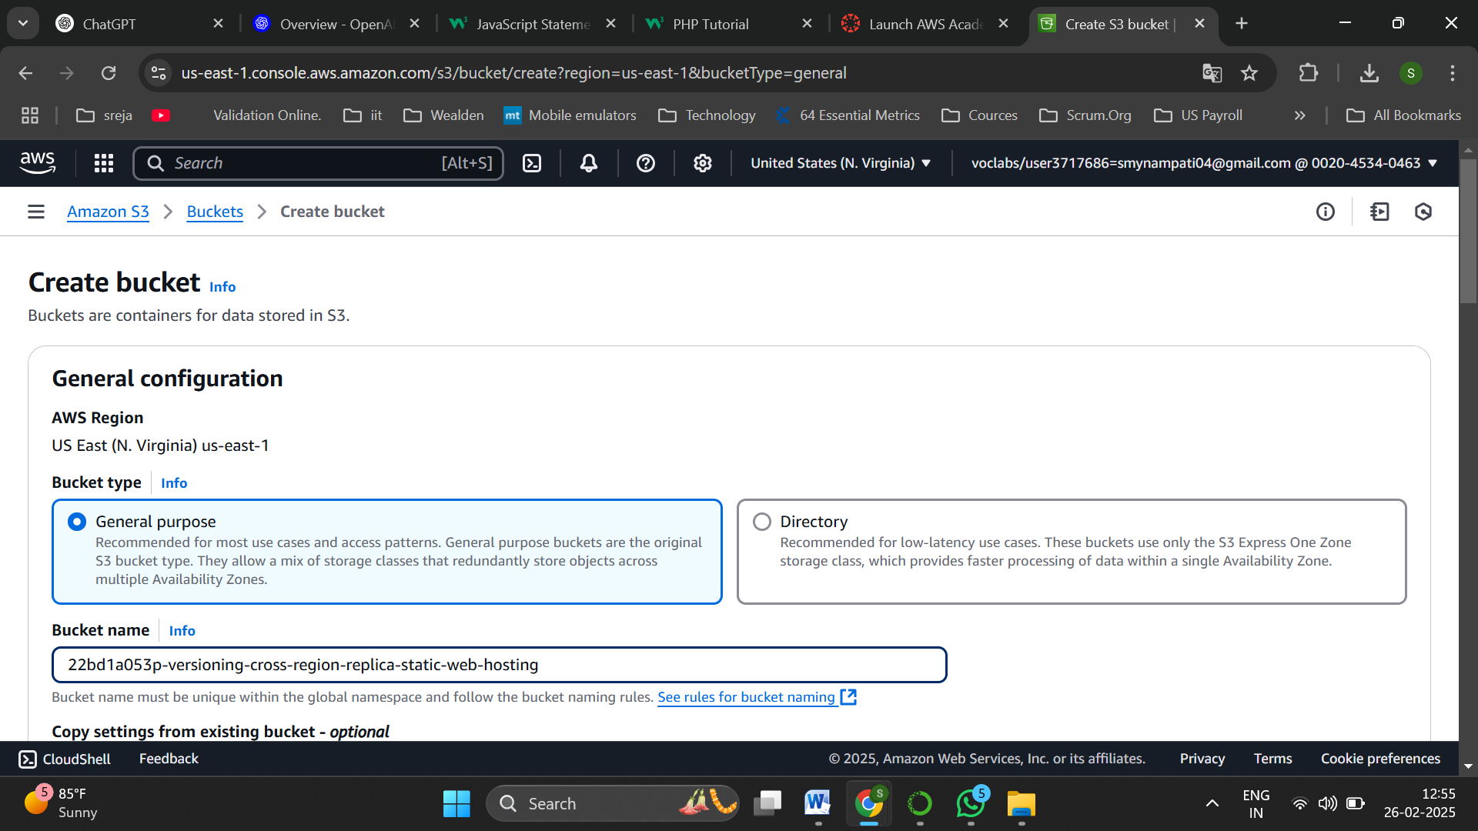

Create a bucket of type general purpose

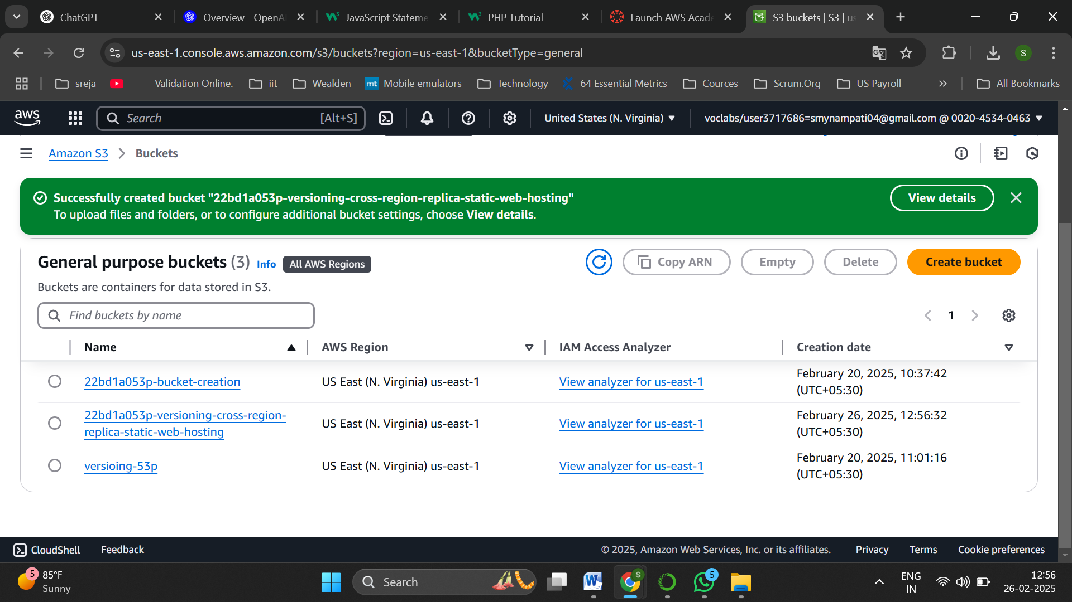

Bucket is successfully created

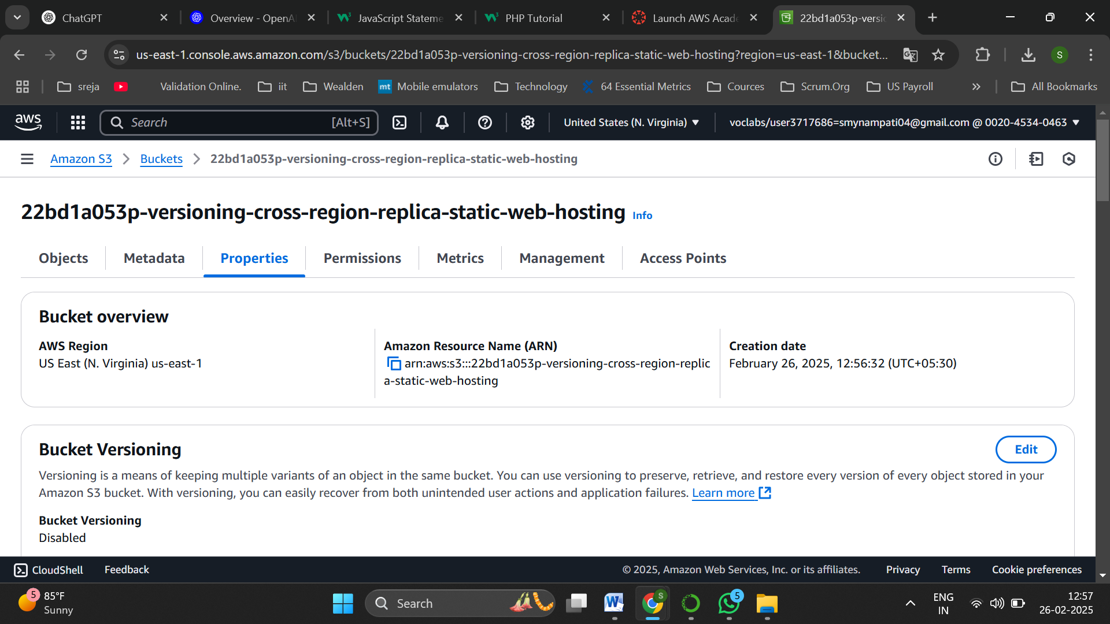

Navigate to properties of the bucket

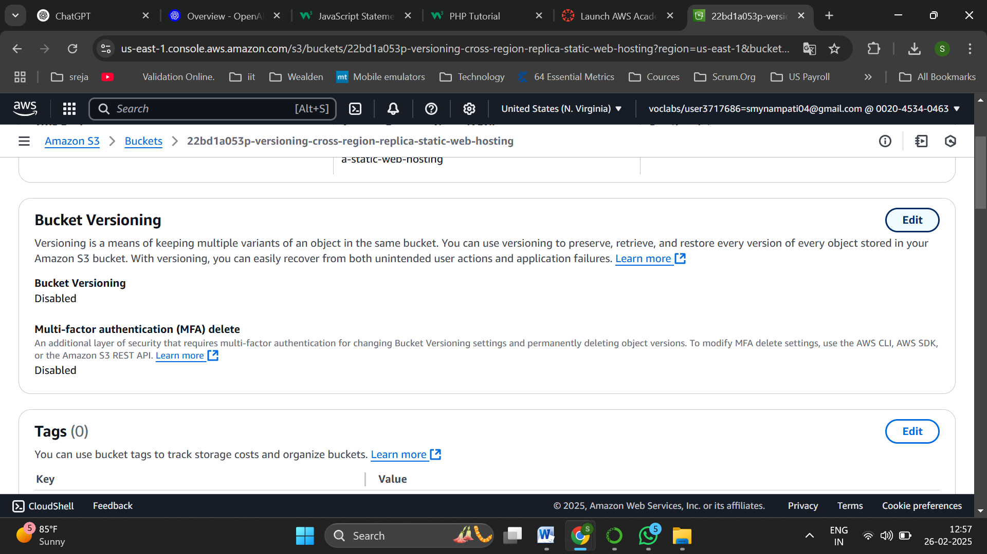

Edit the Bucket Versioning

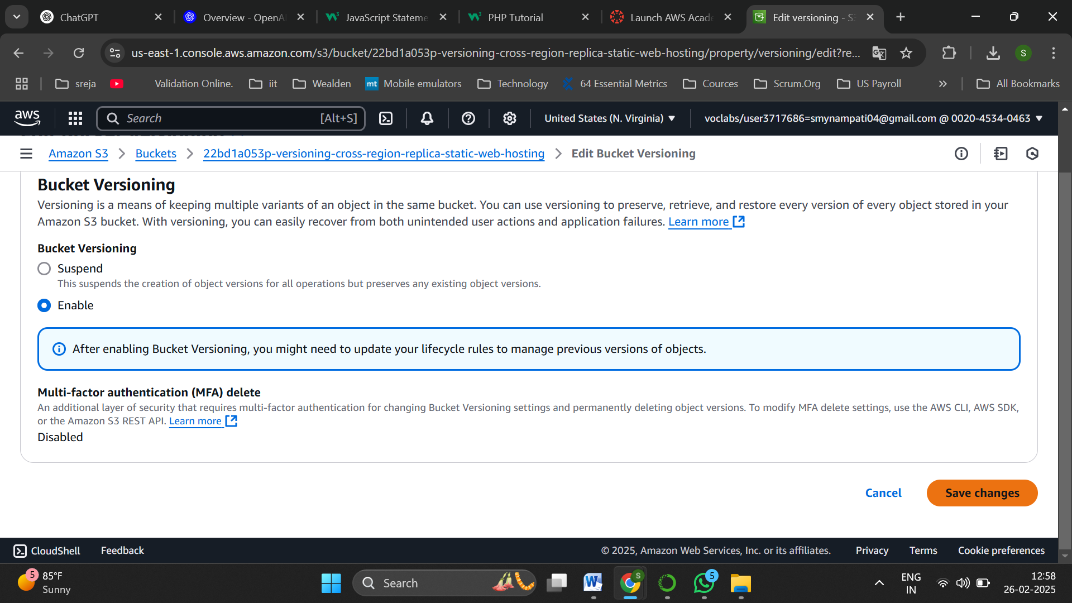

Enable versioning and save changes

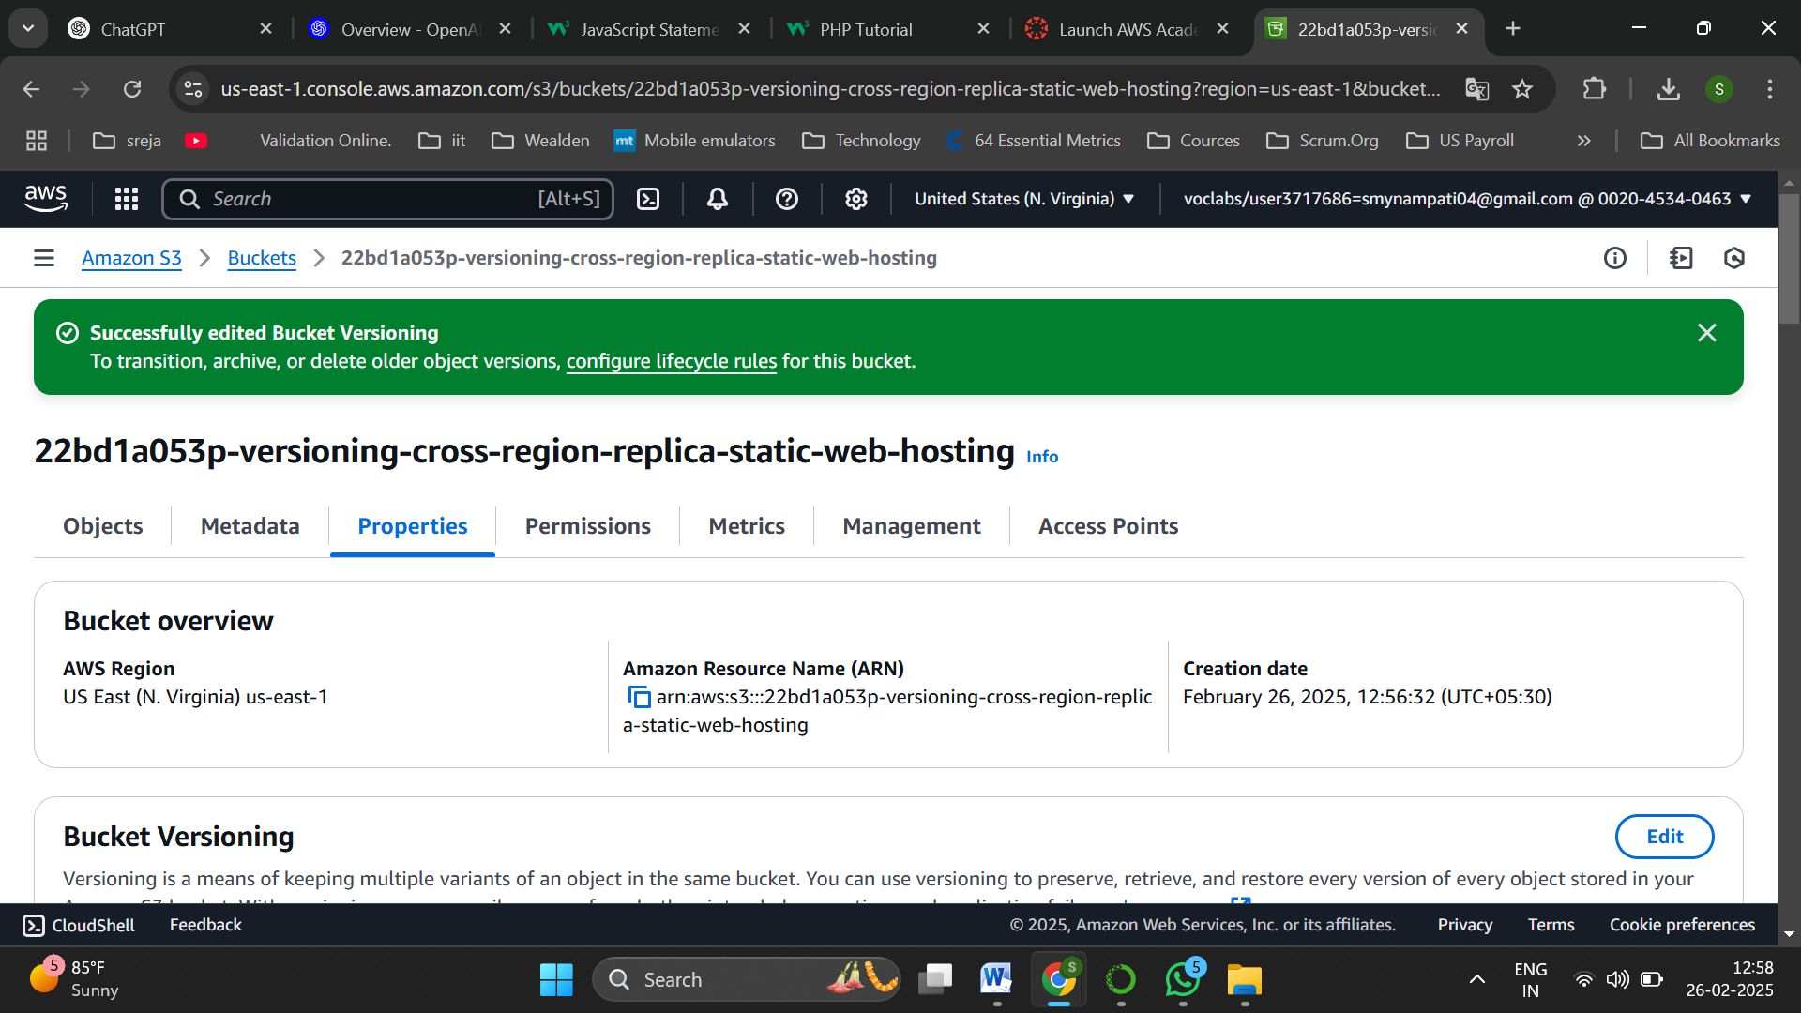

Successfully updated

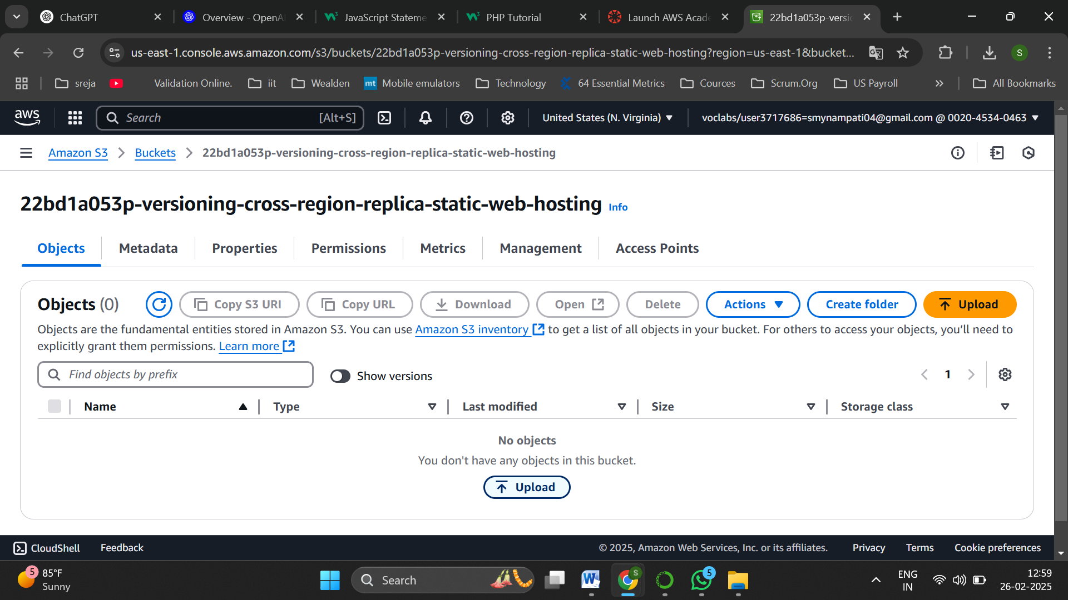

Now upload files into the bucket

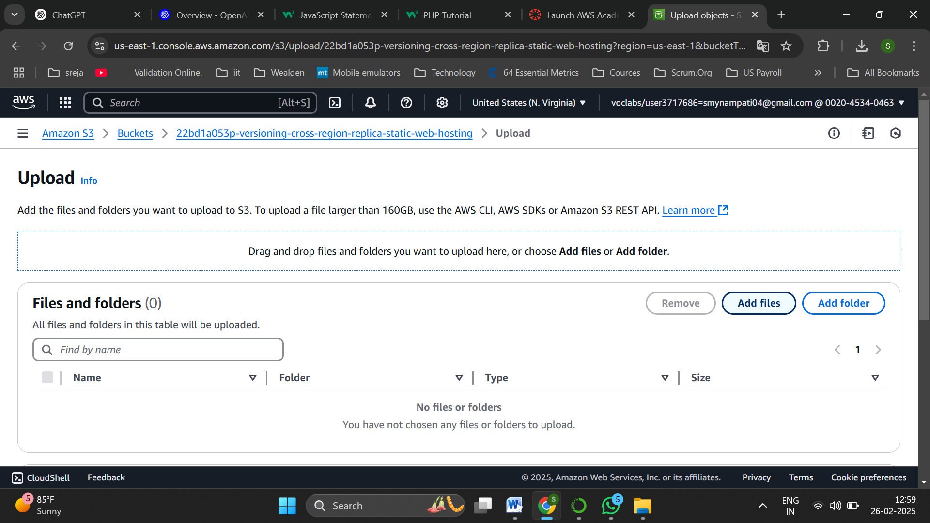

Click on add files

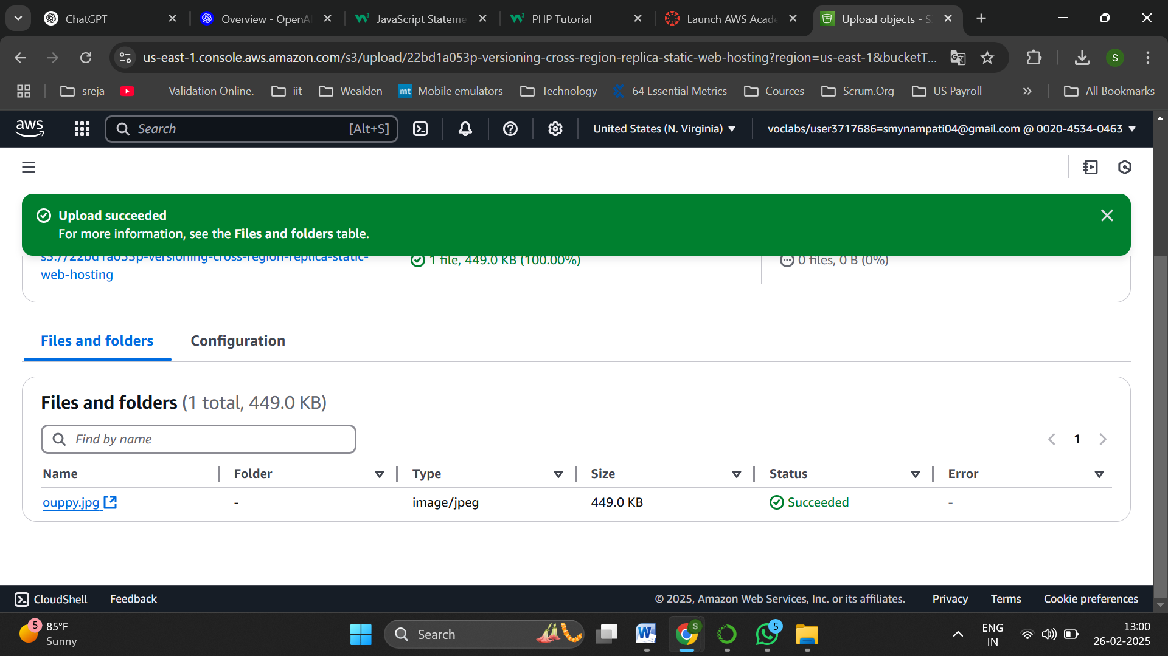

An image file is uploaded

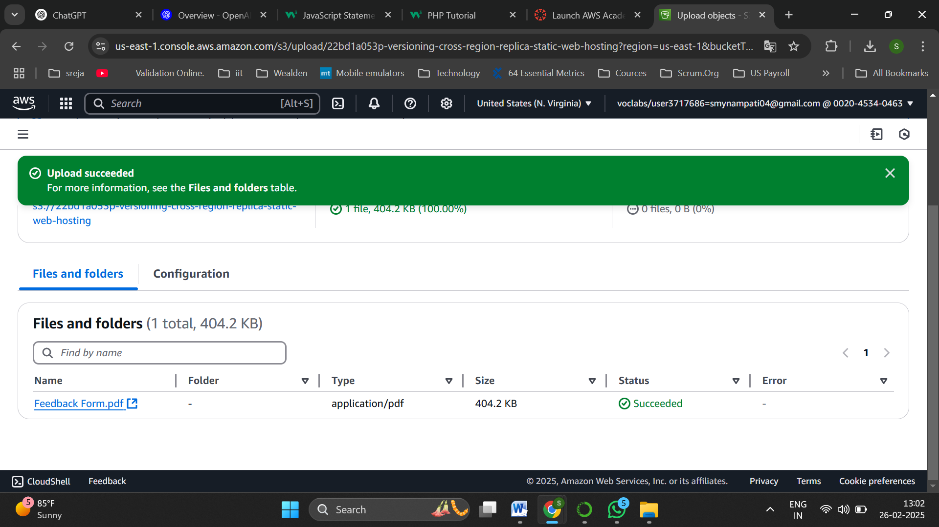

Similarly upload a pdf file too

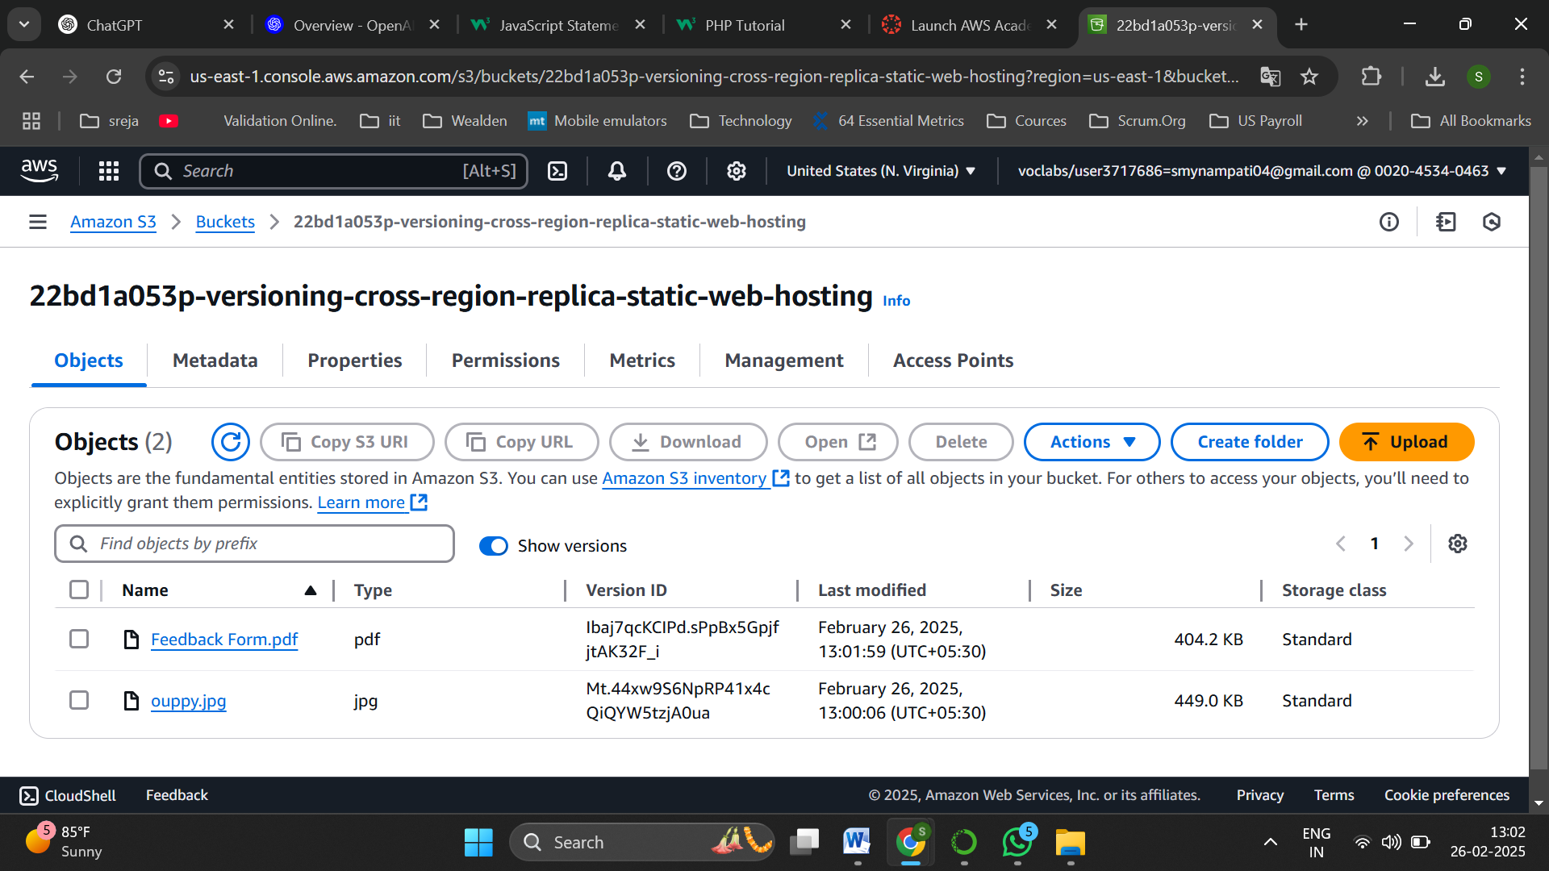

Now these are the 2 objects available in the bucket

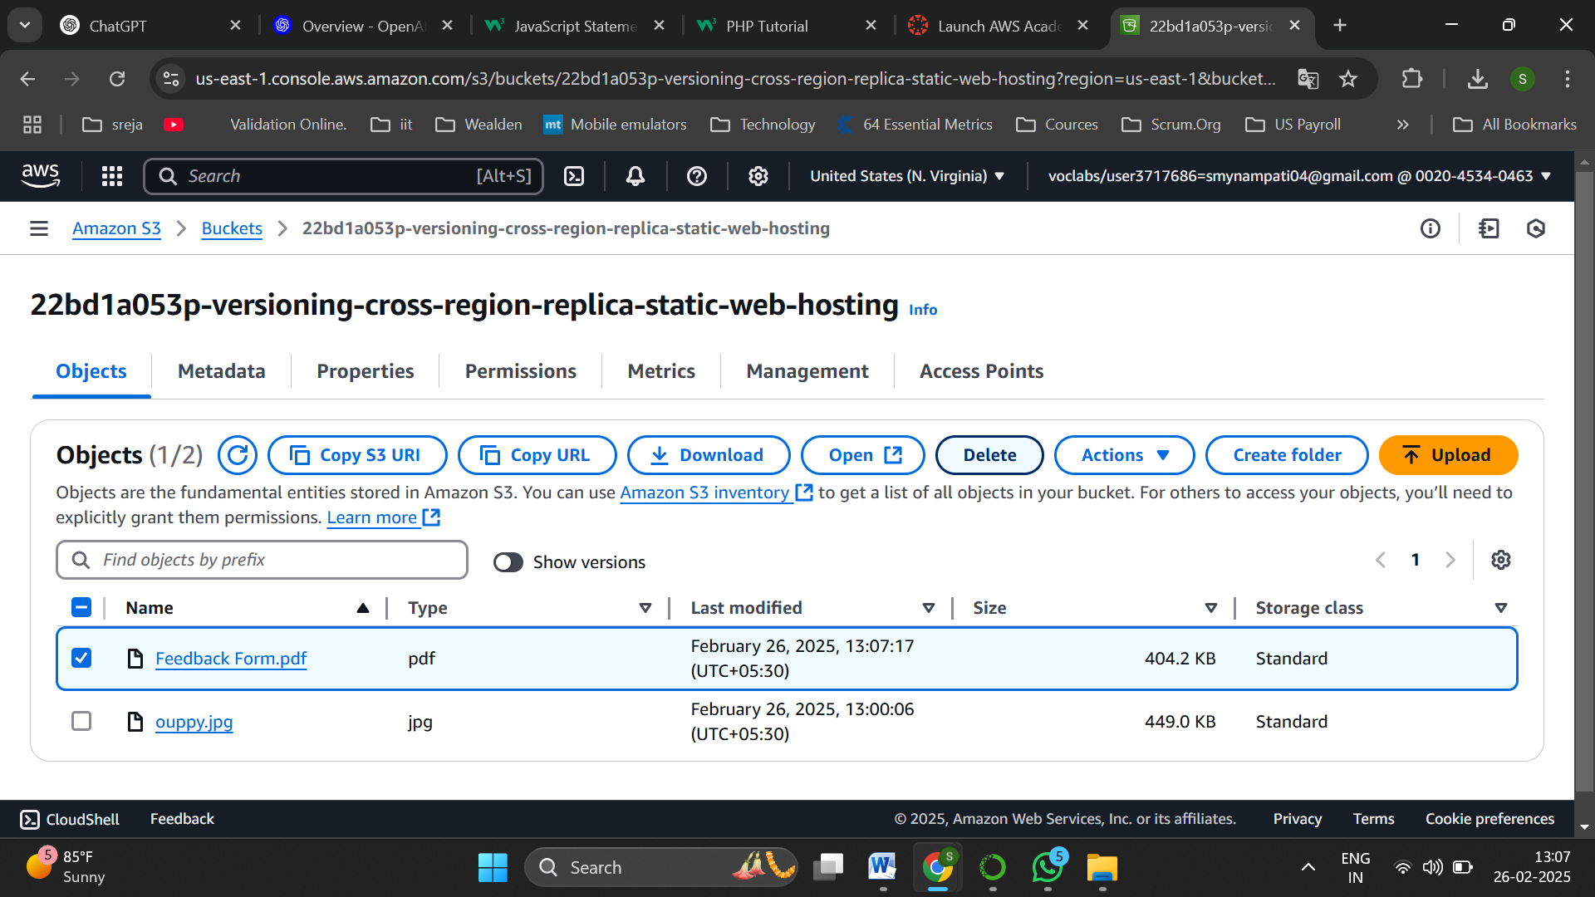

Now select the pdf file and delete it

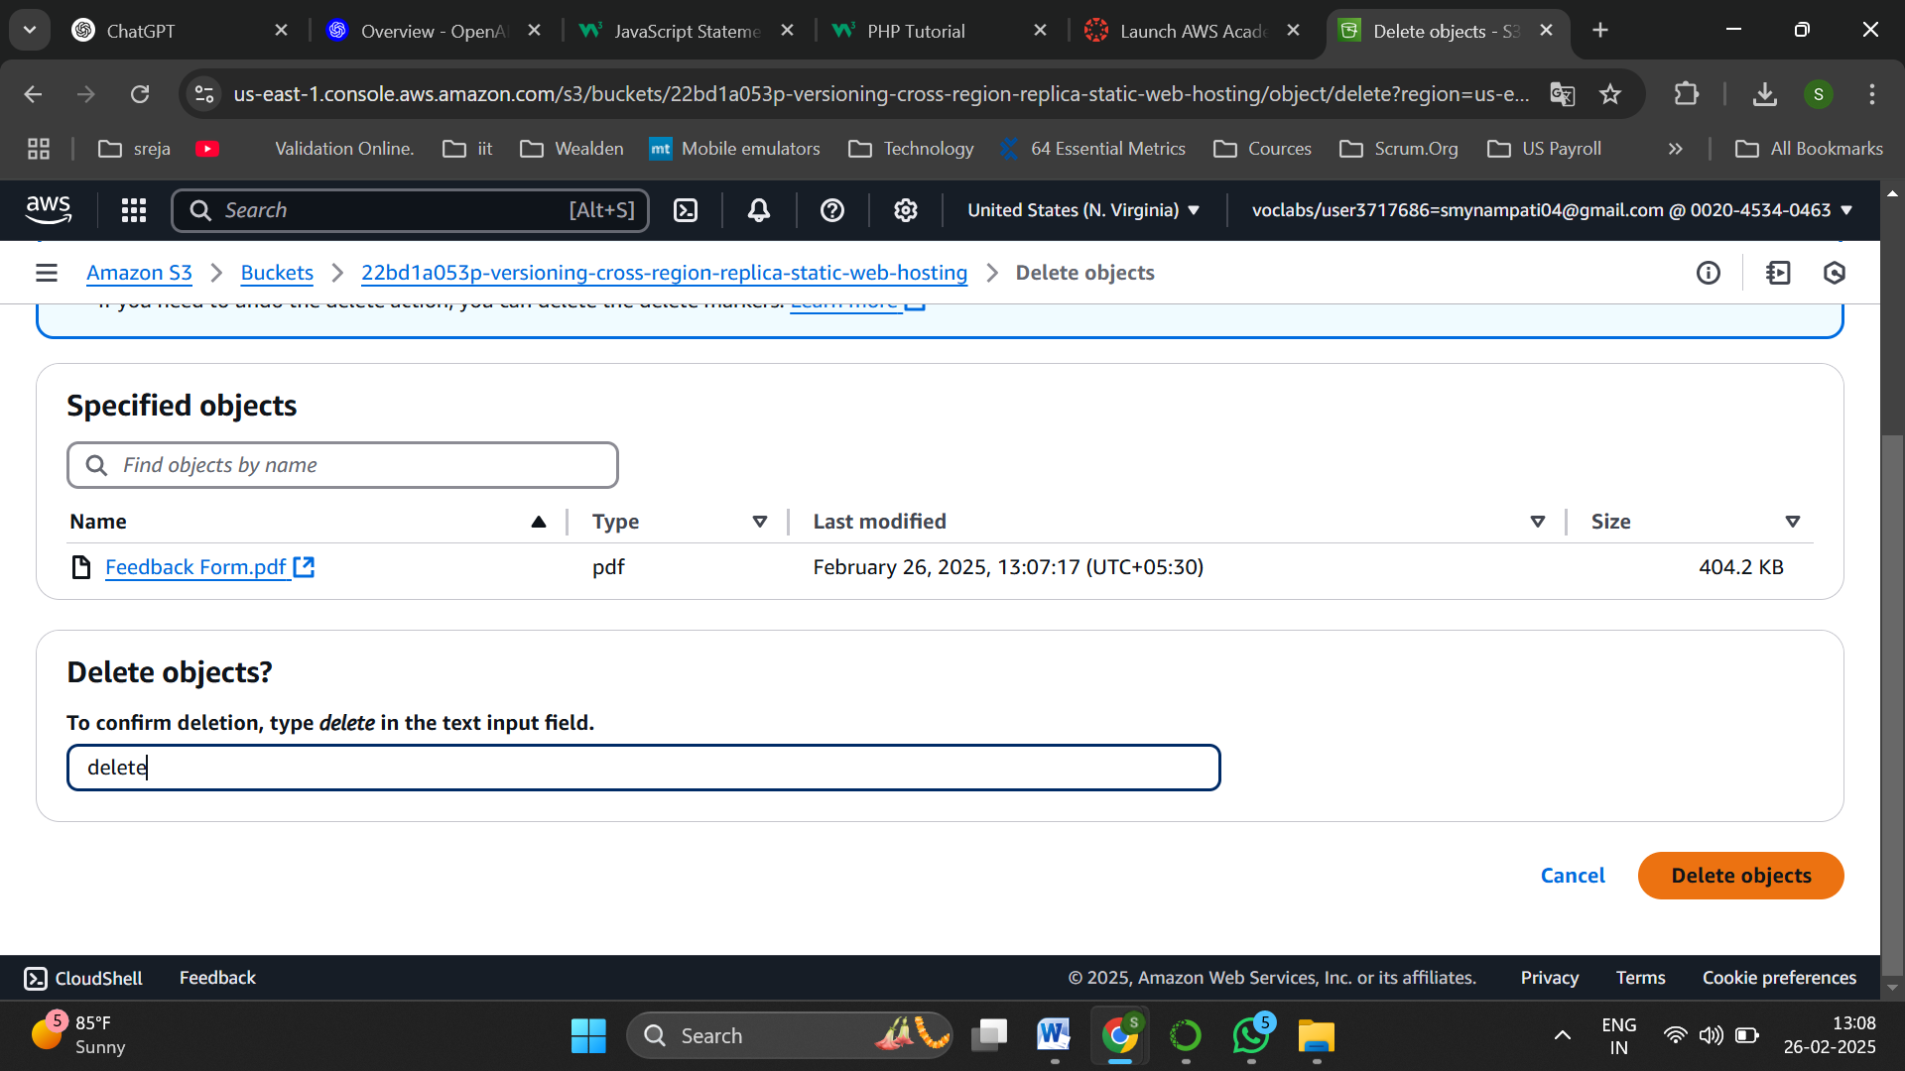

Confirm to delete it

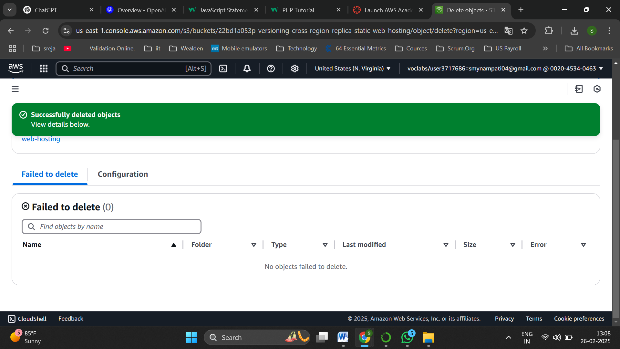

Successfully deleted object

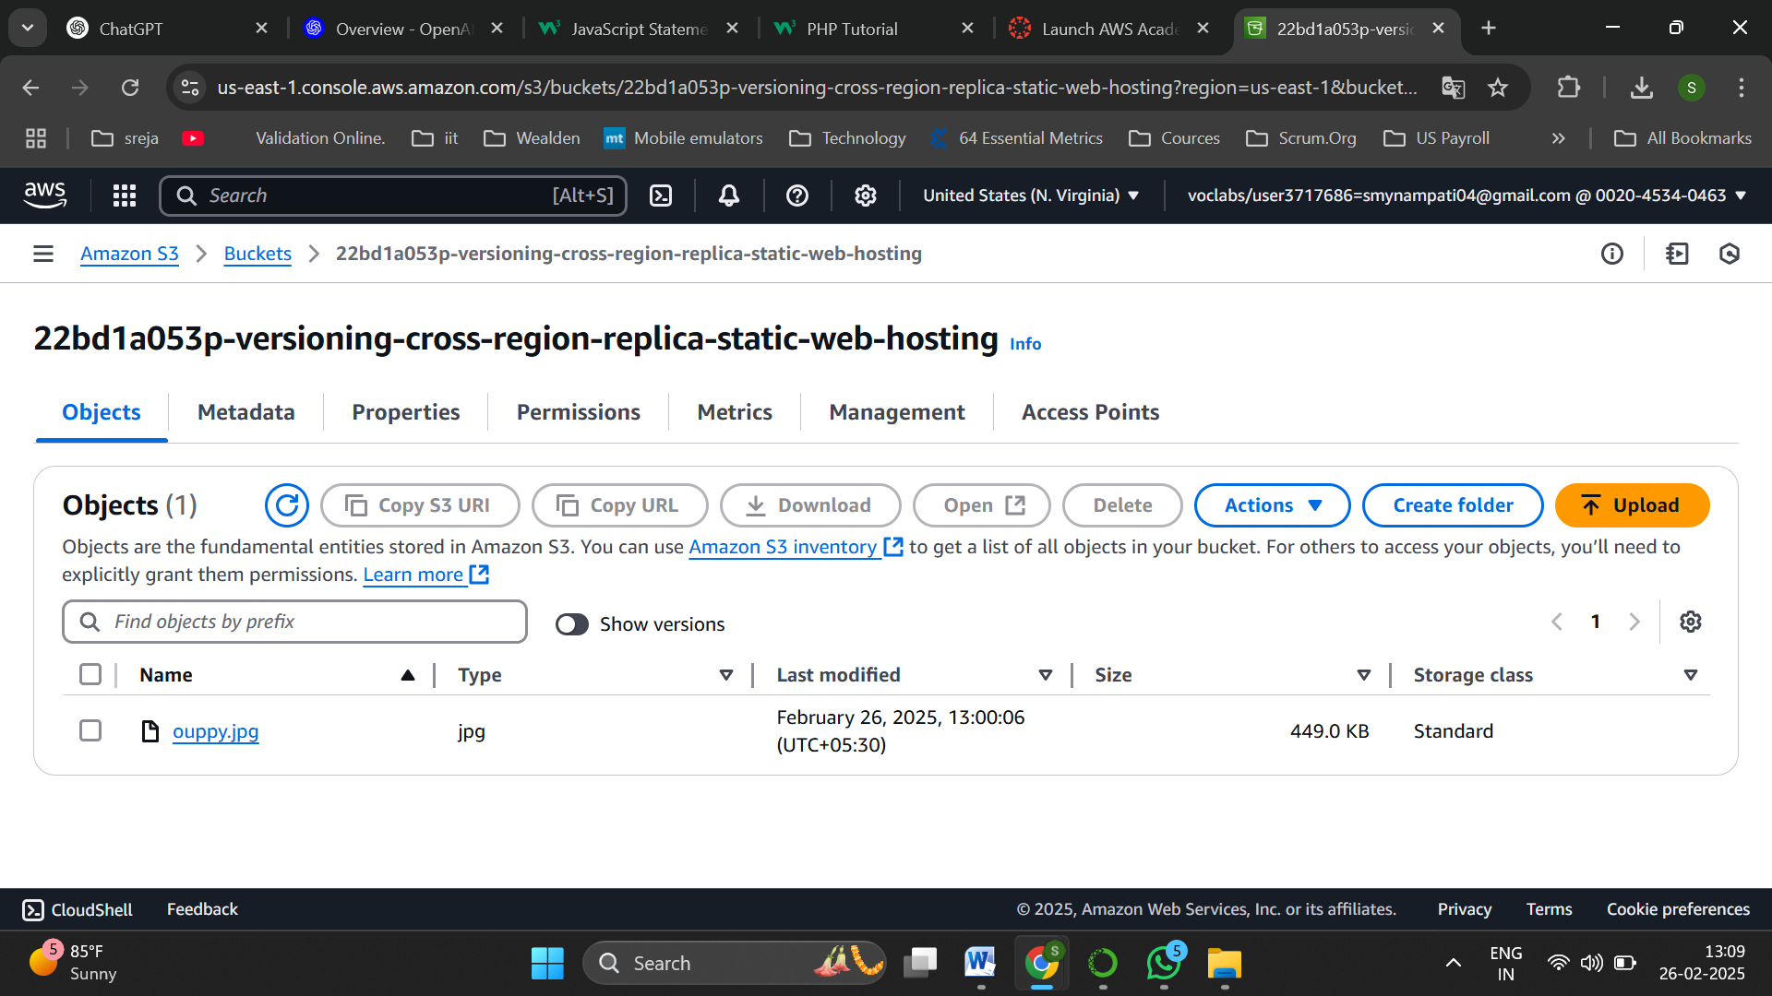

Now in bucket only one object is visible to be present

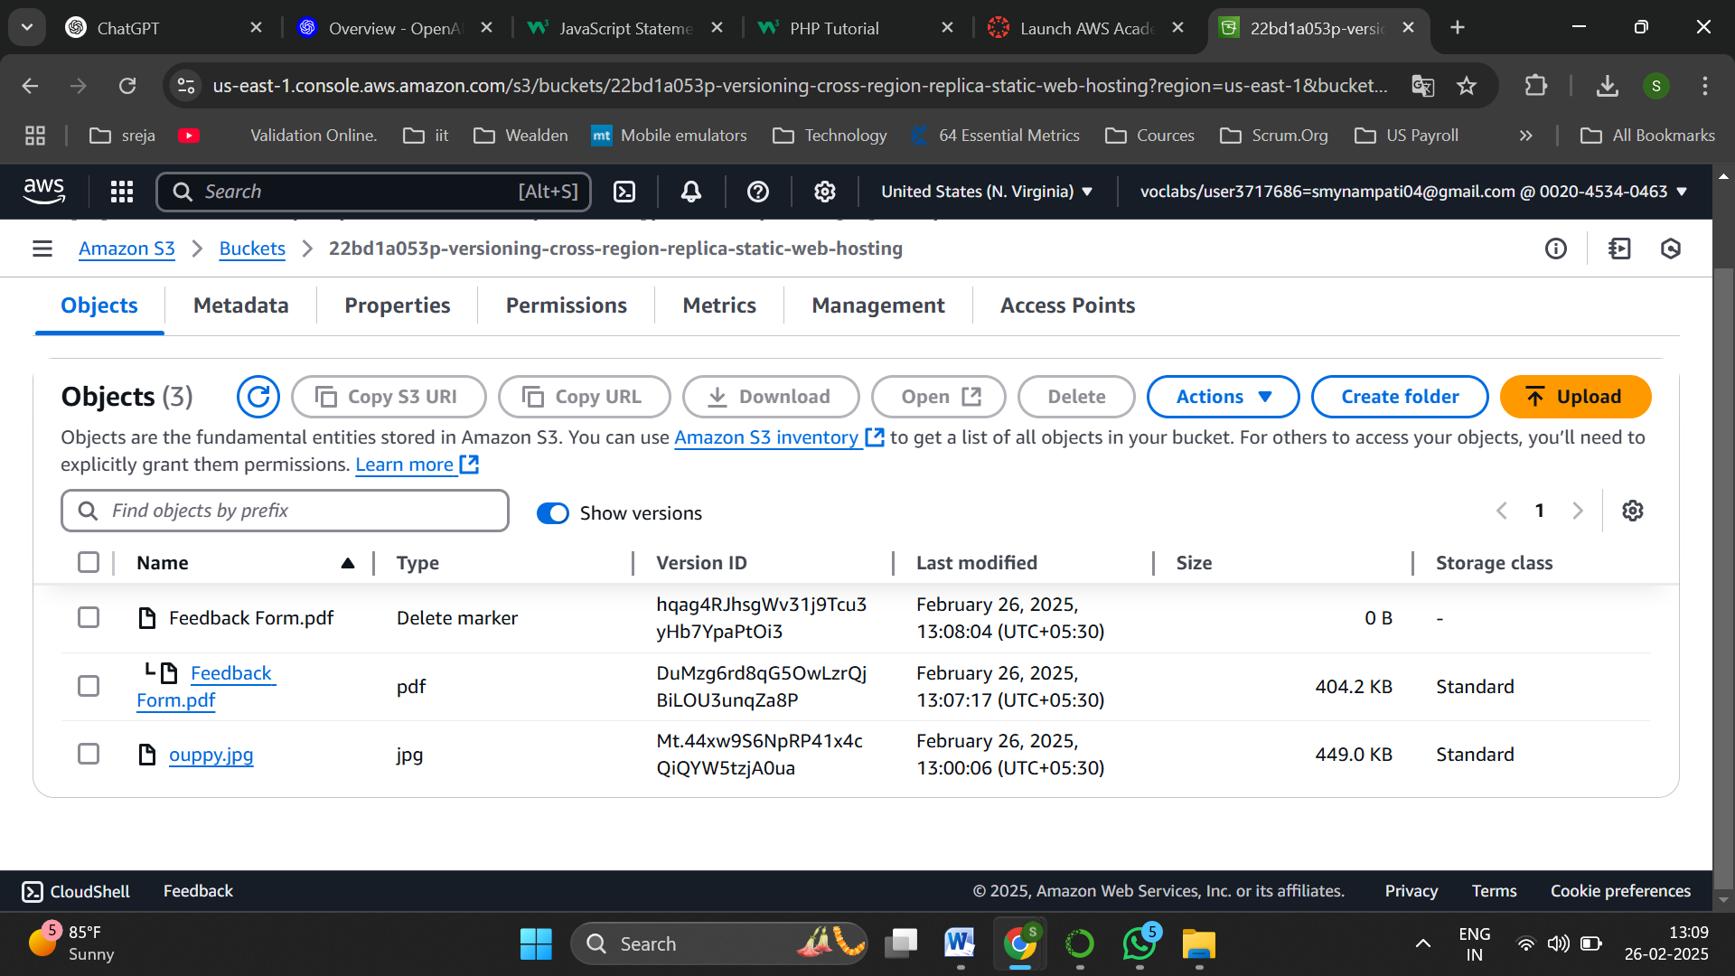

Now enable show versions

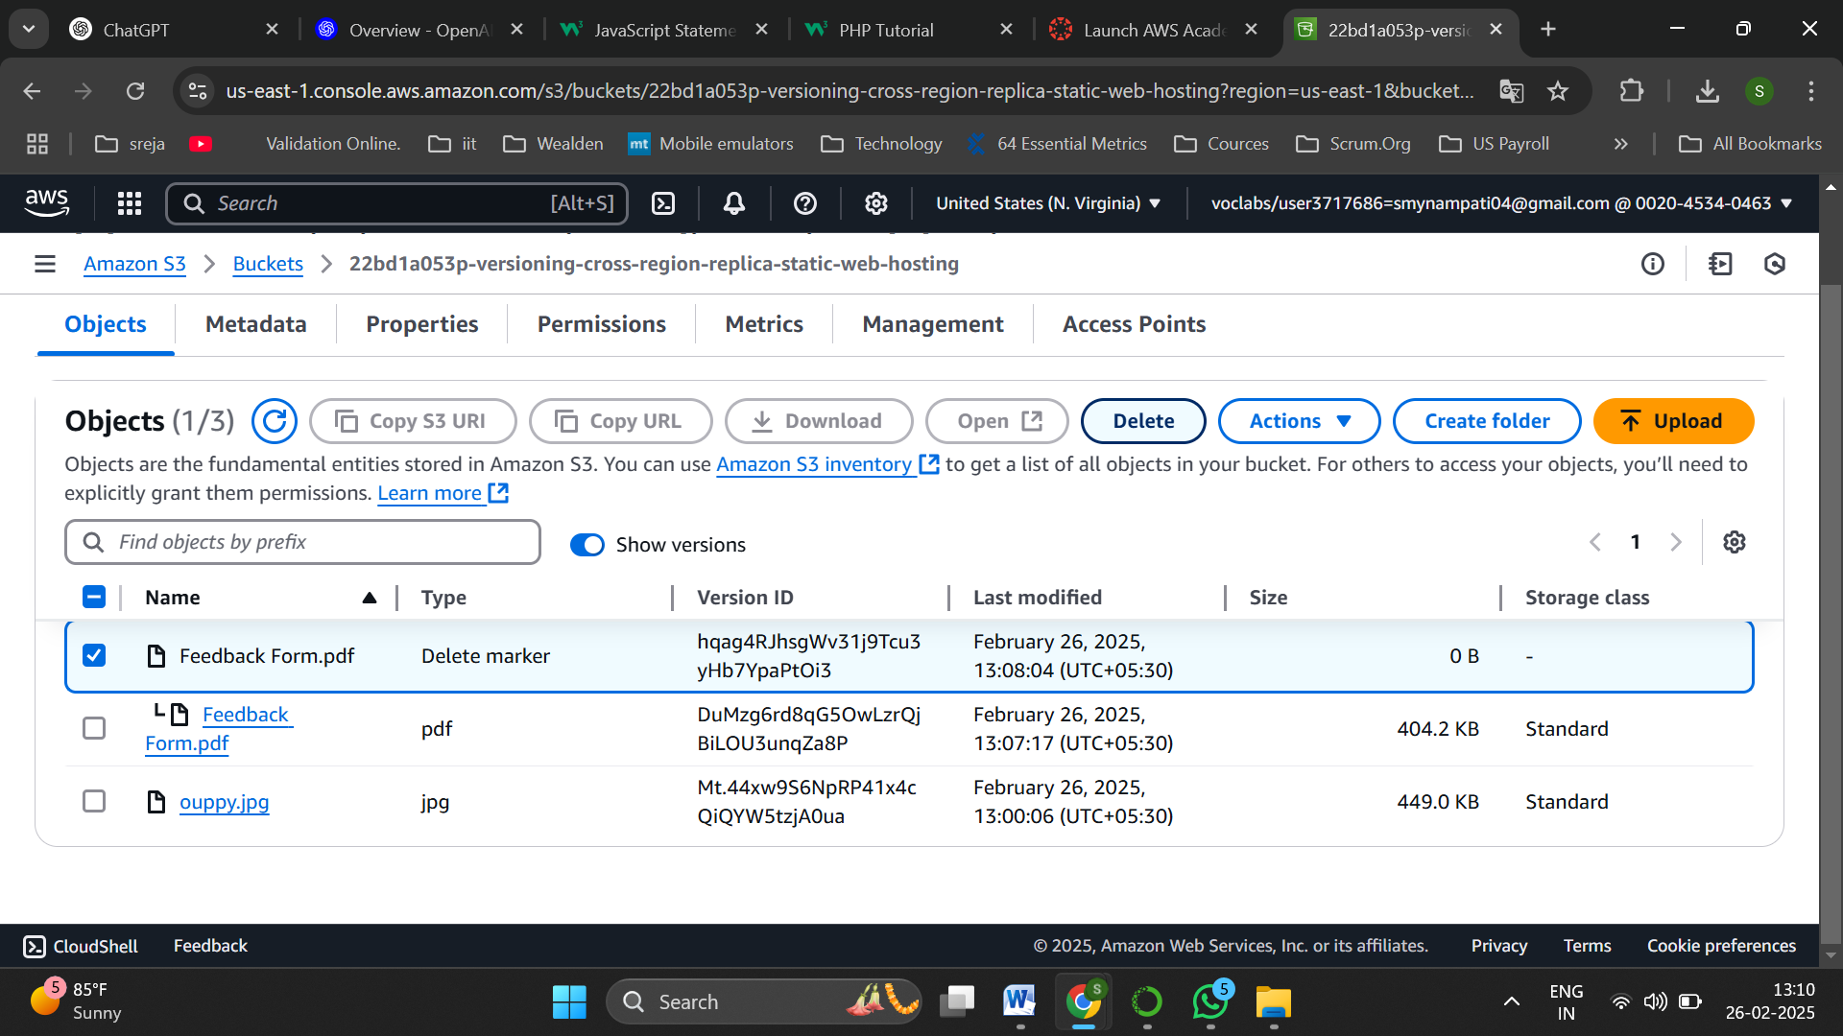

A delete marker and all objects including deleted ones are visible in the bucket,select the delete marker

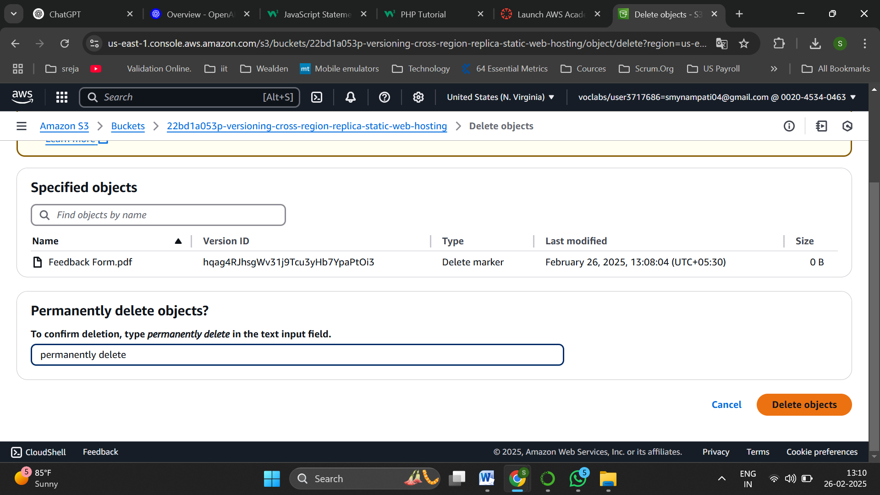

And delete it permenantly

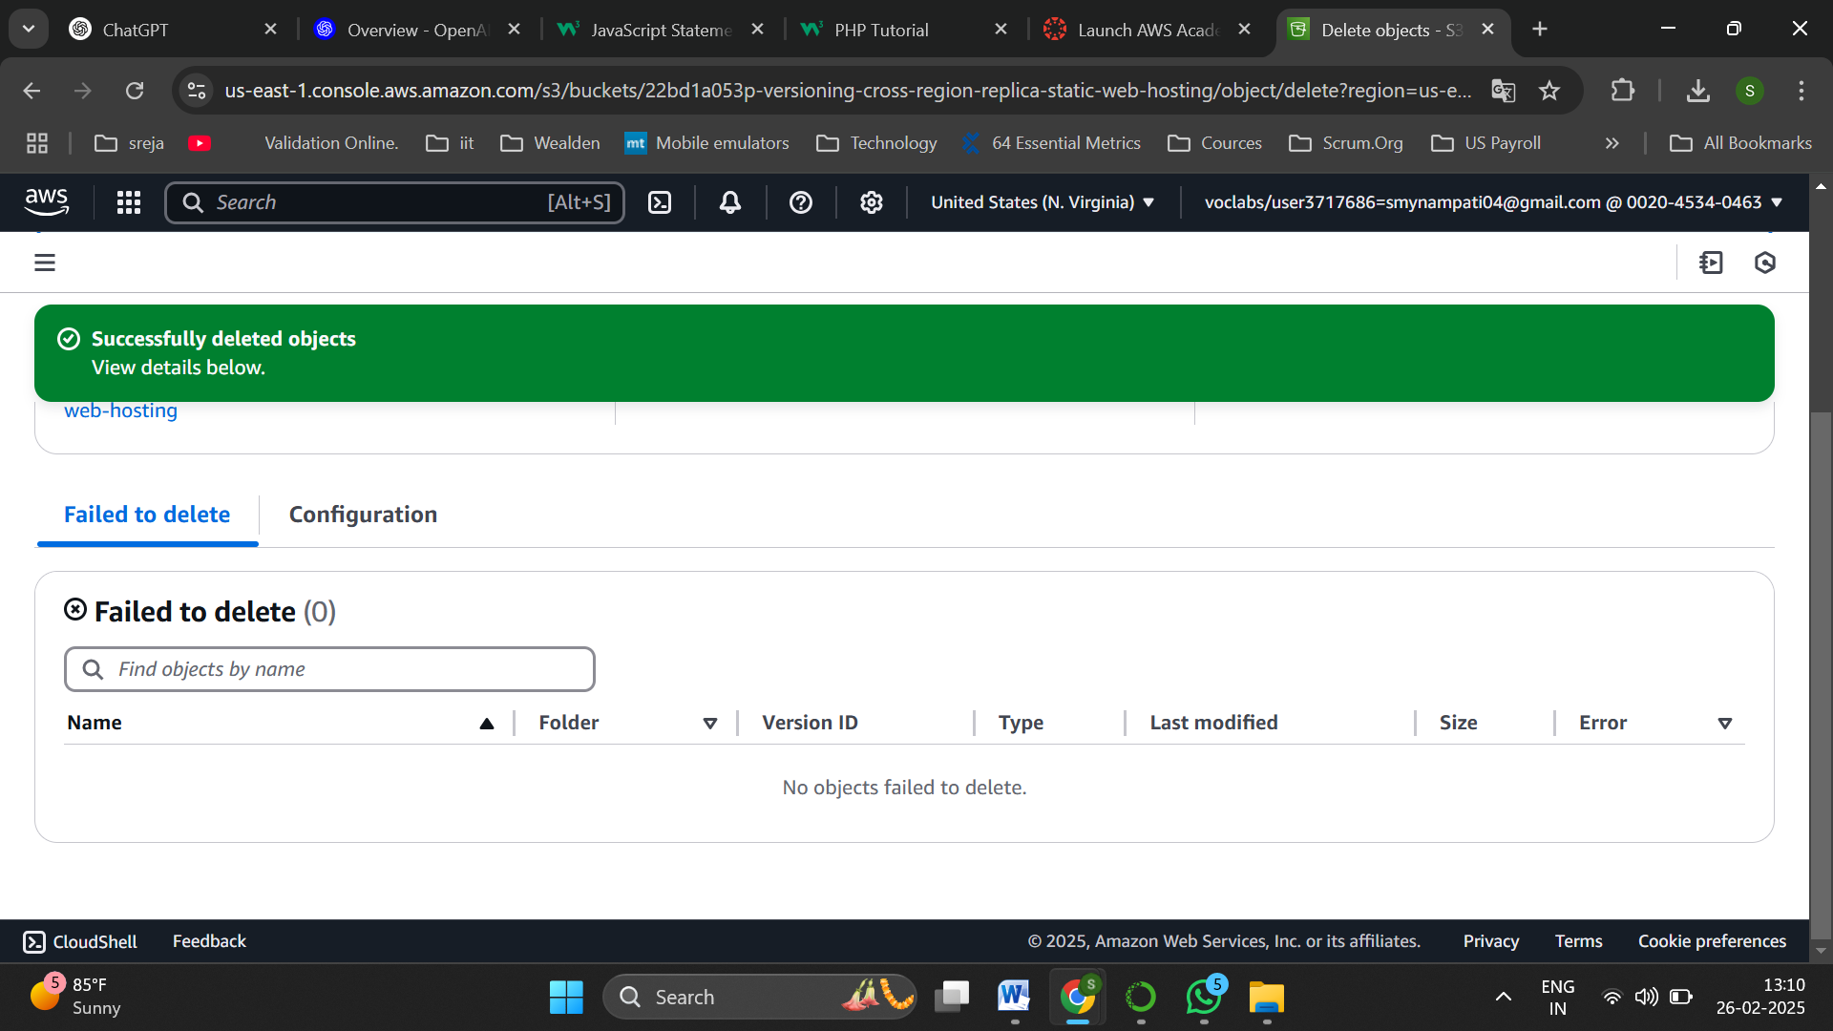

Successfully deleted the delete marker

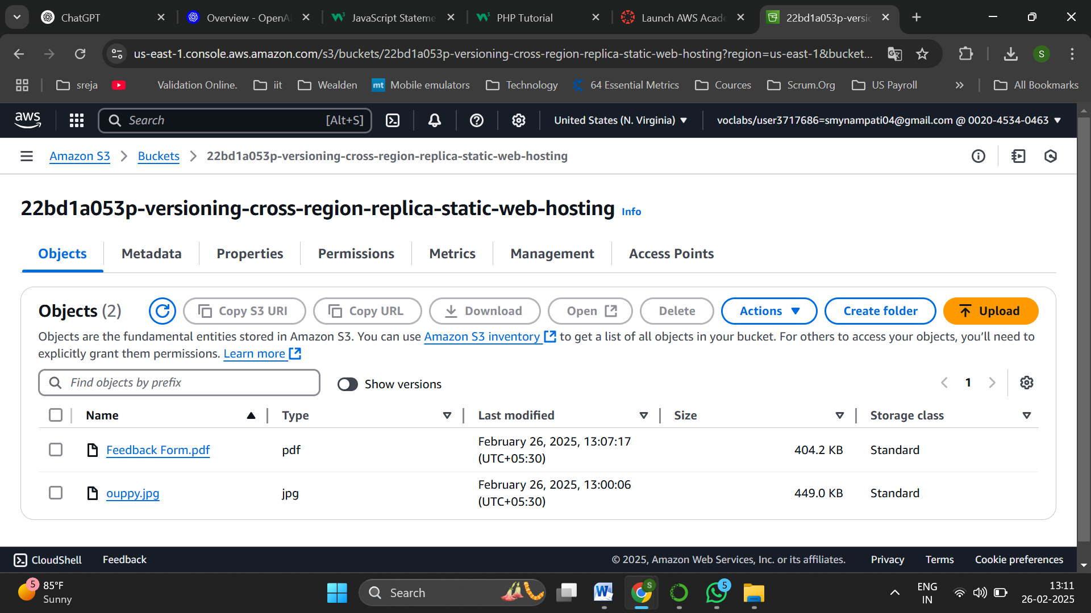

Now,once we disable the show versions the deleted file is retrieved

Duplicate files

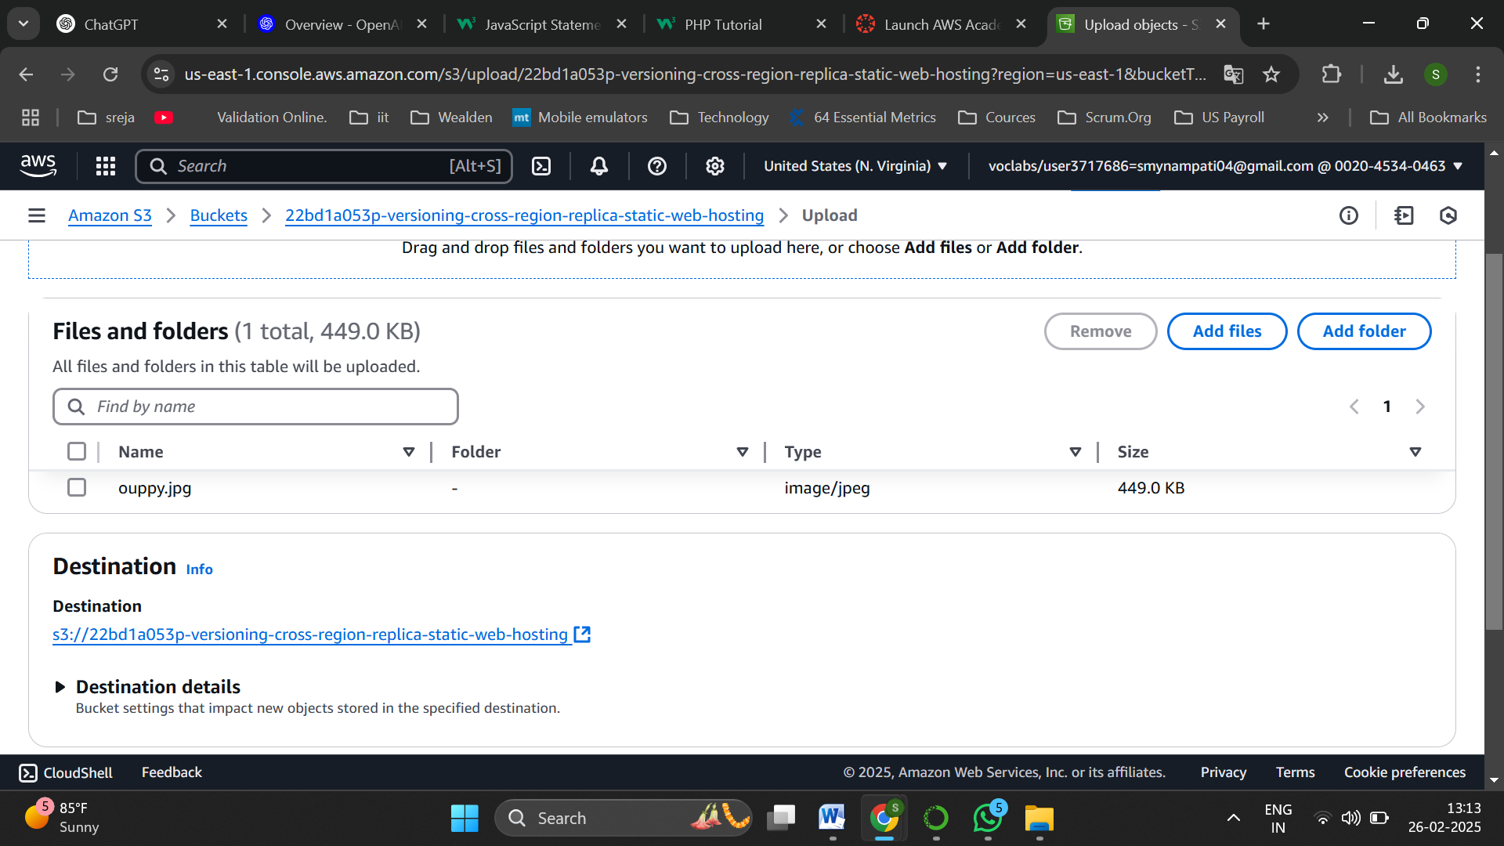

Upload the same image file that is already existing in the bucket

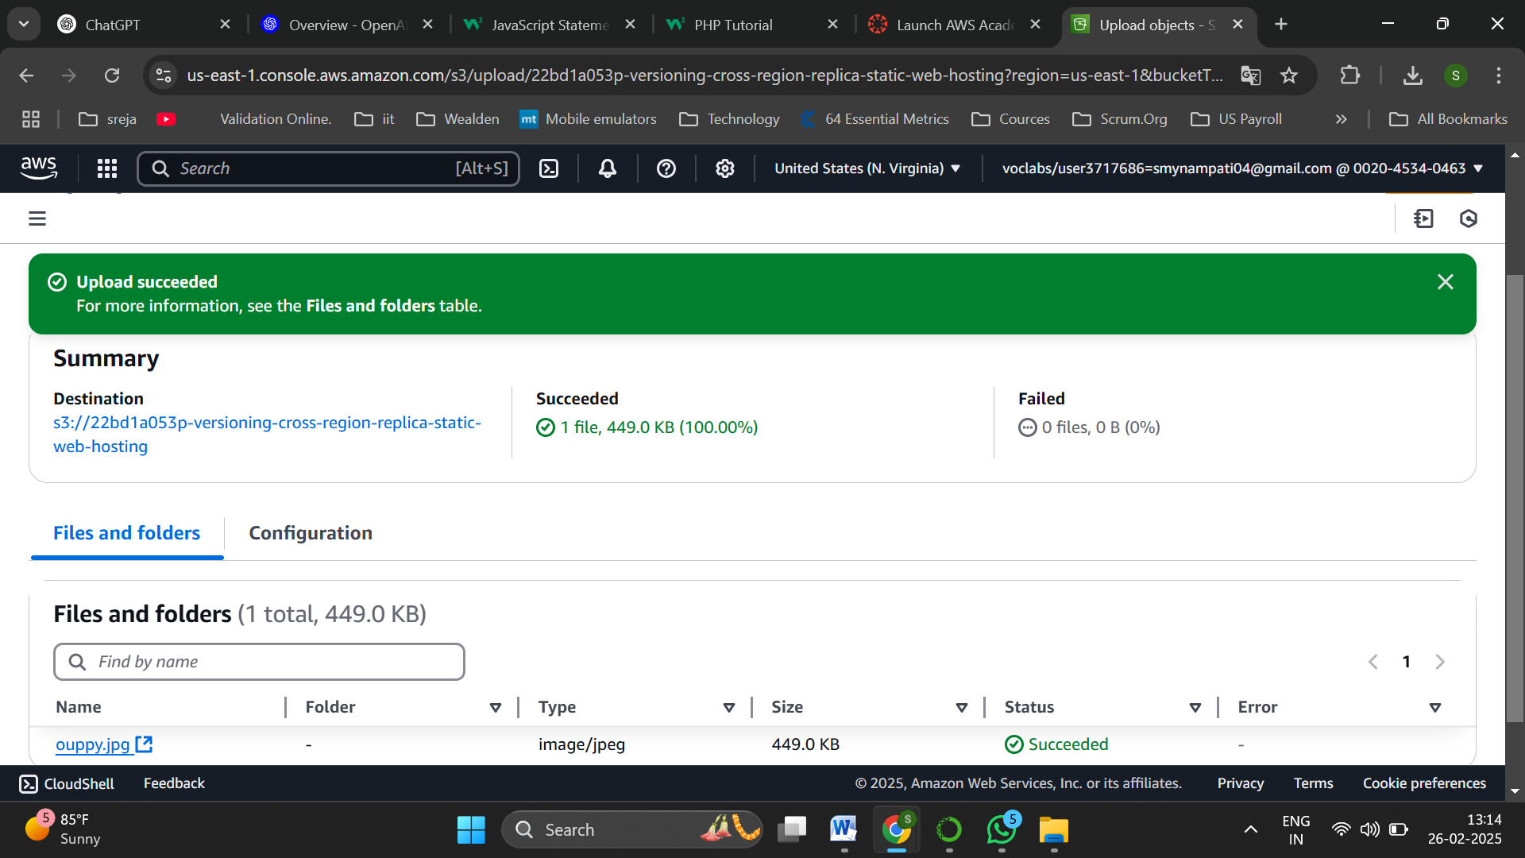

Uploded successfully the same object again

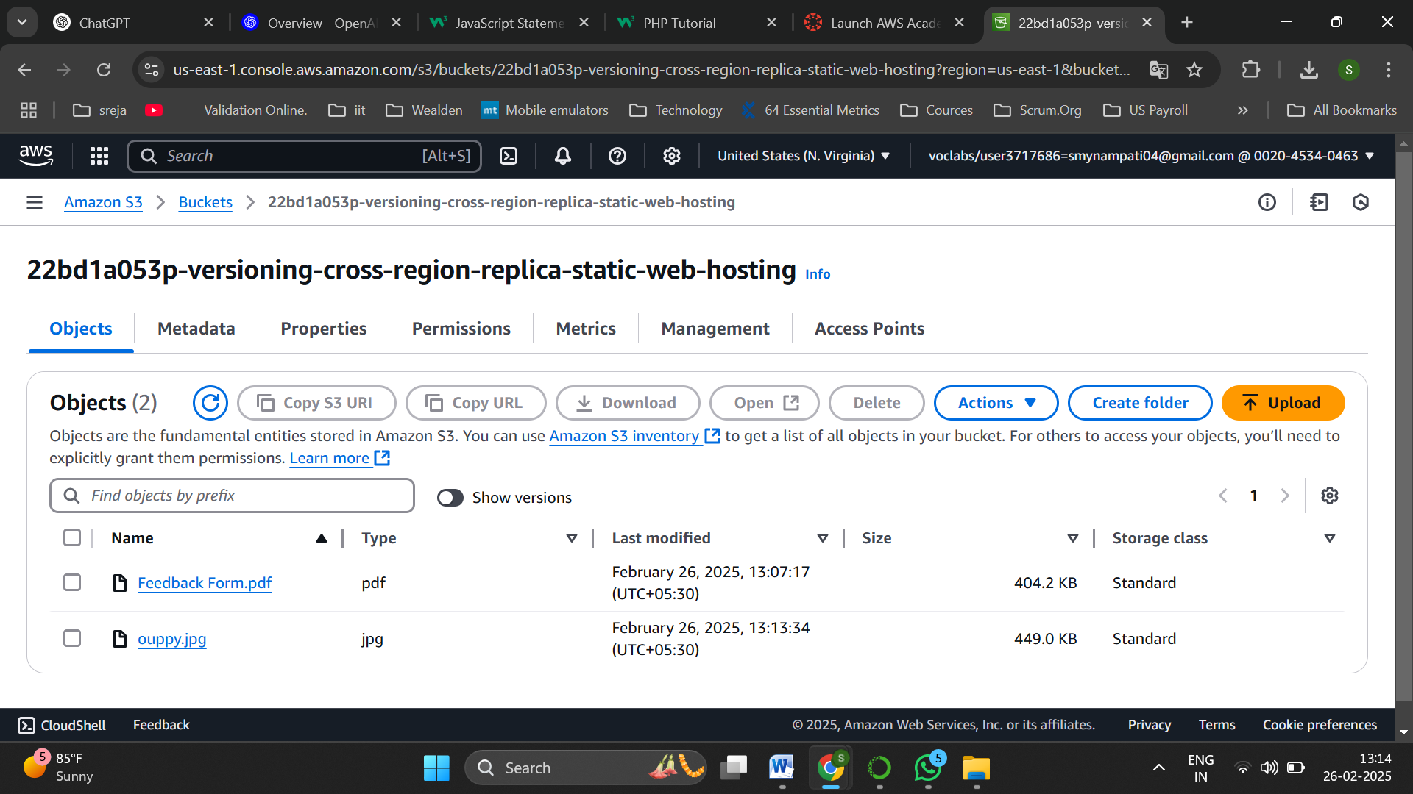

But in object there is no second file visible on same name,only 1 image file is present

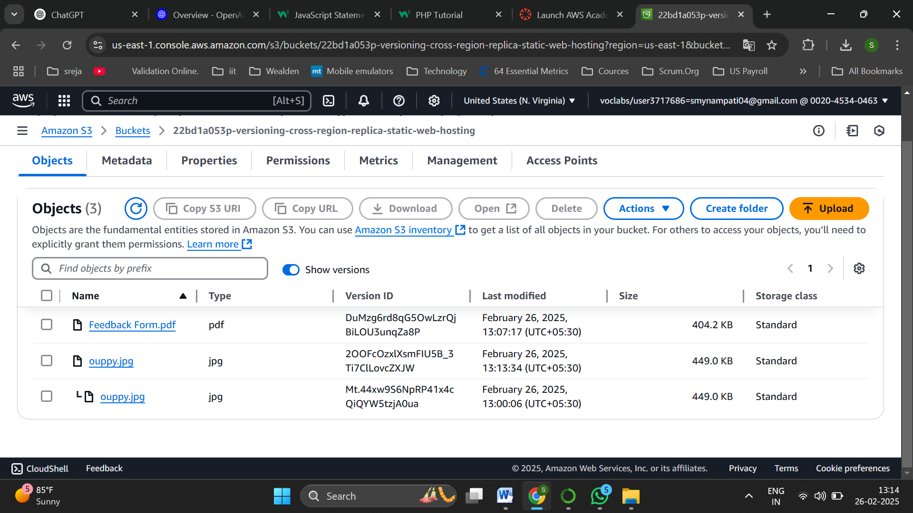

But on enabling show versions along with time stamp didderent files are available,in this way bucket versioning stores various versions of same file

Cross Region Replica:

**Cross-Region Replication (CRR)** in AWS S3 is a feature that automatically replicates objects from one S3 bucket to another in a different AWS region. It enhances data redundancy, disaster recovery, and latency reduction by ensuring copies of data are available across geographically separate locations. CRR requires versioning to be enabled and can be configured with specific replication rules, including filtering by prefixes or object tags.

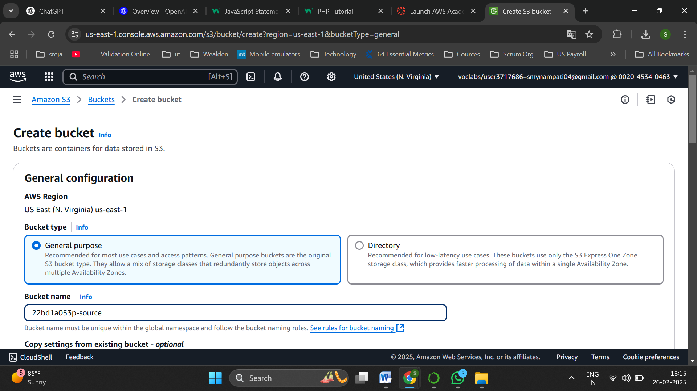

Create and name the bucket as source in the region Virginia

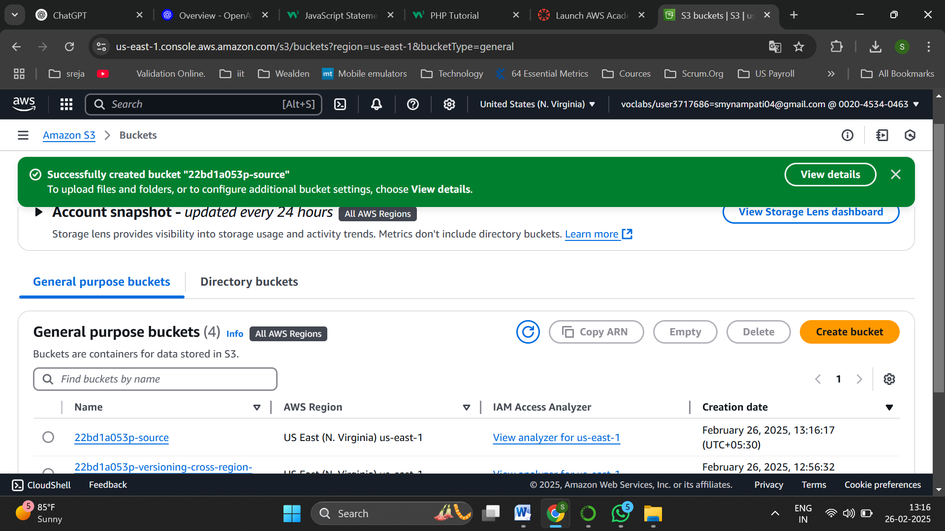

Bucket successfully created

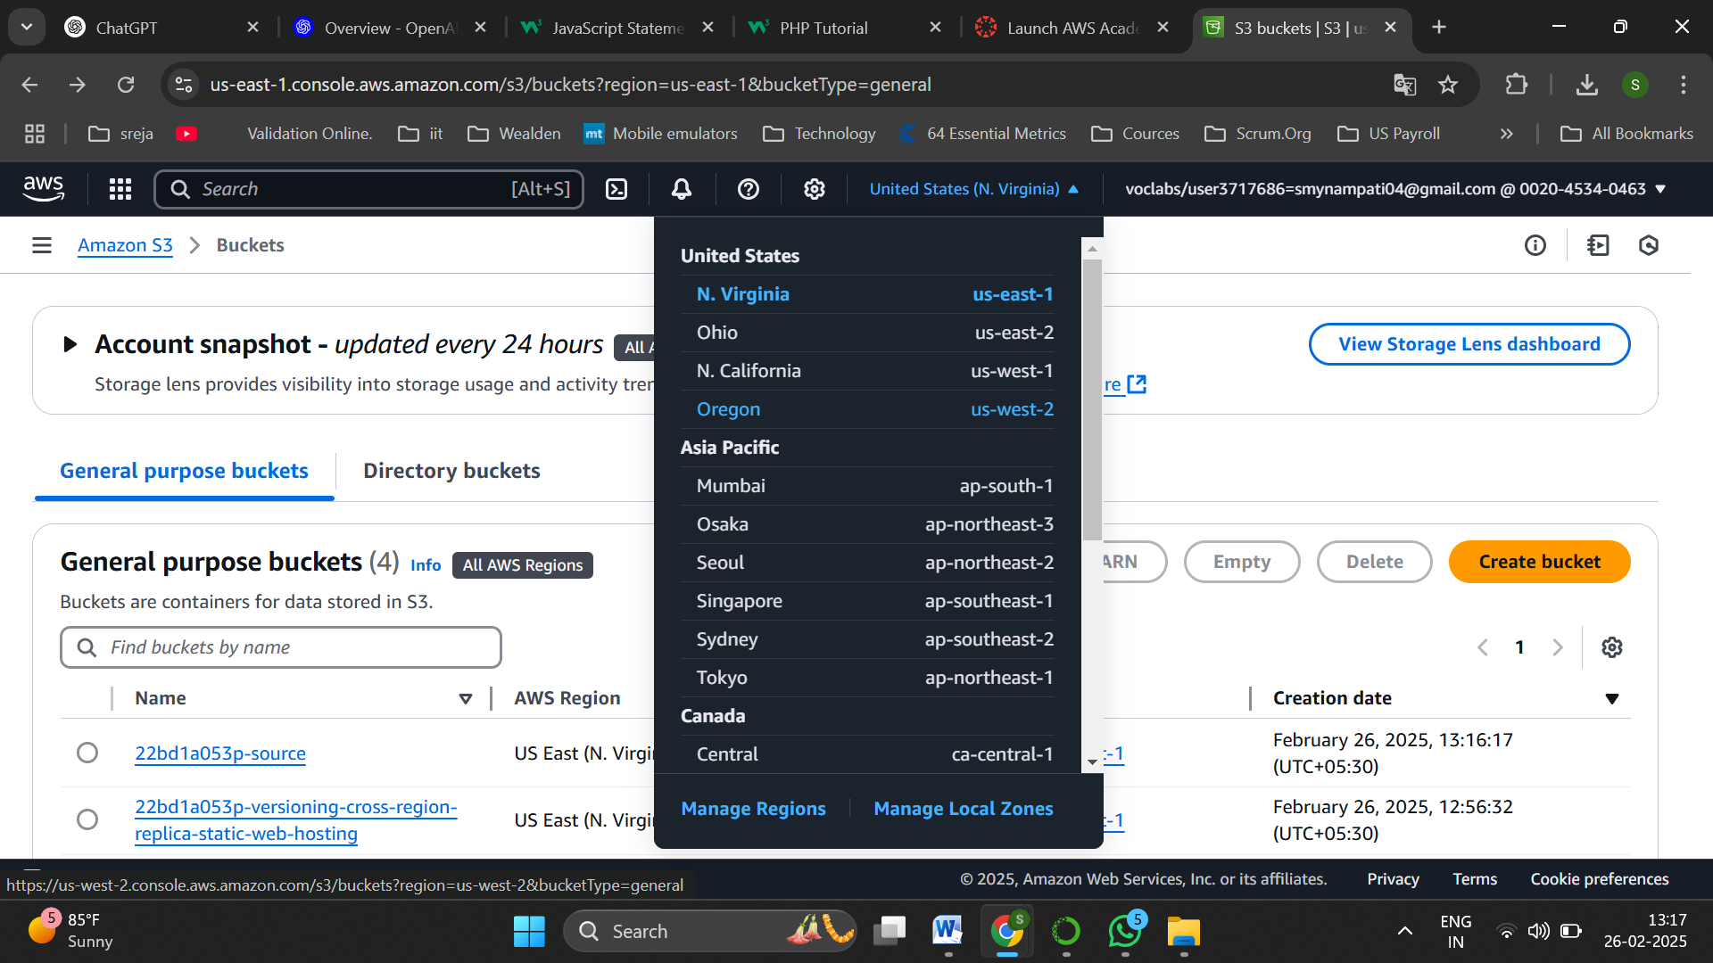

Now change the region to Oregon

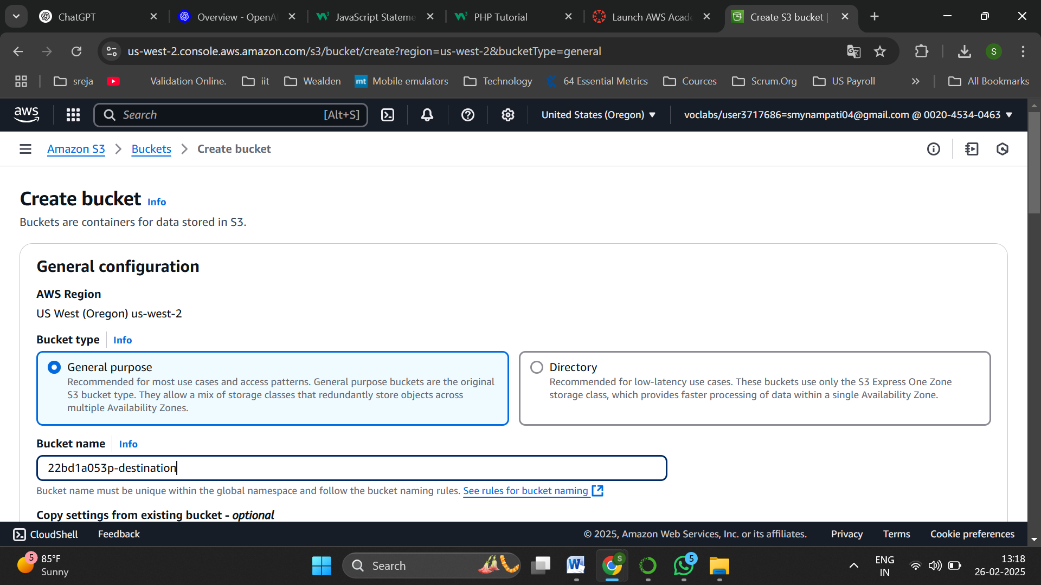

Now create another bucket and name it destination

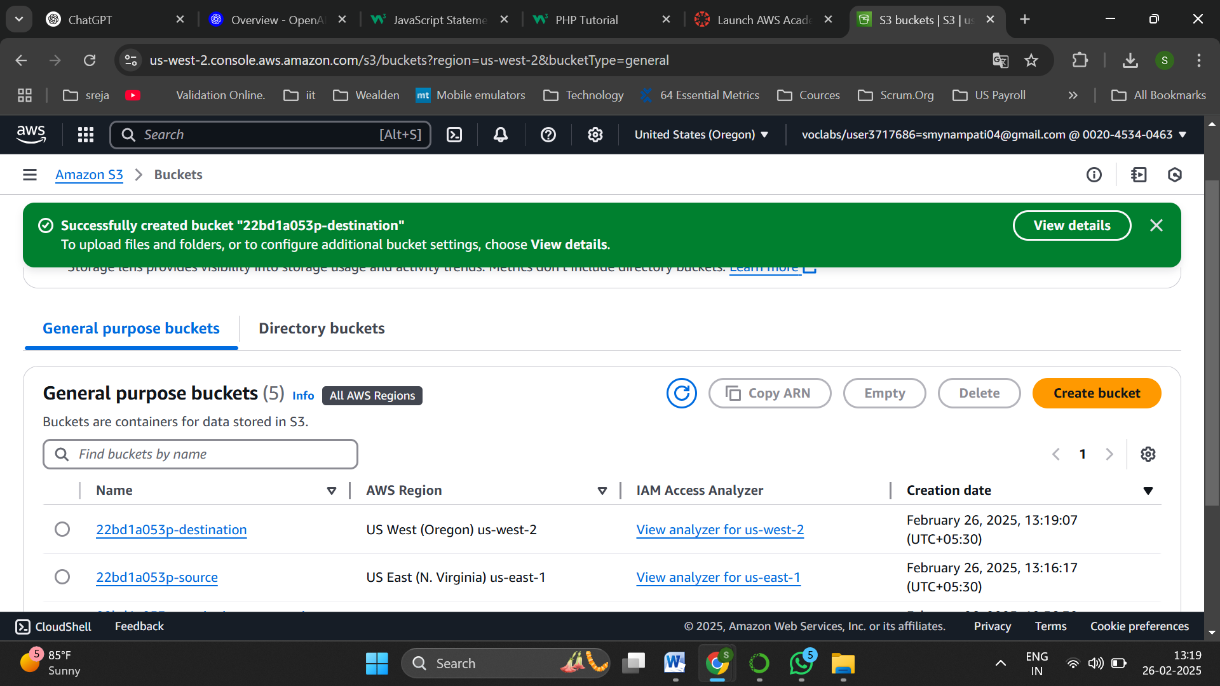

Destination bucket is also successfully created

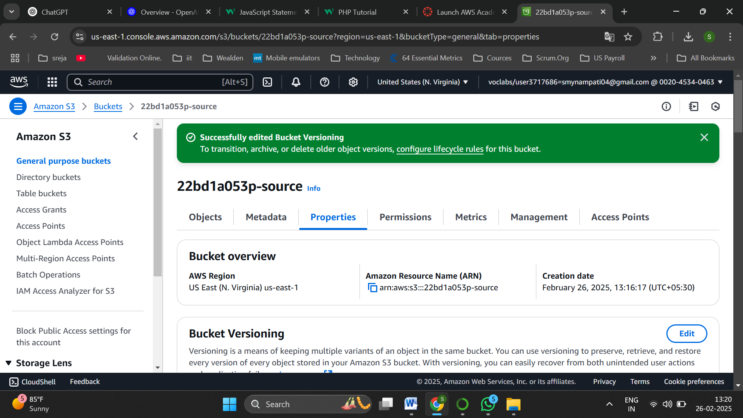

Now in source bucket navigate to properties

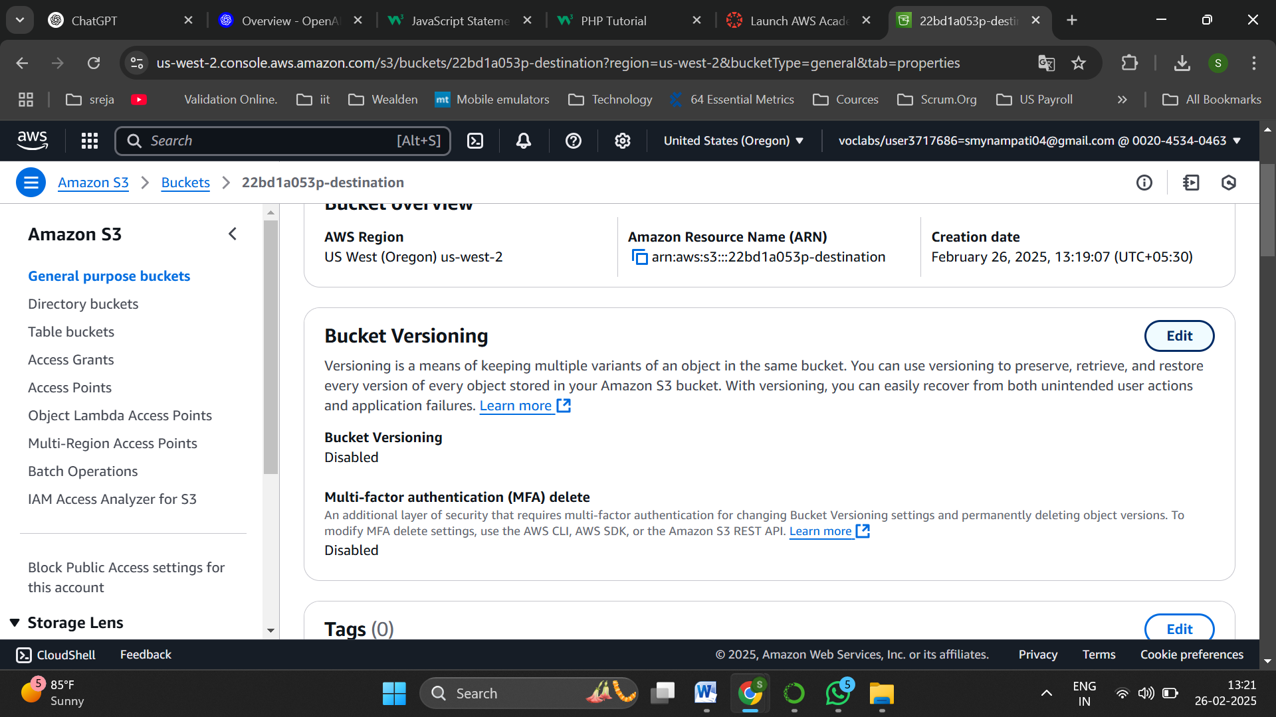

Enable Bucket versioning

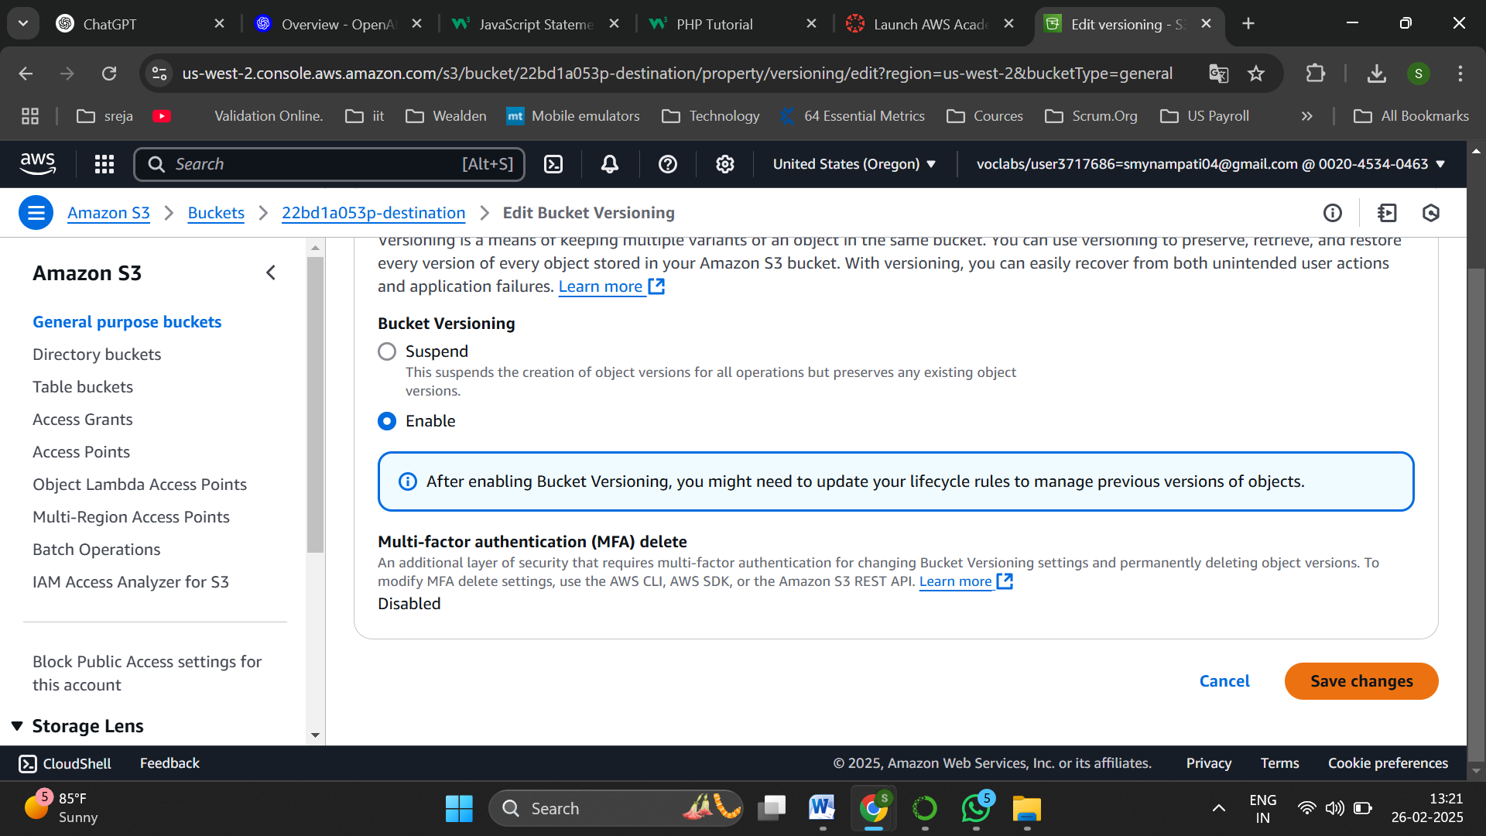

Save the changes

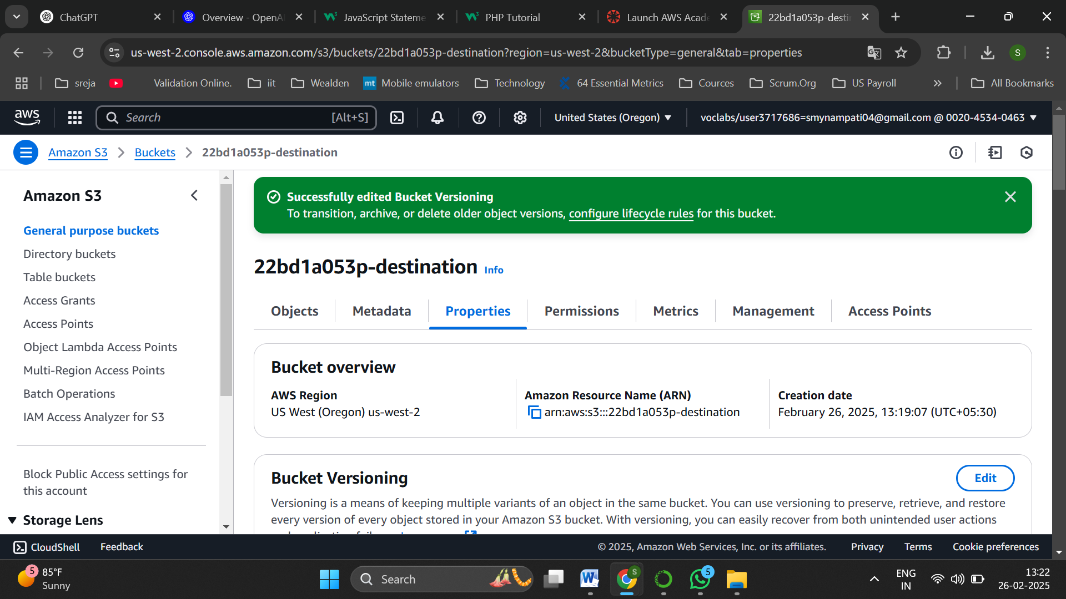

Do the same for destination bucket also,save changes successfully

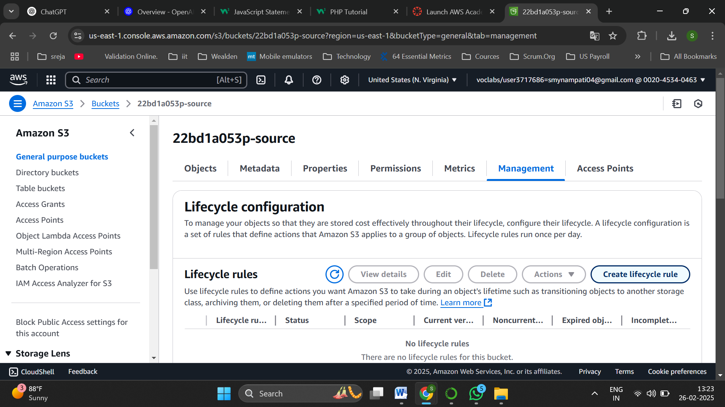

Now in source bucket navigate to Management

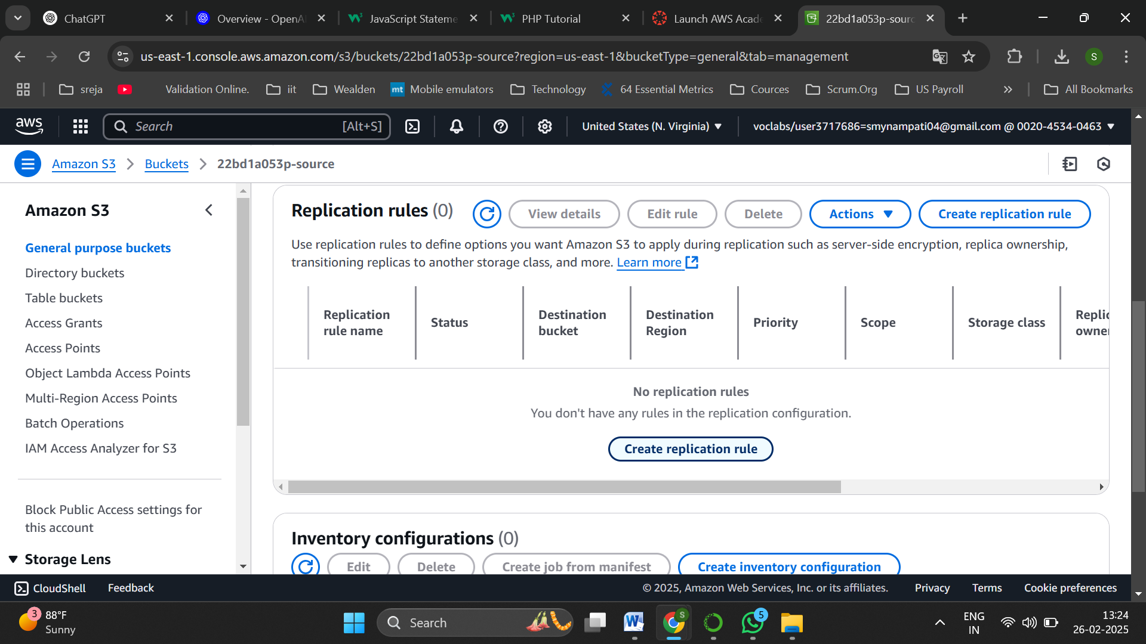

Click on create replication rule

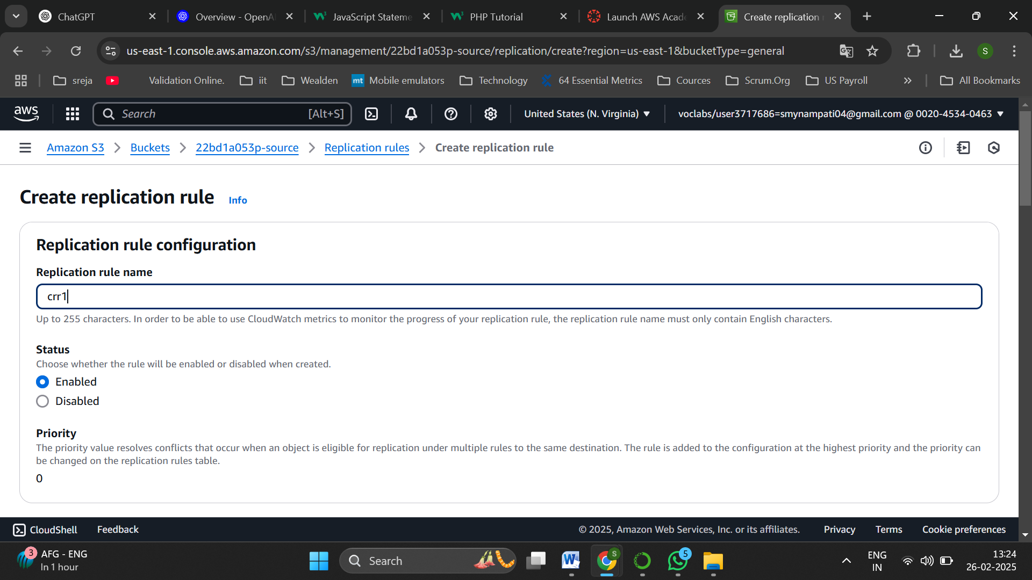

Name the rule as crr1

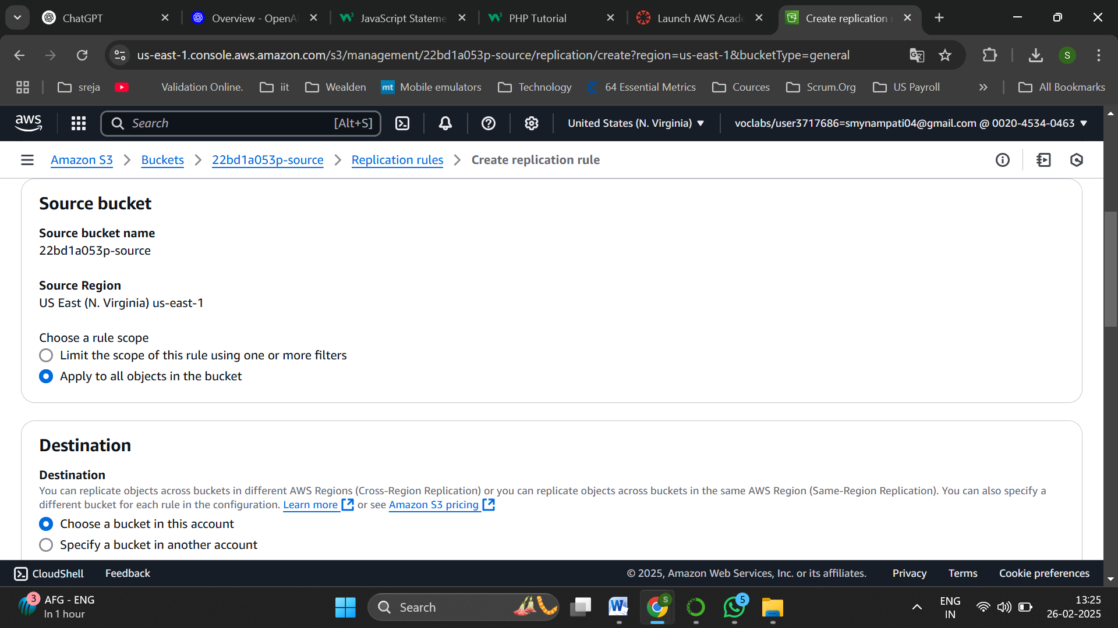

Select apply to all objects in the bucket

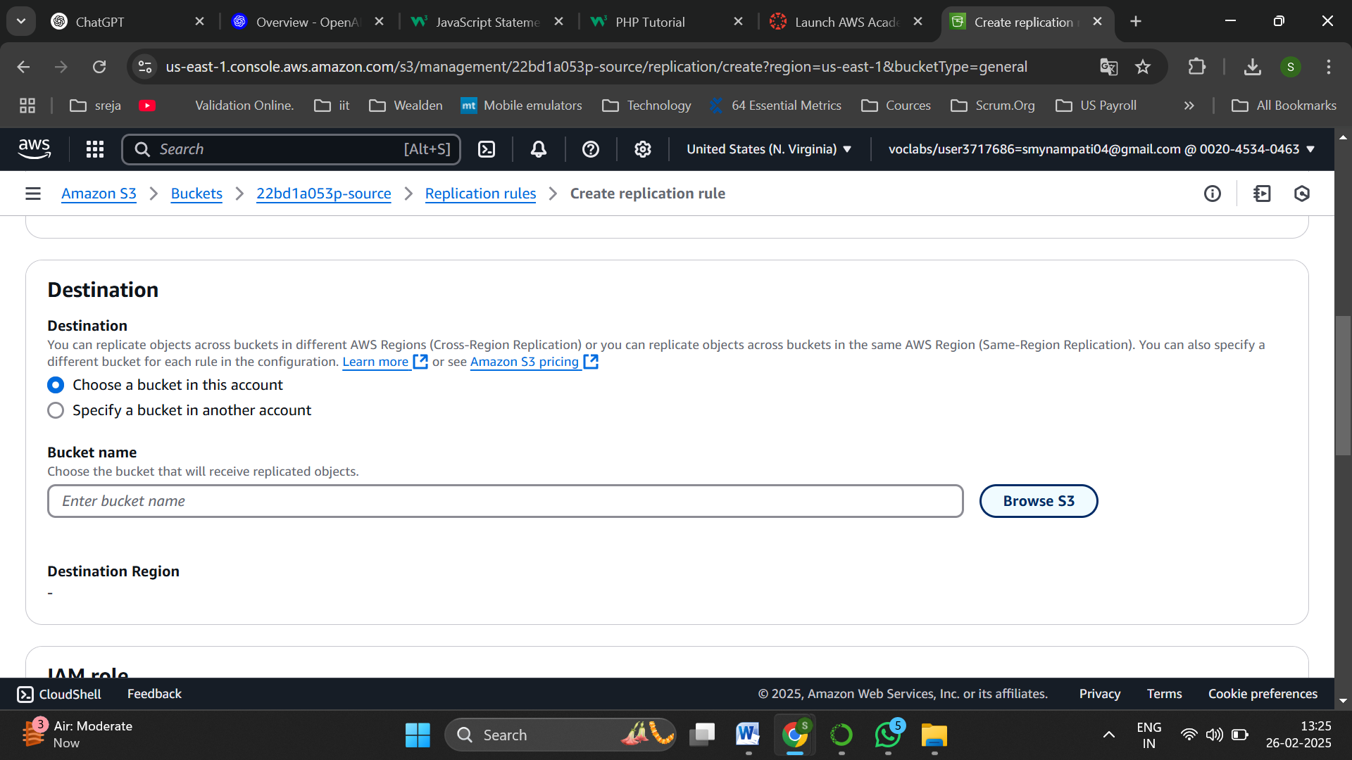

Select choose a bucket in this account

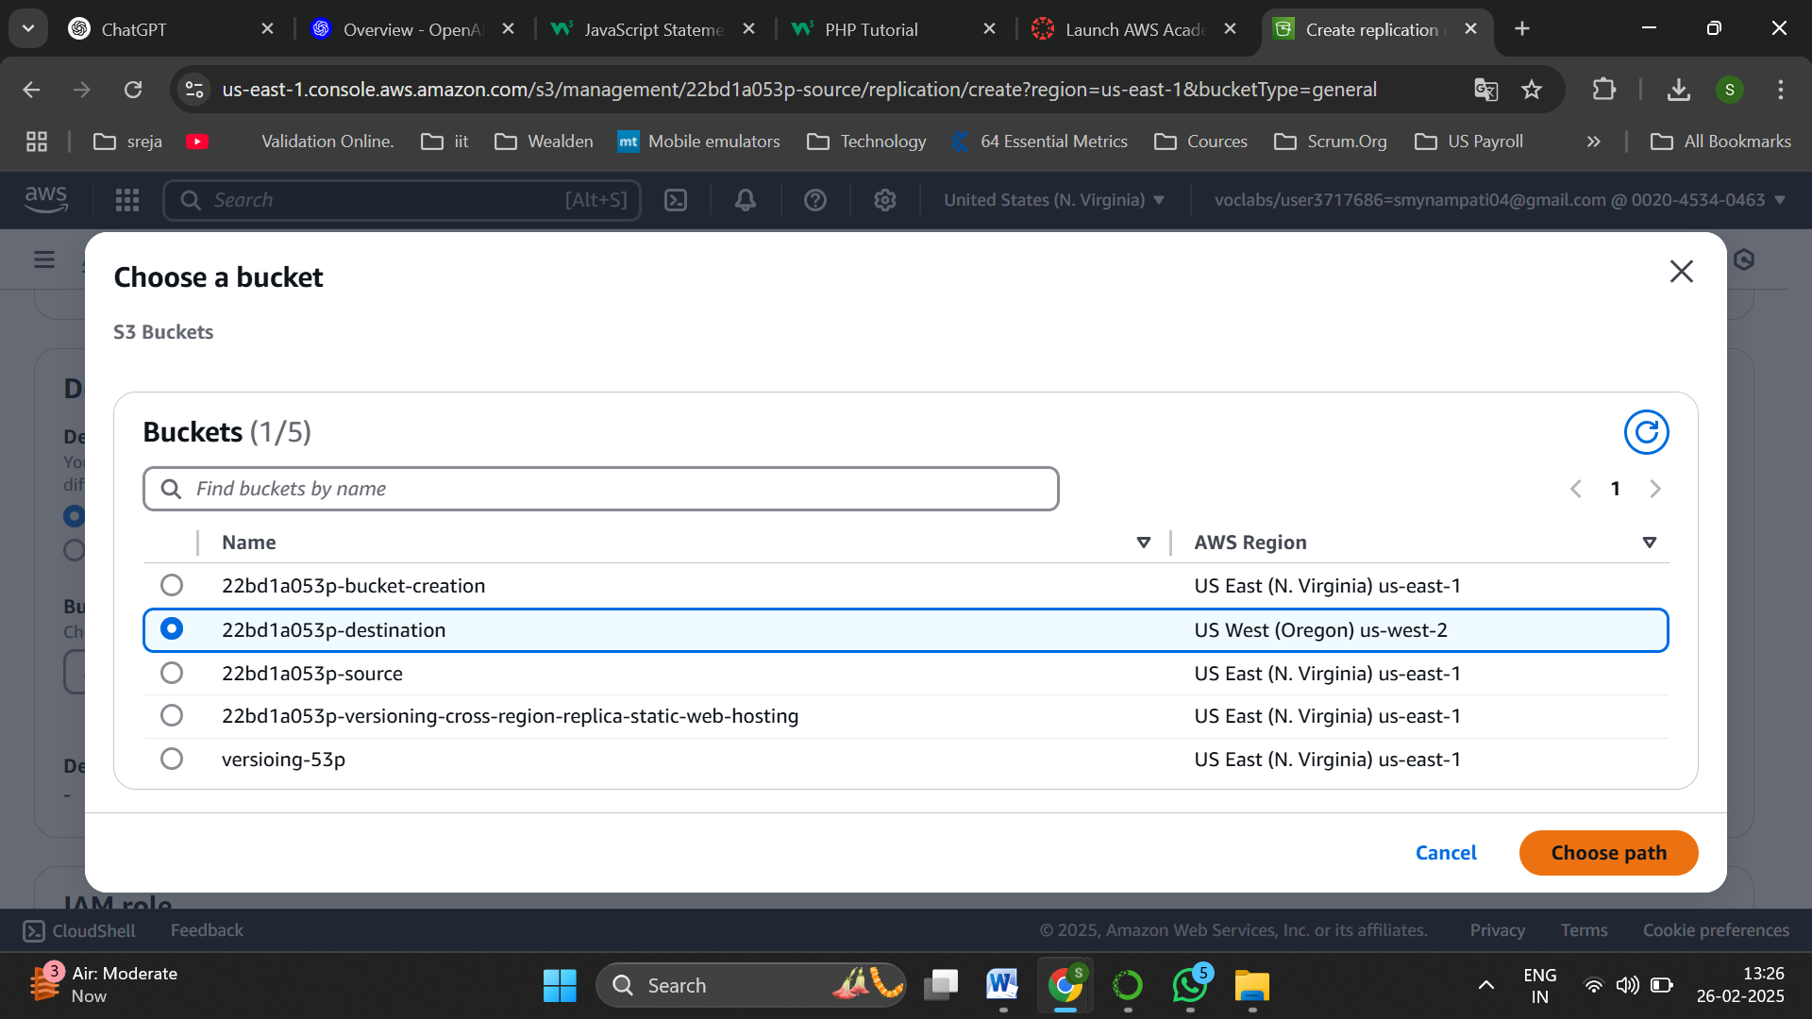

Browse and select destination bucket

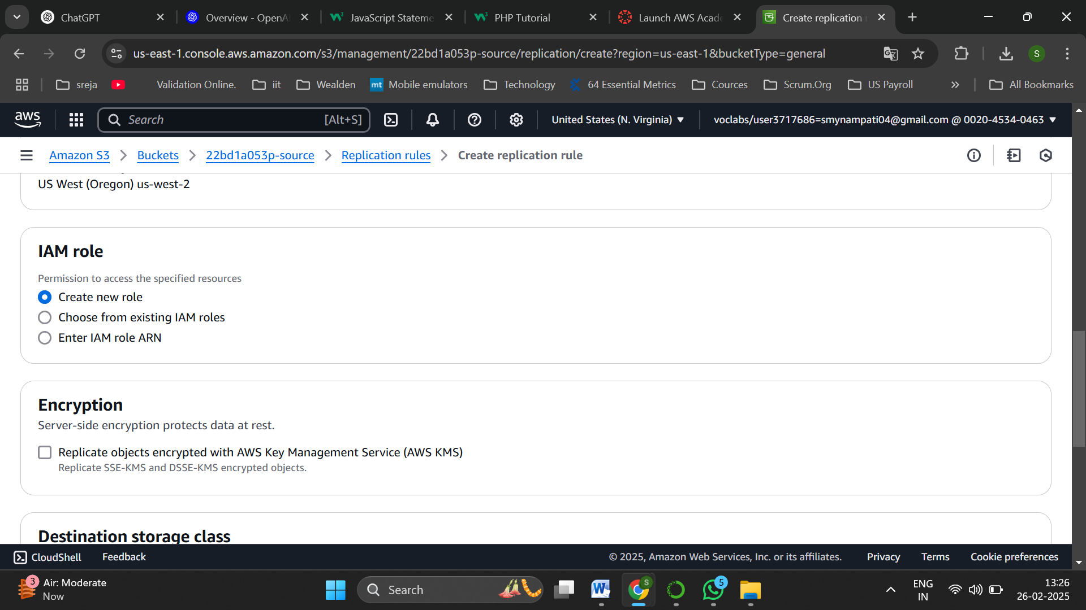

Click on create new role

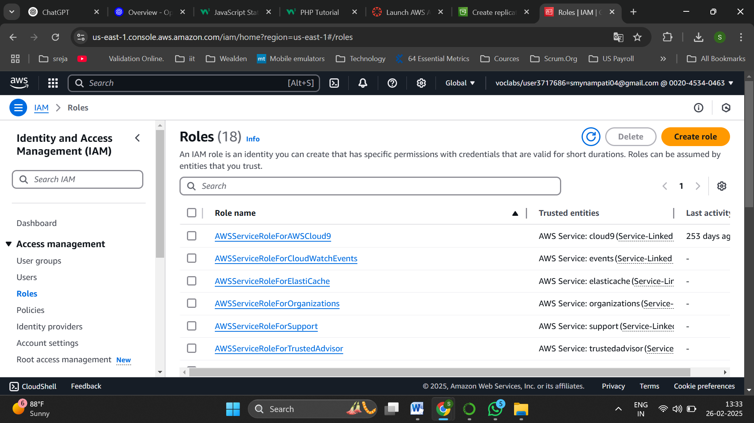

Click on create role

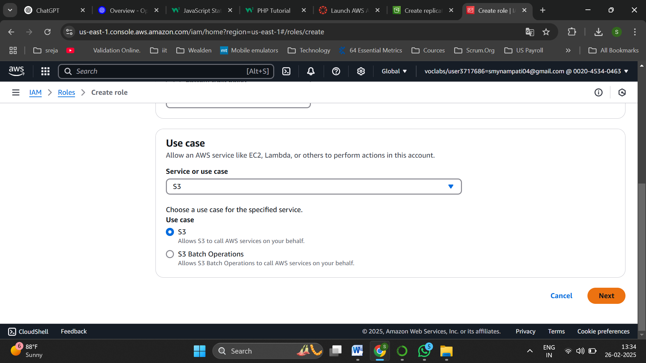

Select S3 as use case

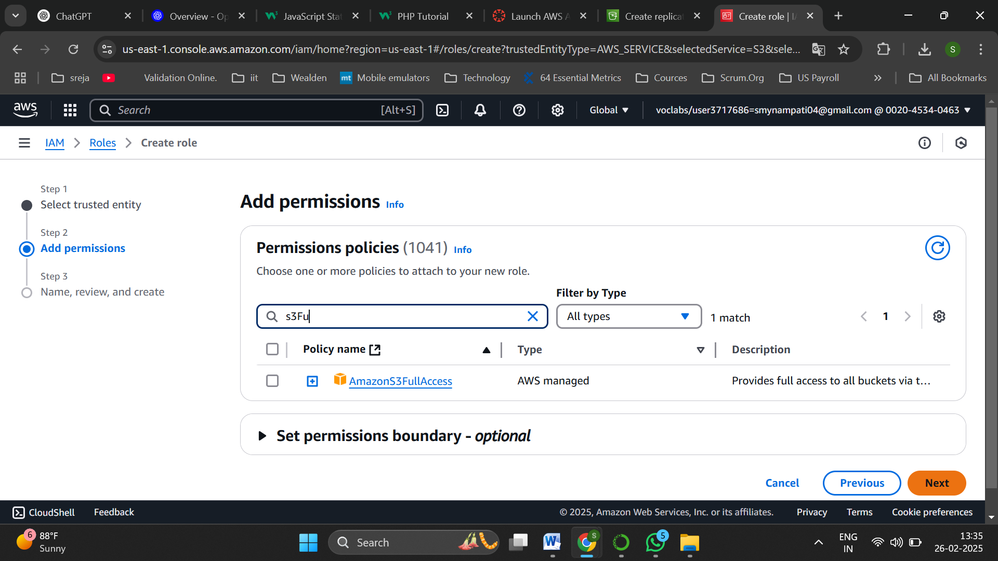

In permissions select Amazon S3Full Access

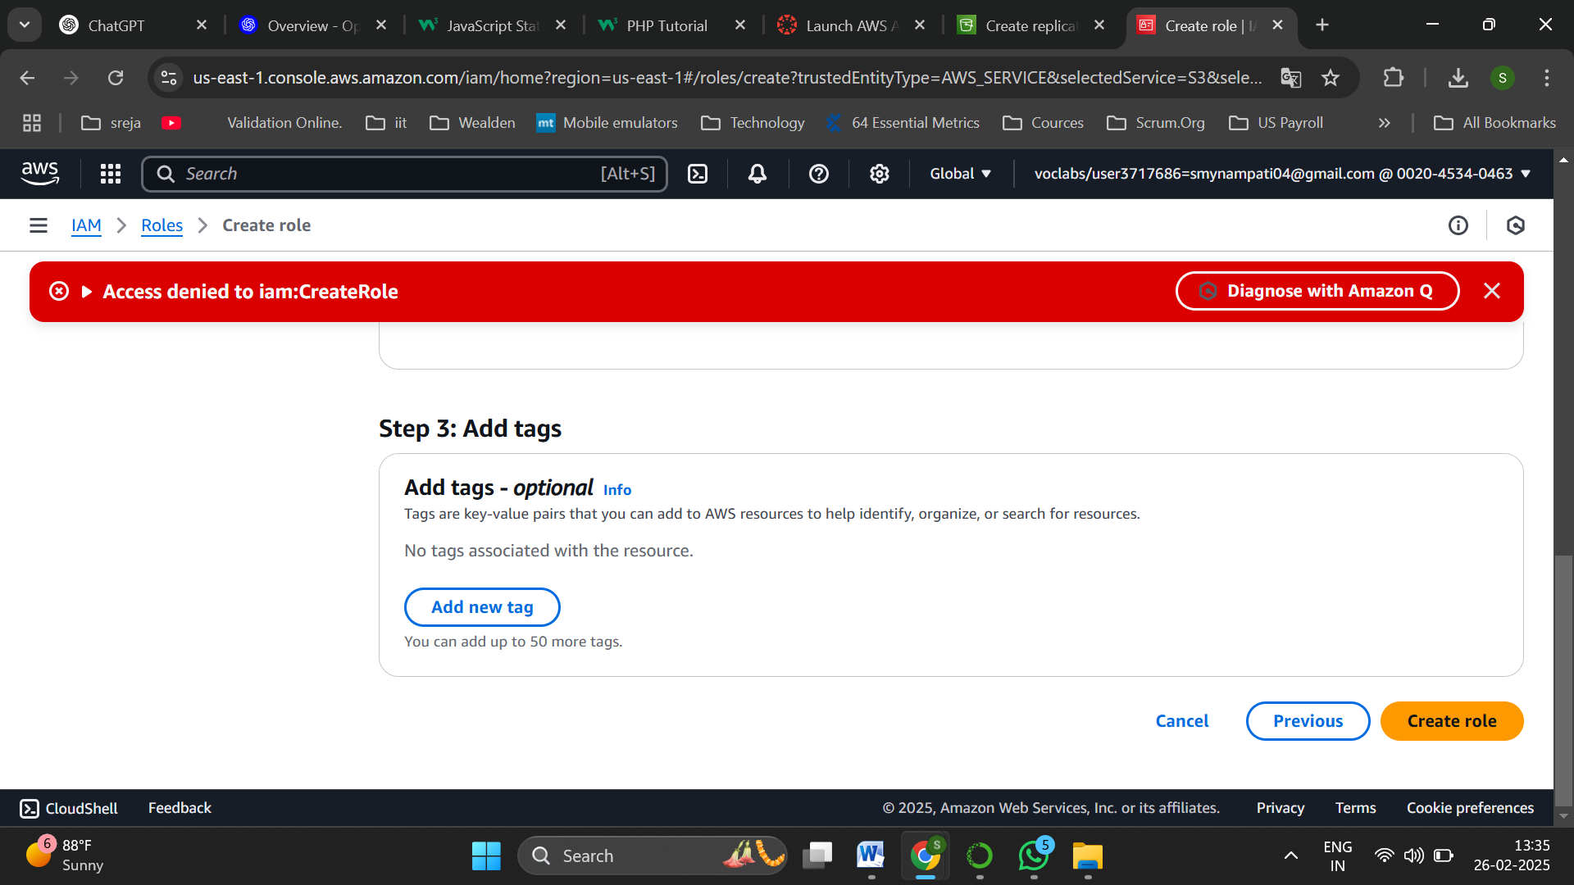

To create a new role Access is denied as a new Role cannot be created

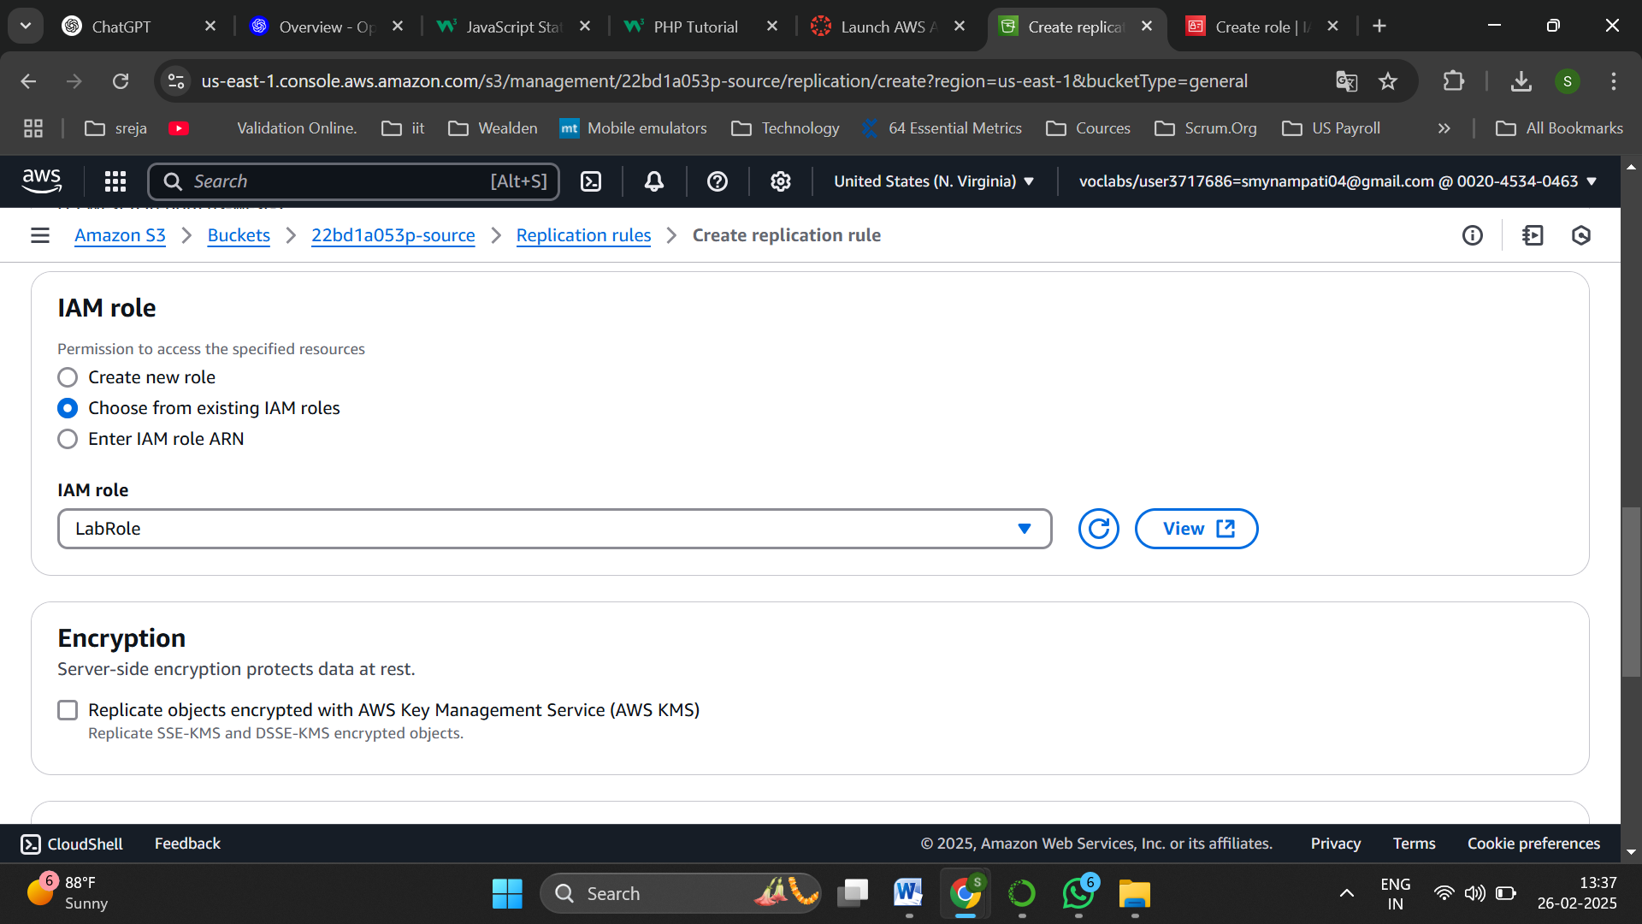

Get back to Replication rules and select Choose from existing IAM role as LabRole

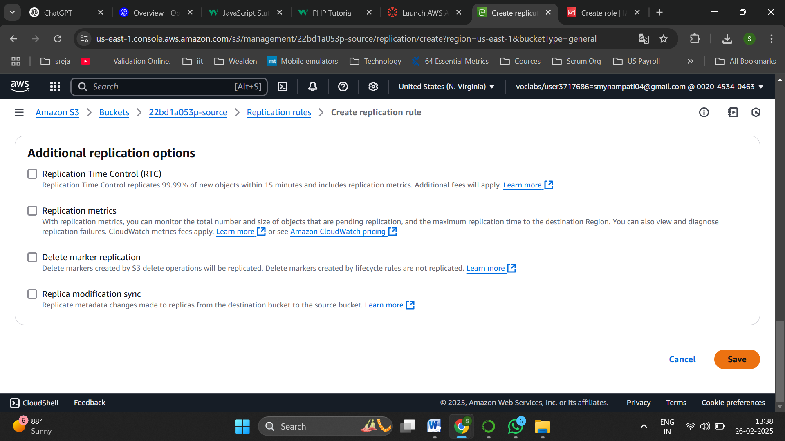

And save the changes

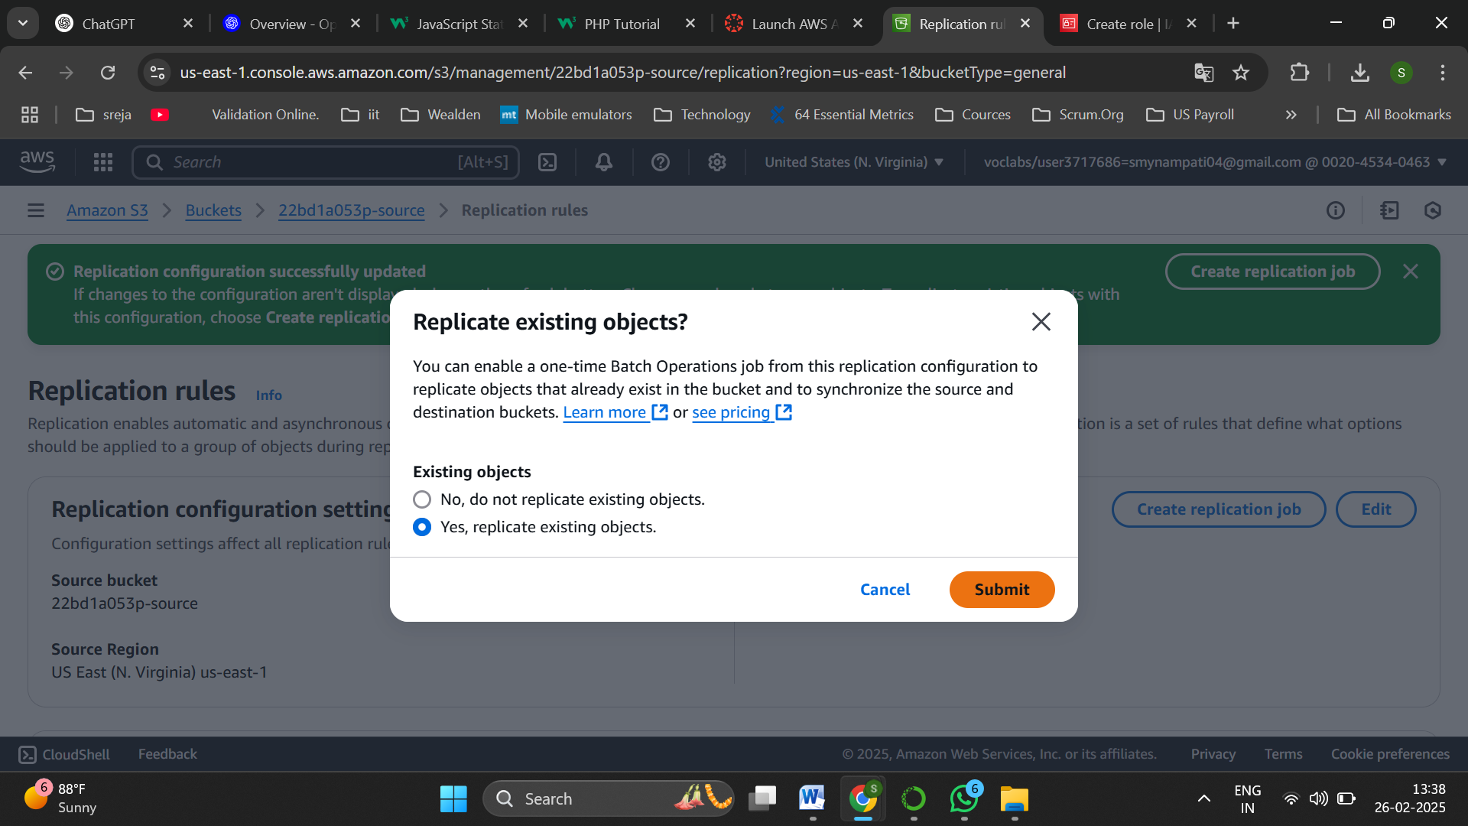

Select Yes replicate existing objects and submit

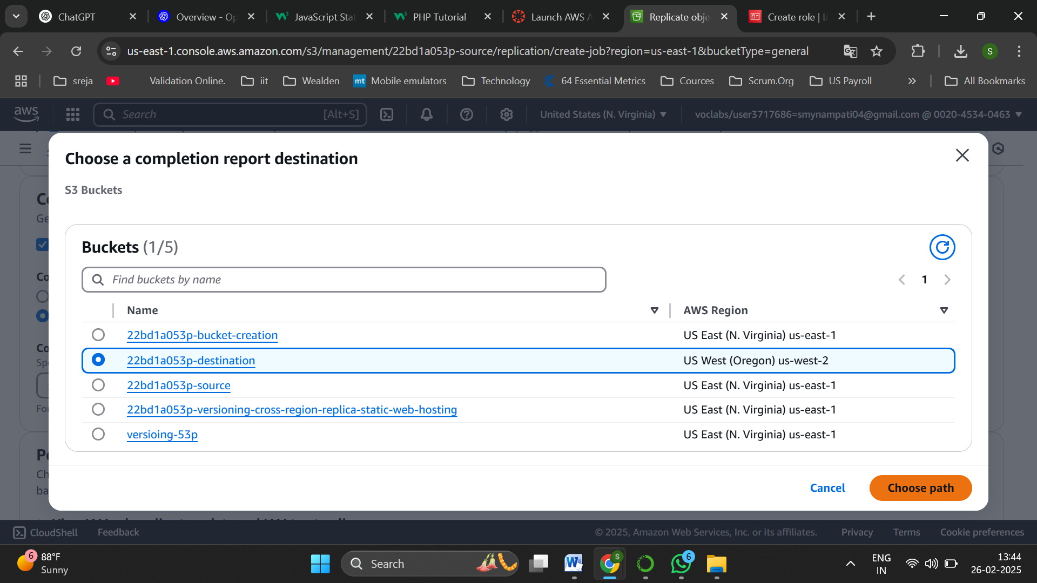

Choose destination bucket for completion report destination

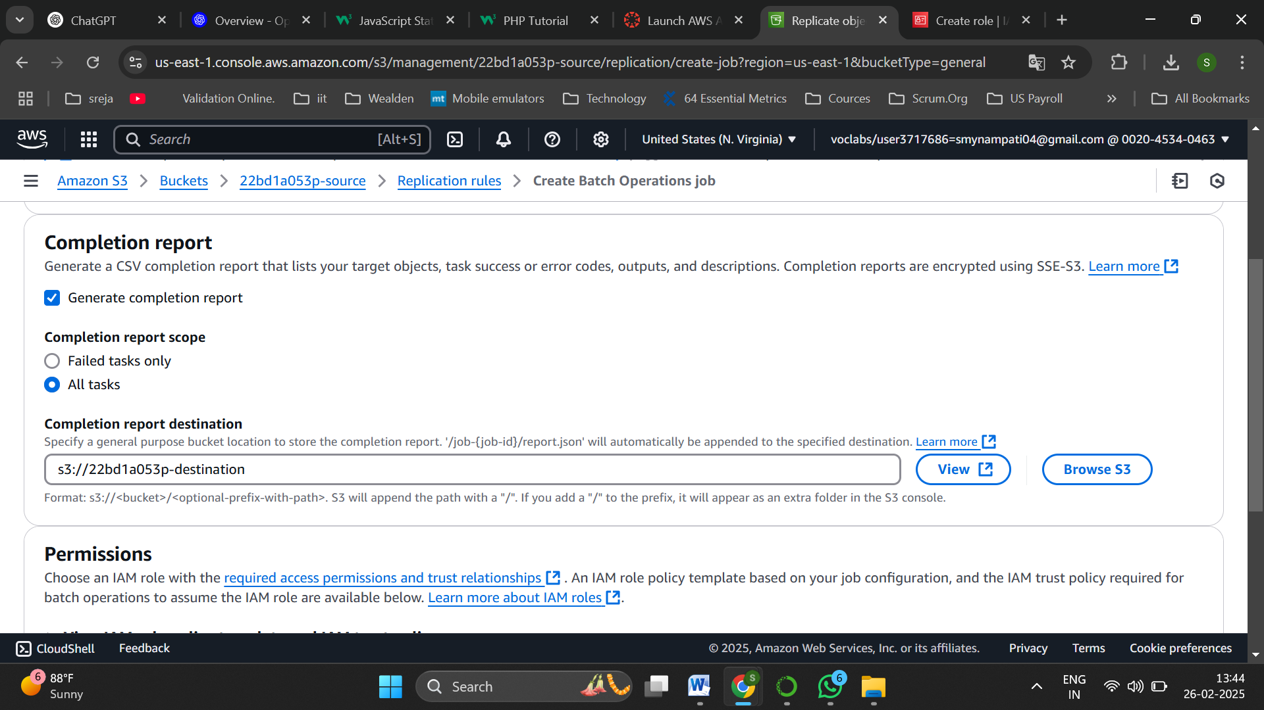

Set destination bucket path as shown

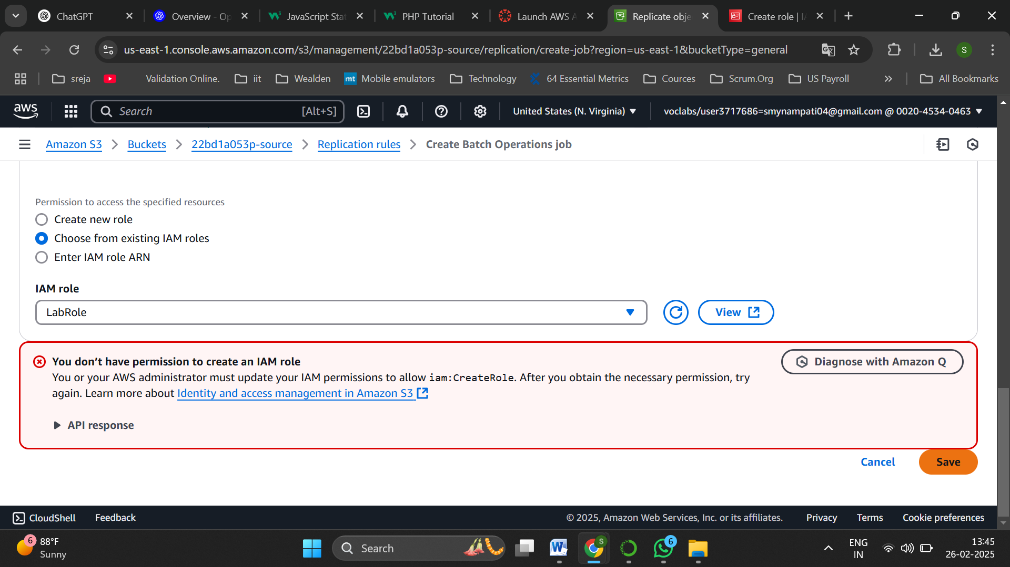

Select IAM role as LabRole and save

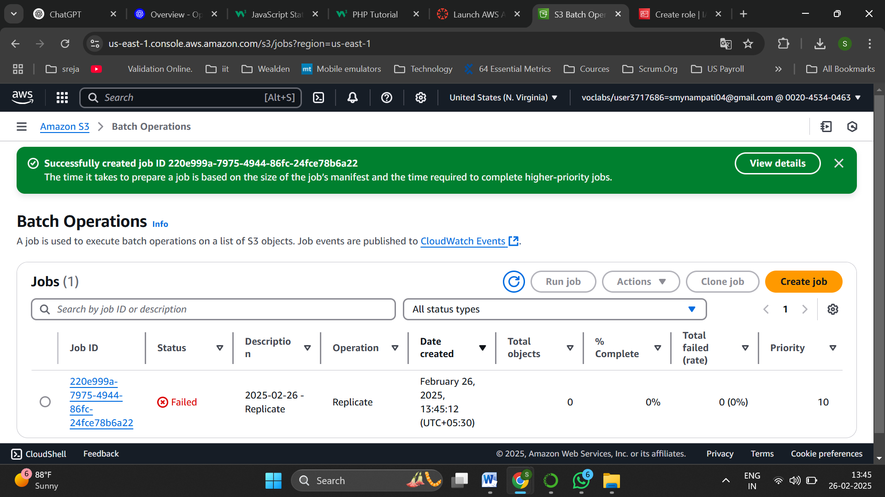

The Job is created

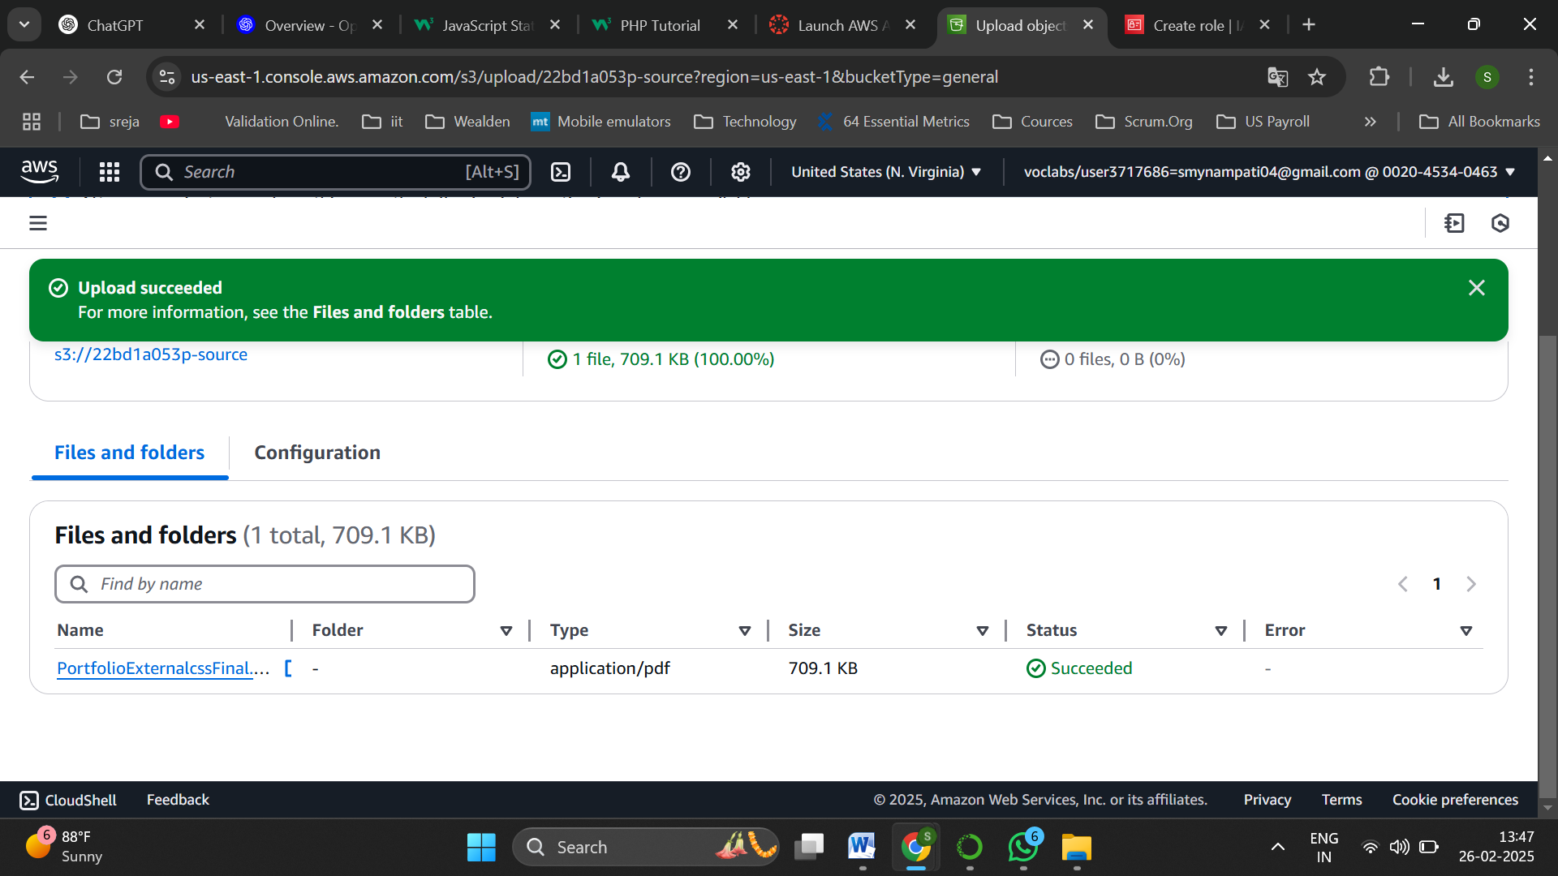

Now navigate to source bucket and upload a file

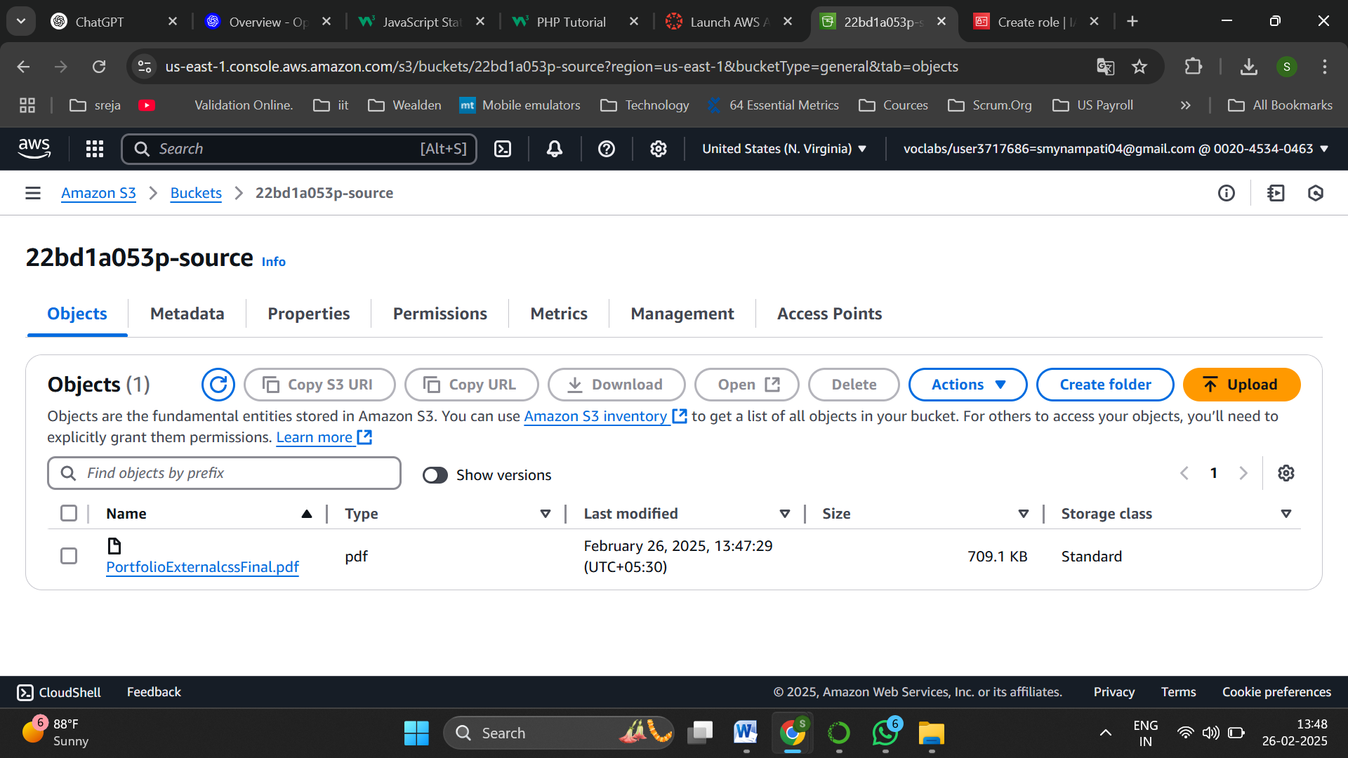

Object is successfully uploaded

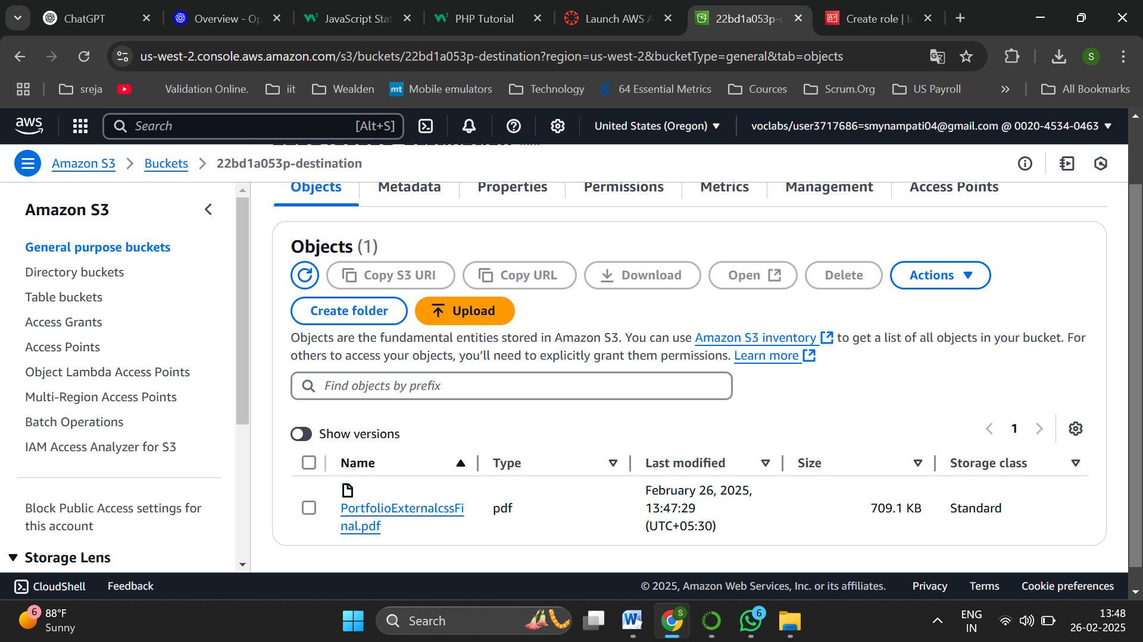

Now navigate to destination to check whether same object is replicated and yes it is replicated

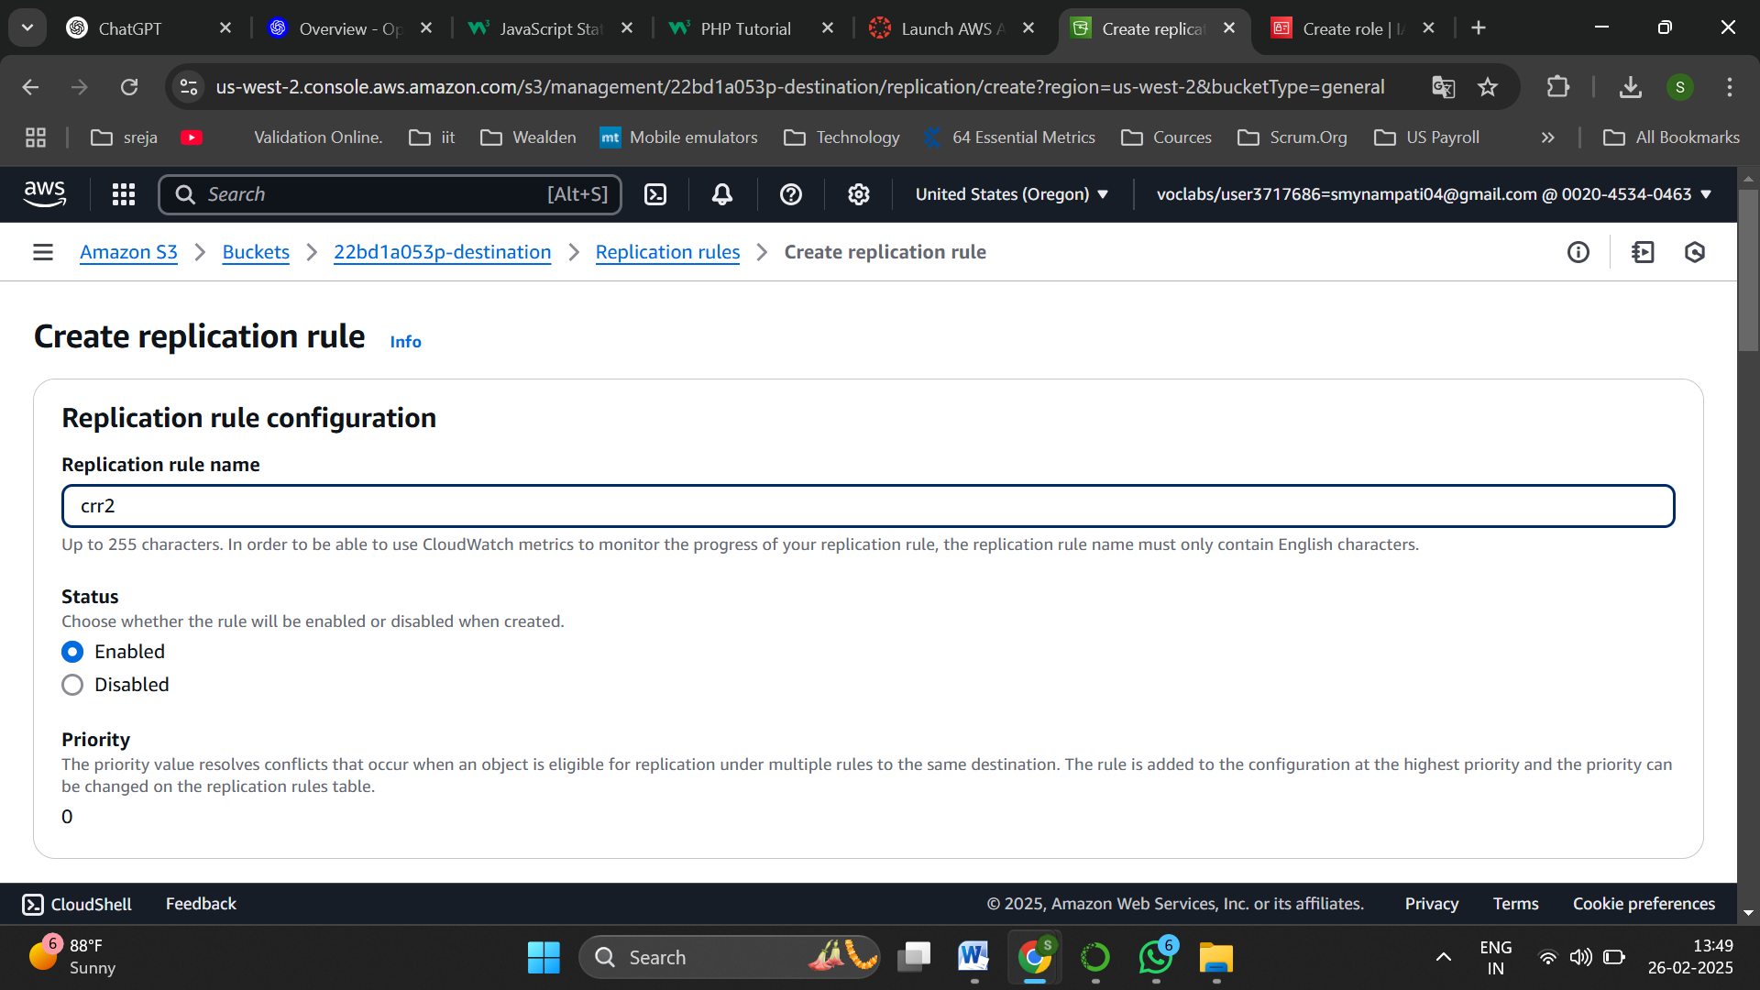

Now create another replication rule crr2

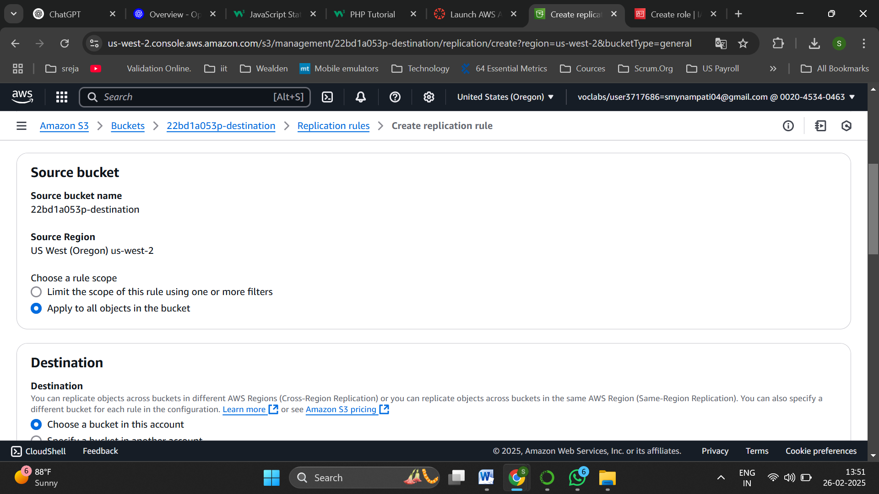

Select apply to all objects in the bucket

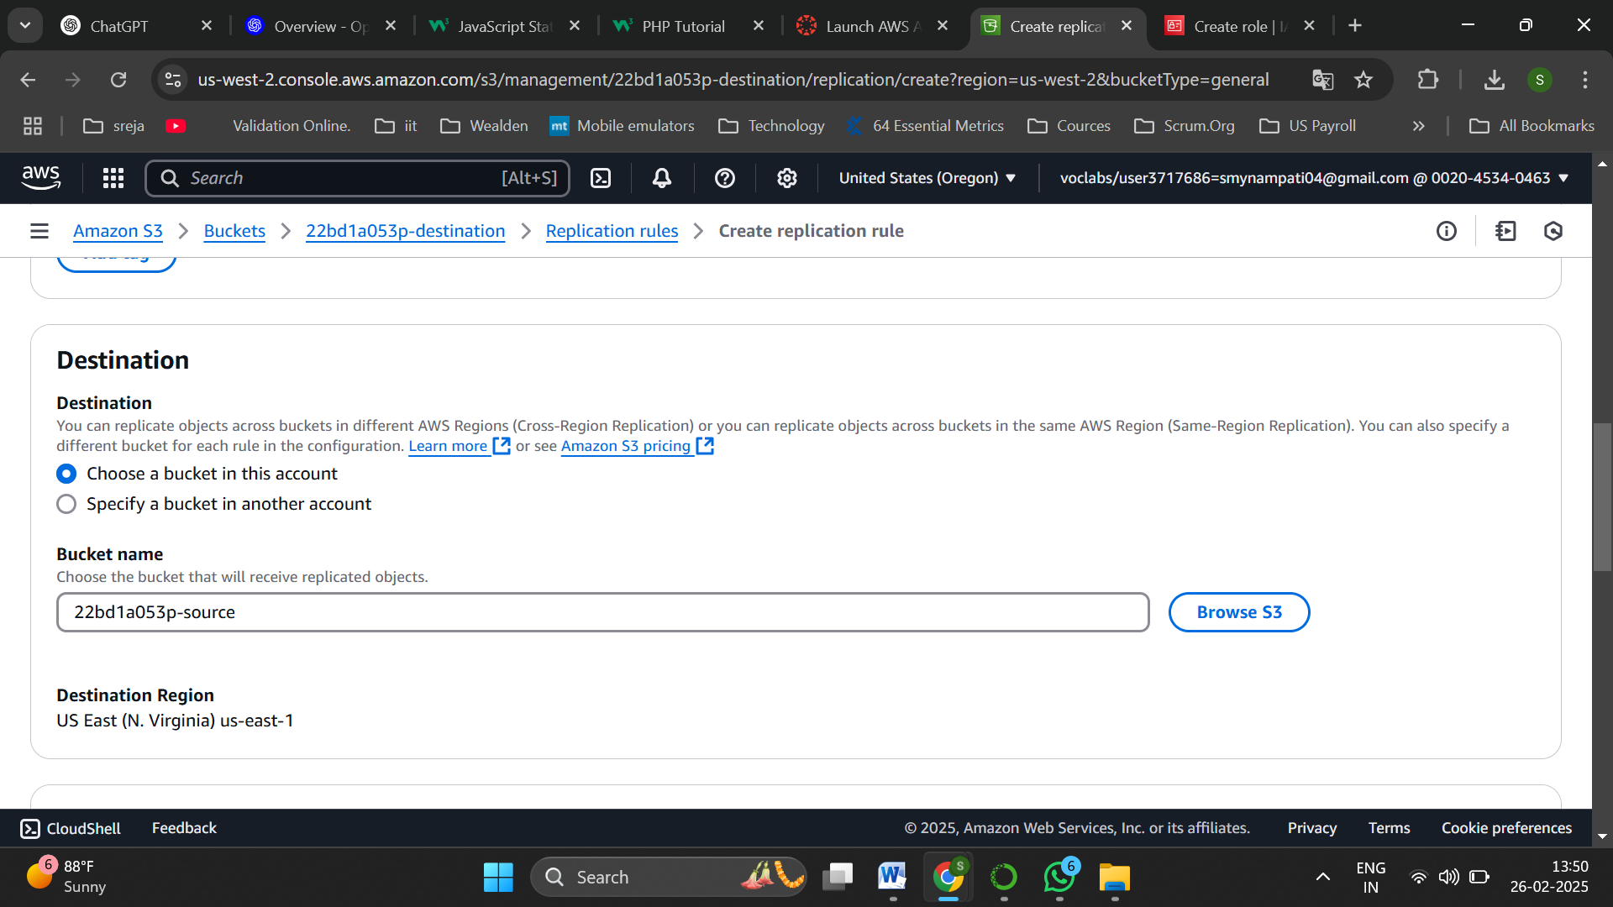

Set the destination as source bucket

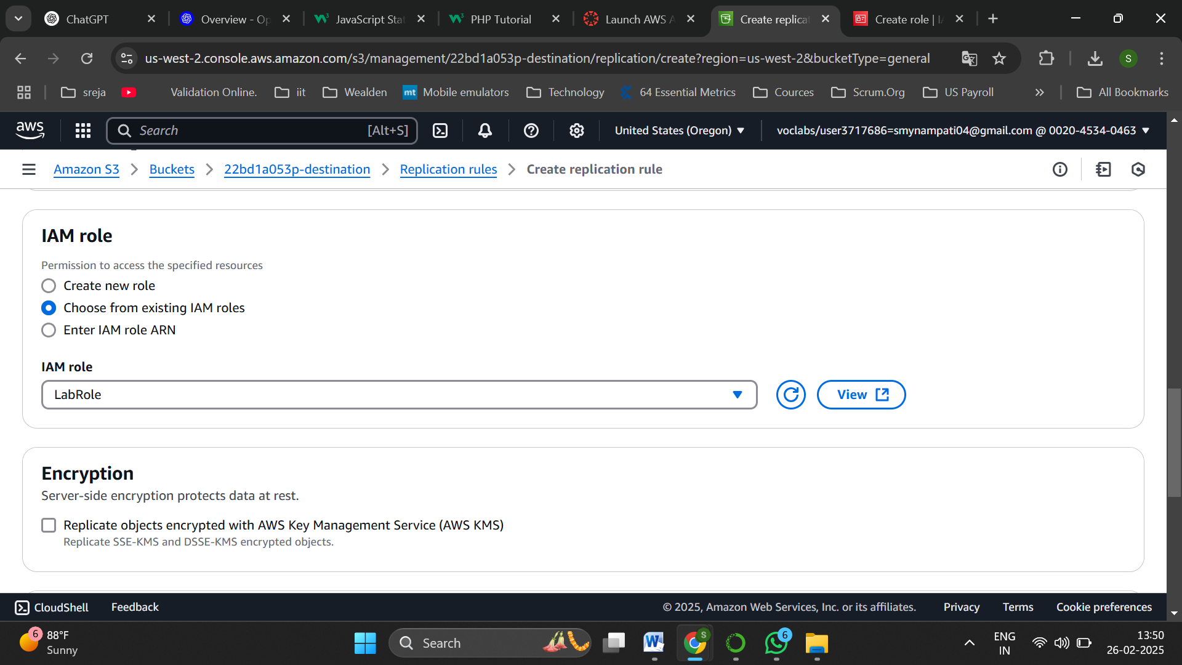

Choose from existing IAM roles and select LabRole

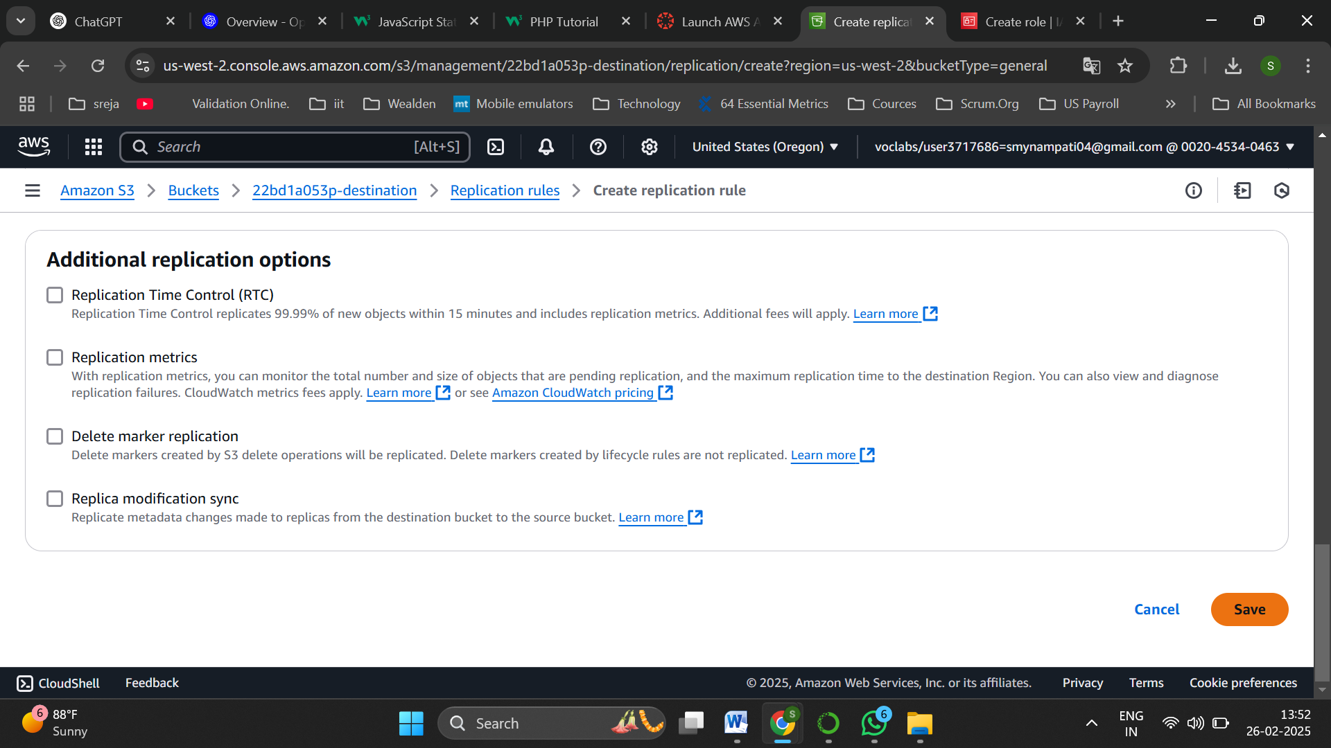

And save the changes

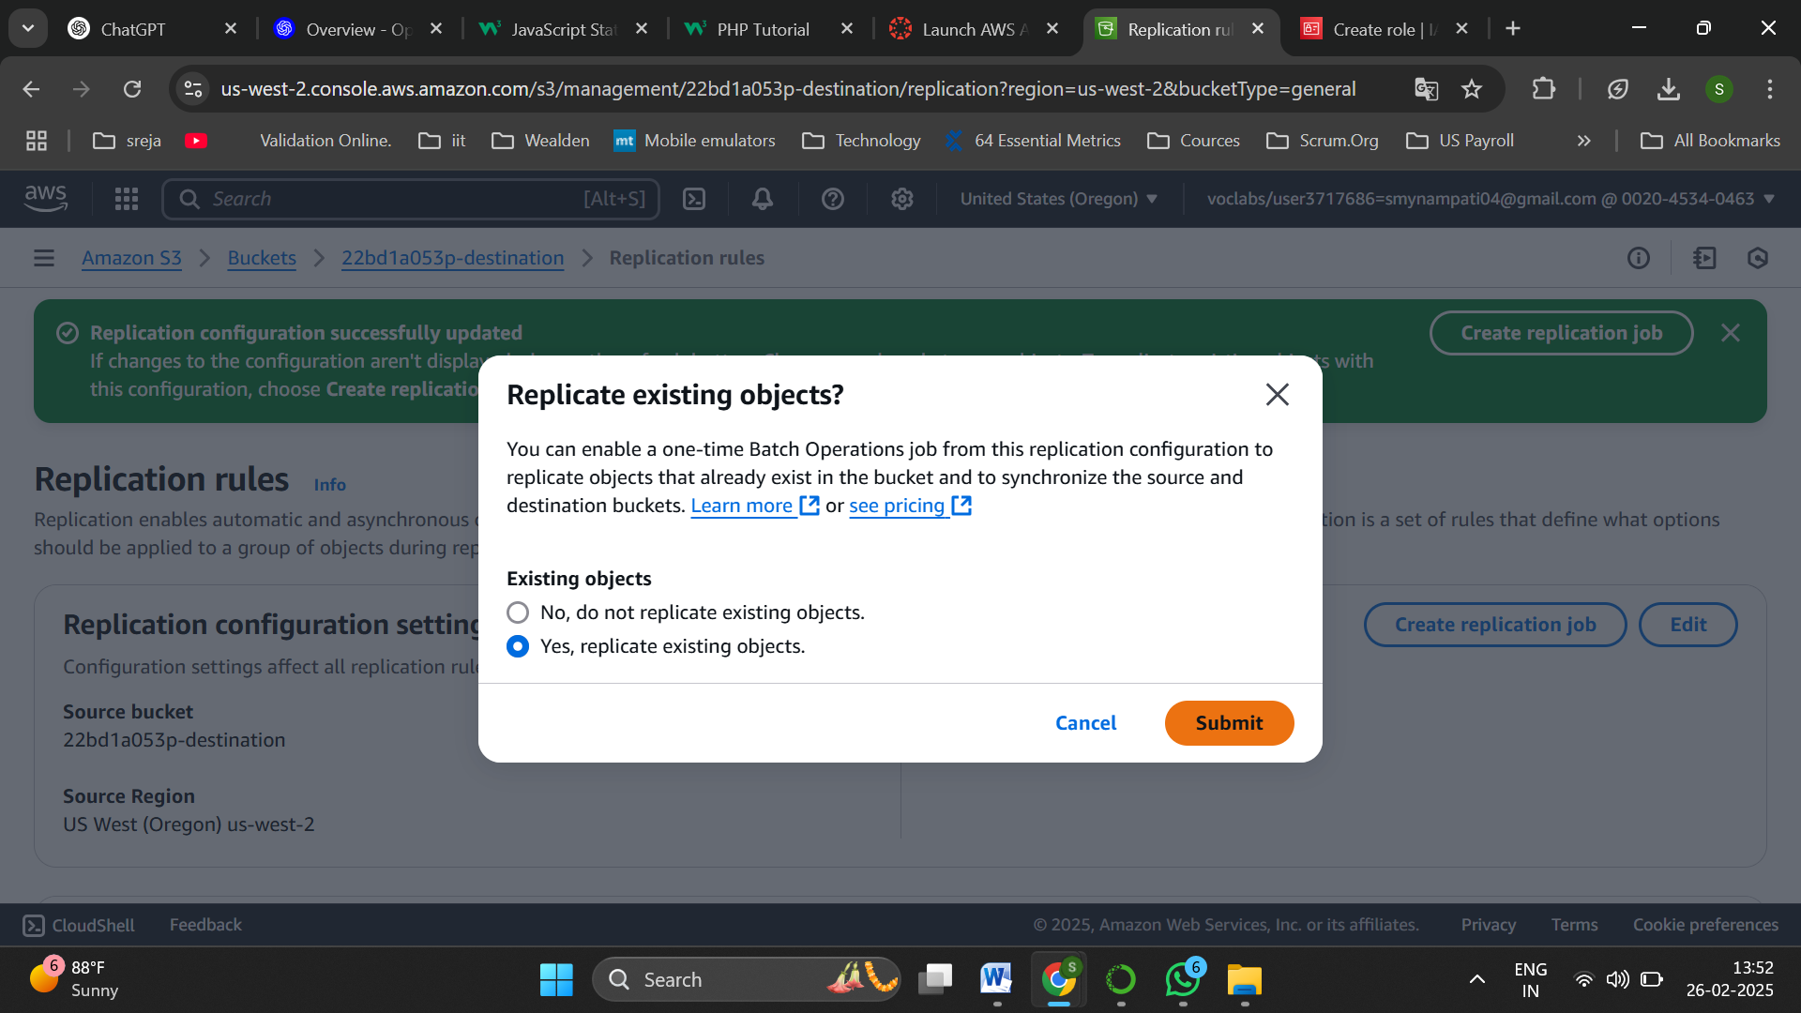

Select ,Yes replicate existing objects

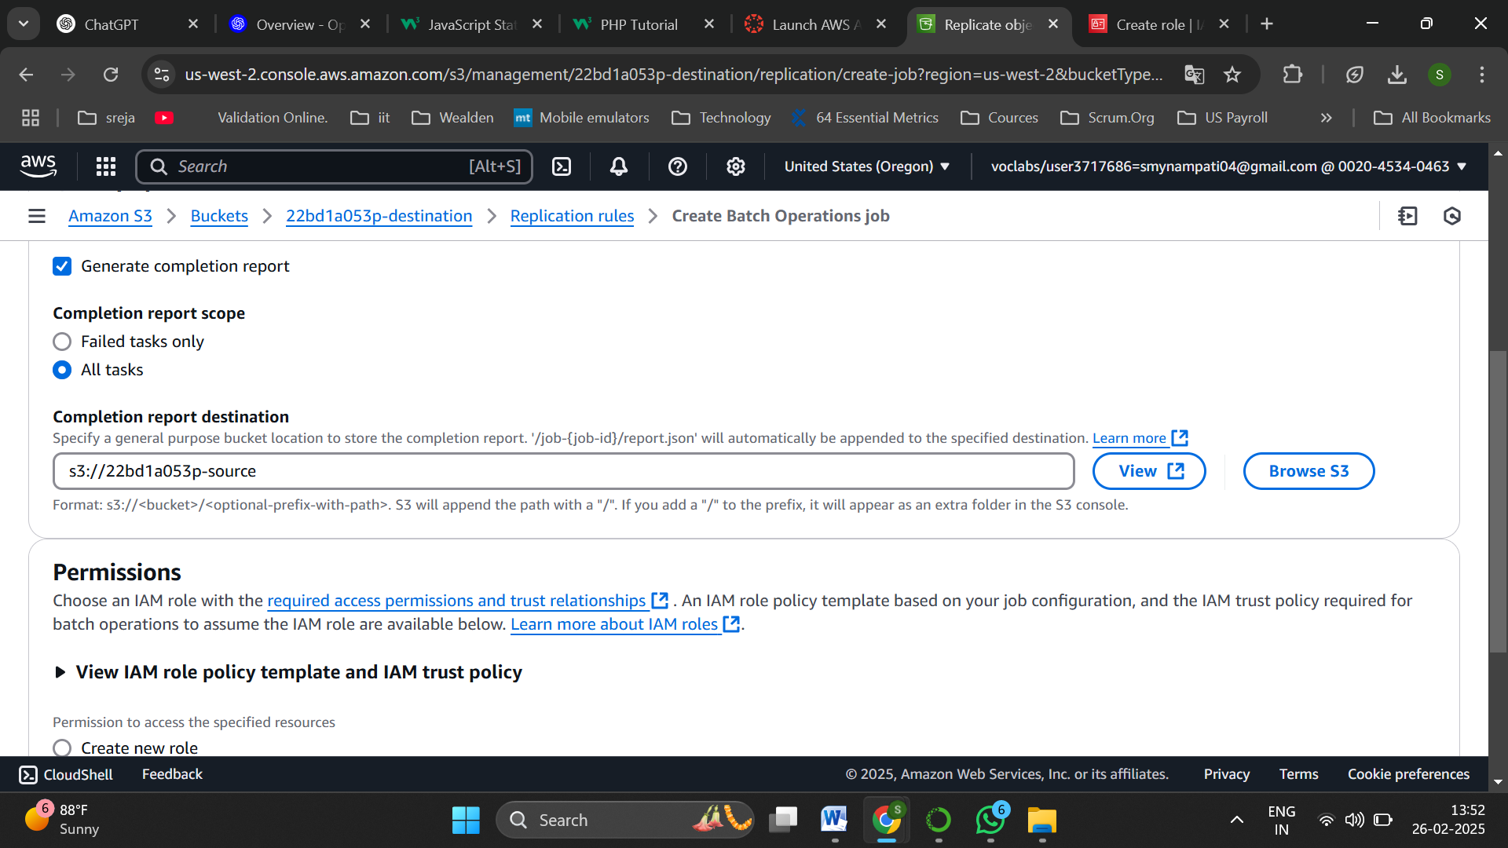

Browse and set source bucket path as Completion report destination

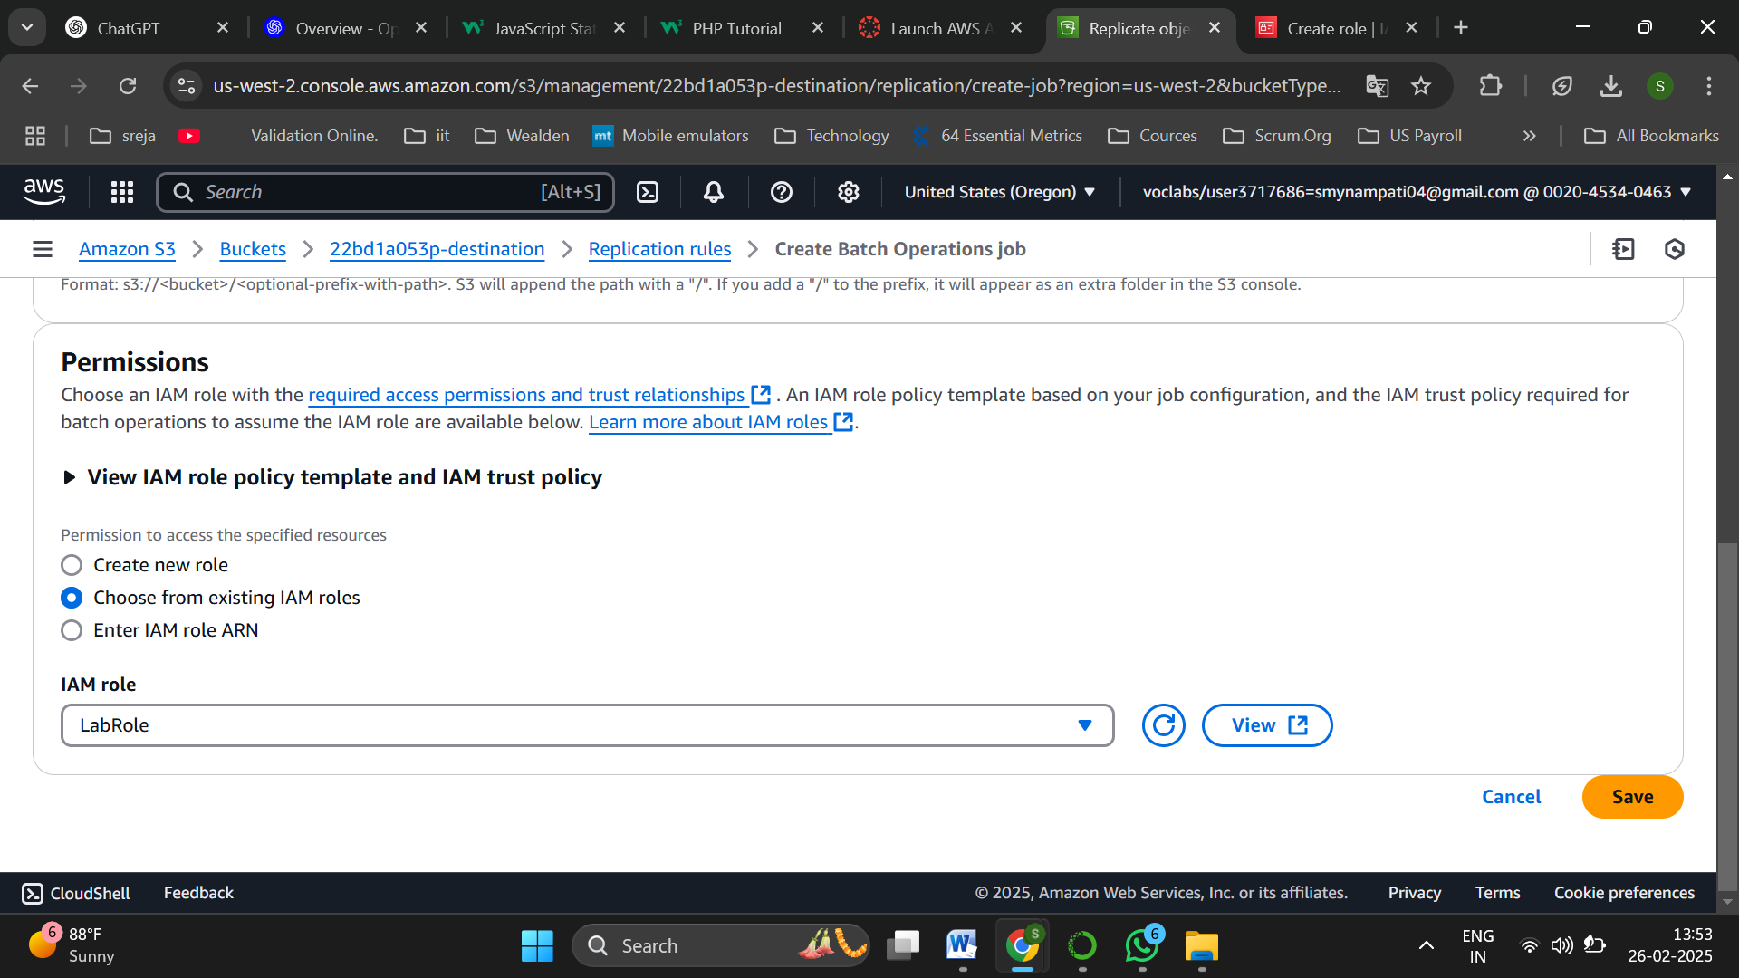

Choose IAM role as LabRole and save

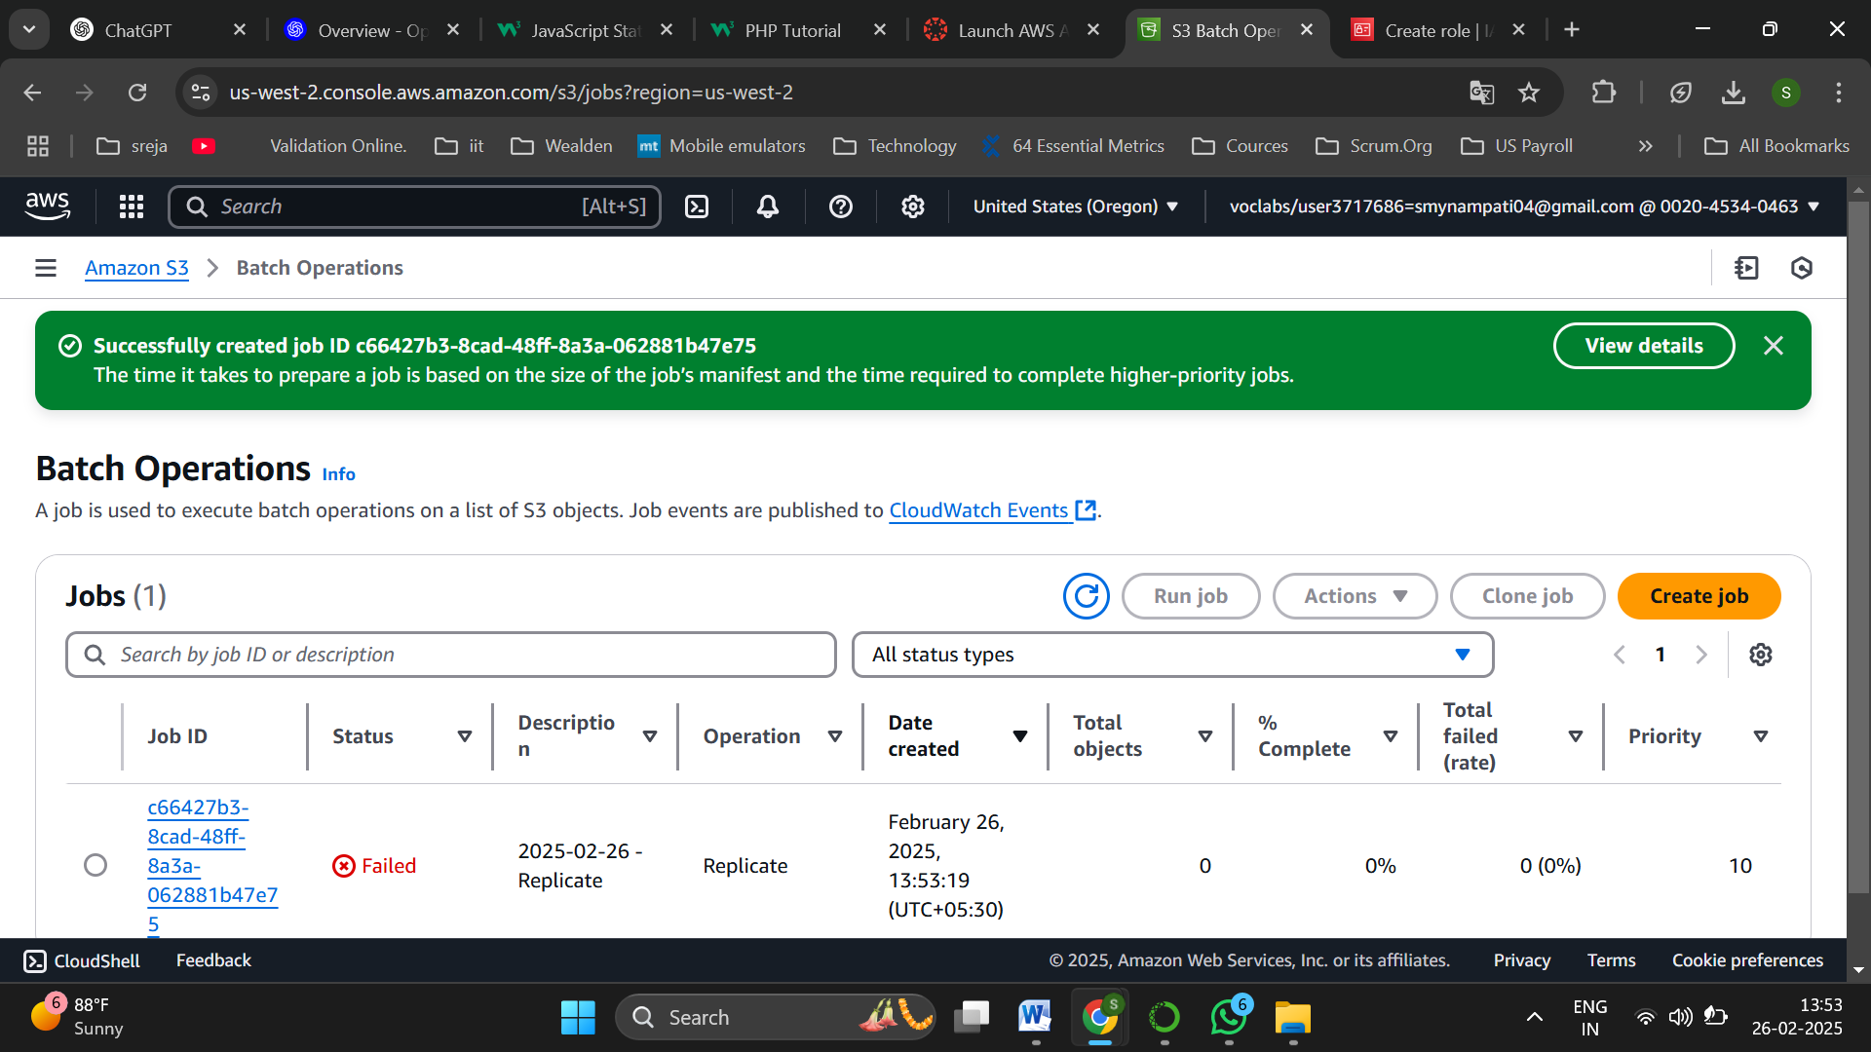

The Job is created

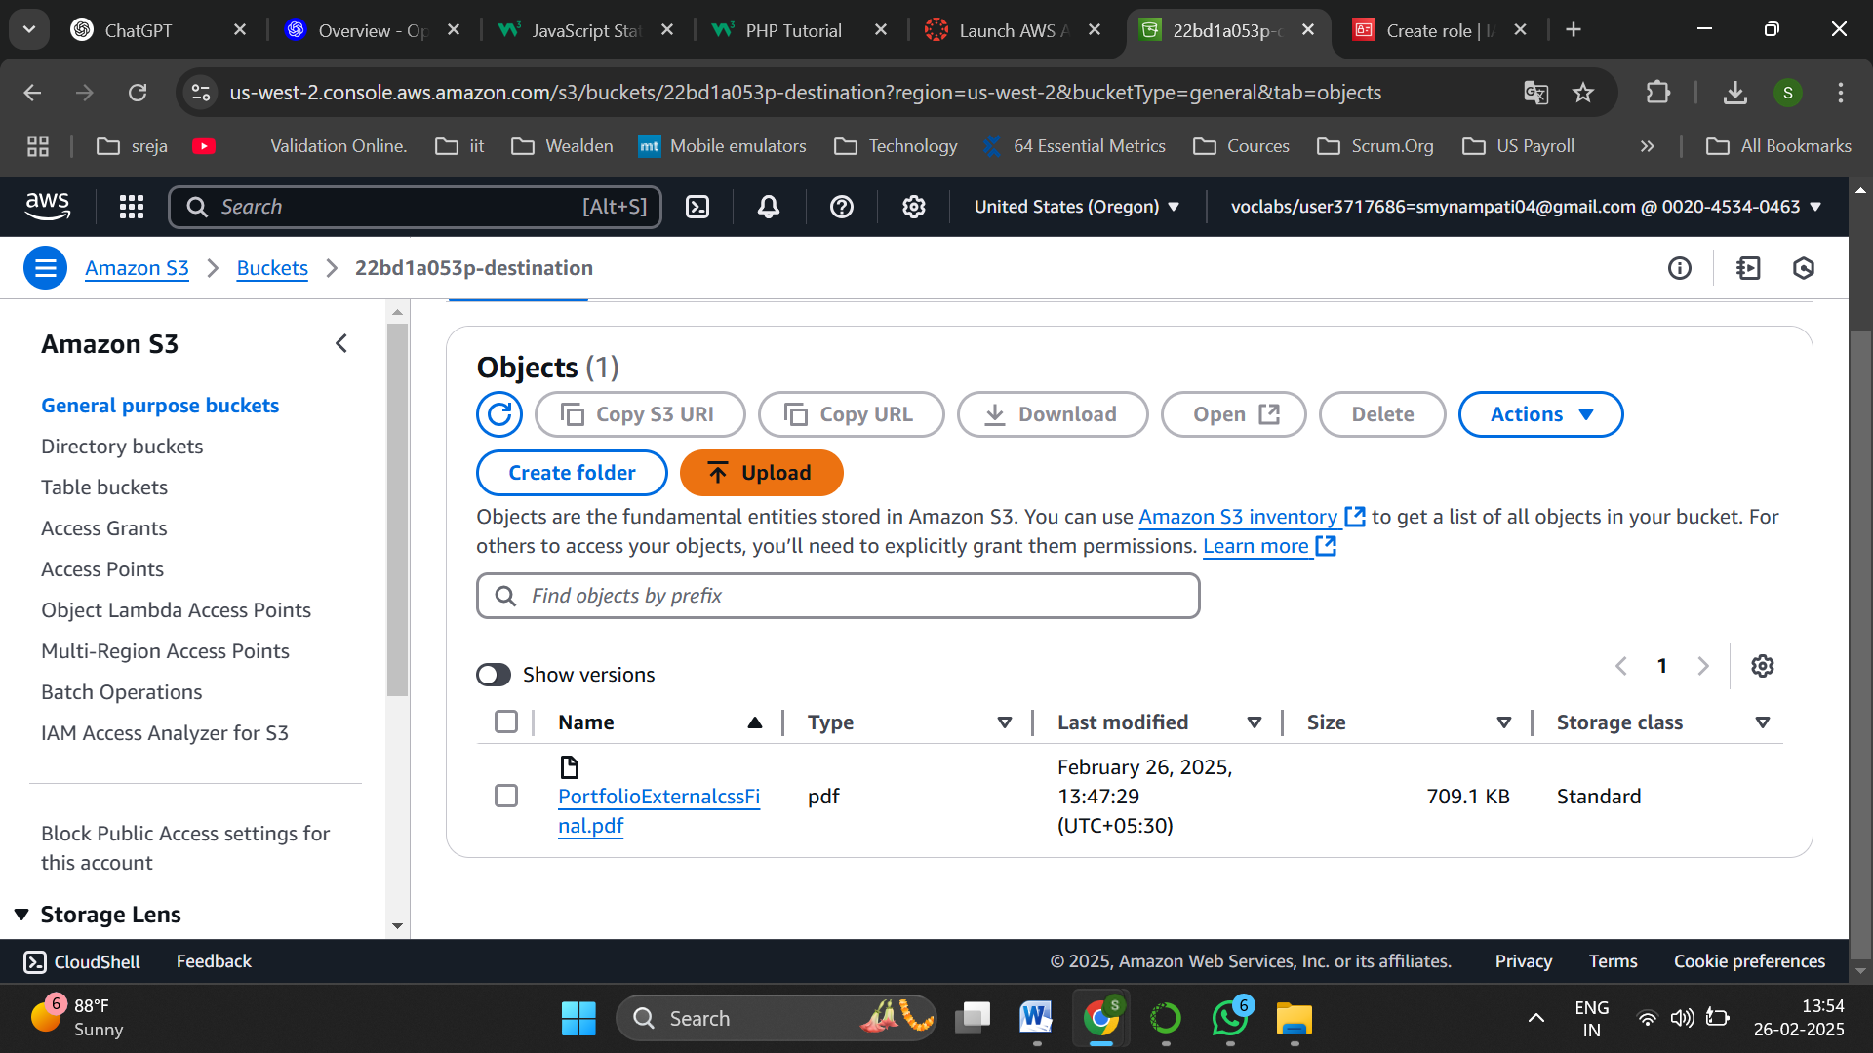

Now navigate to destination file and upload a file

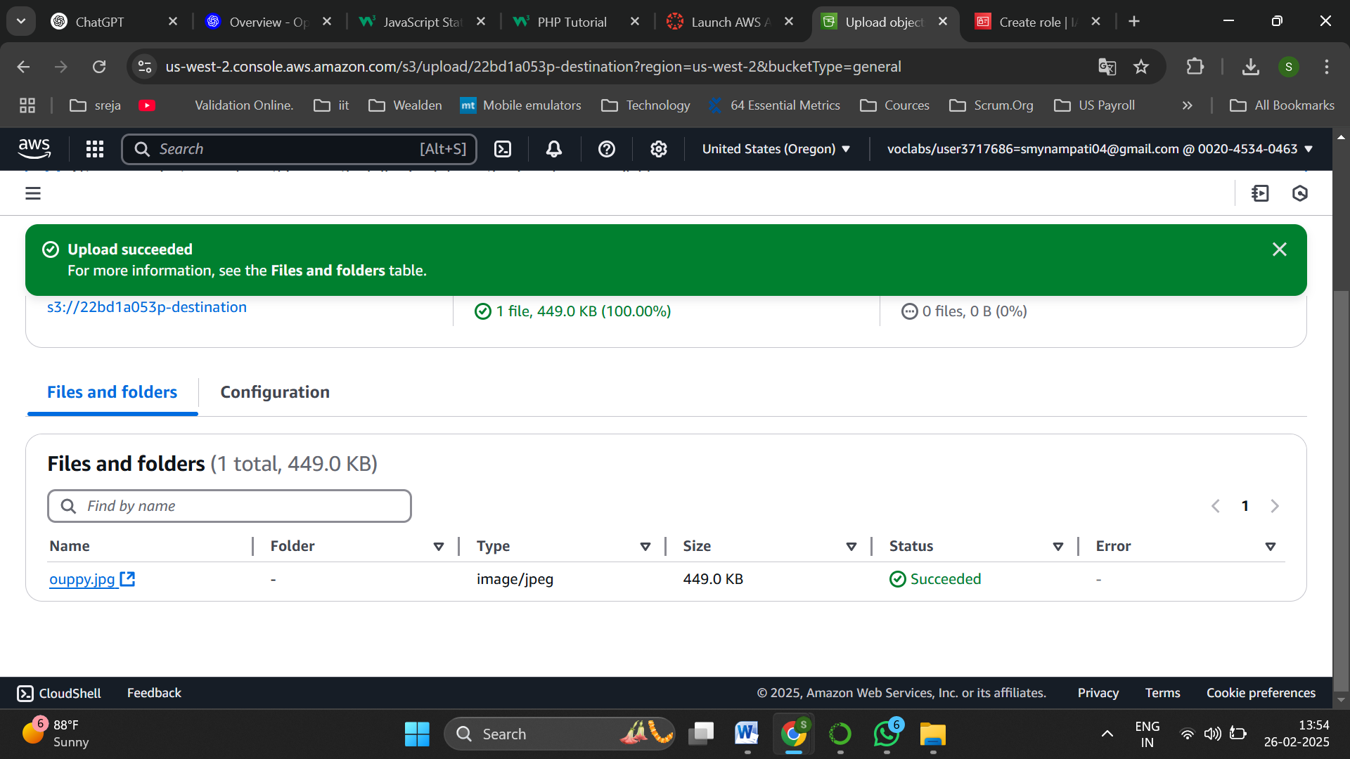

Upload an image file into destination bucket successfully

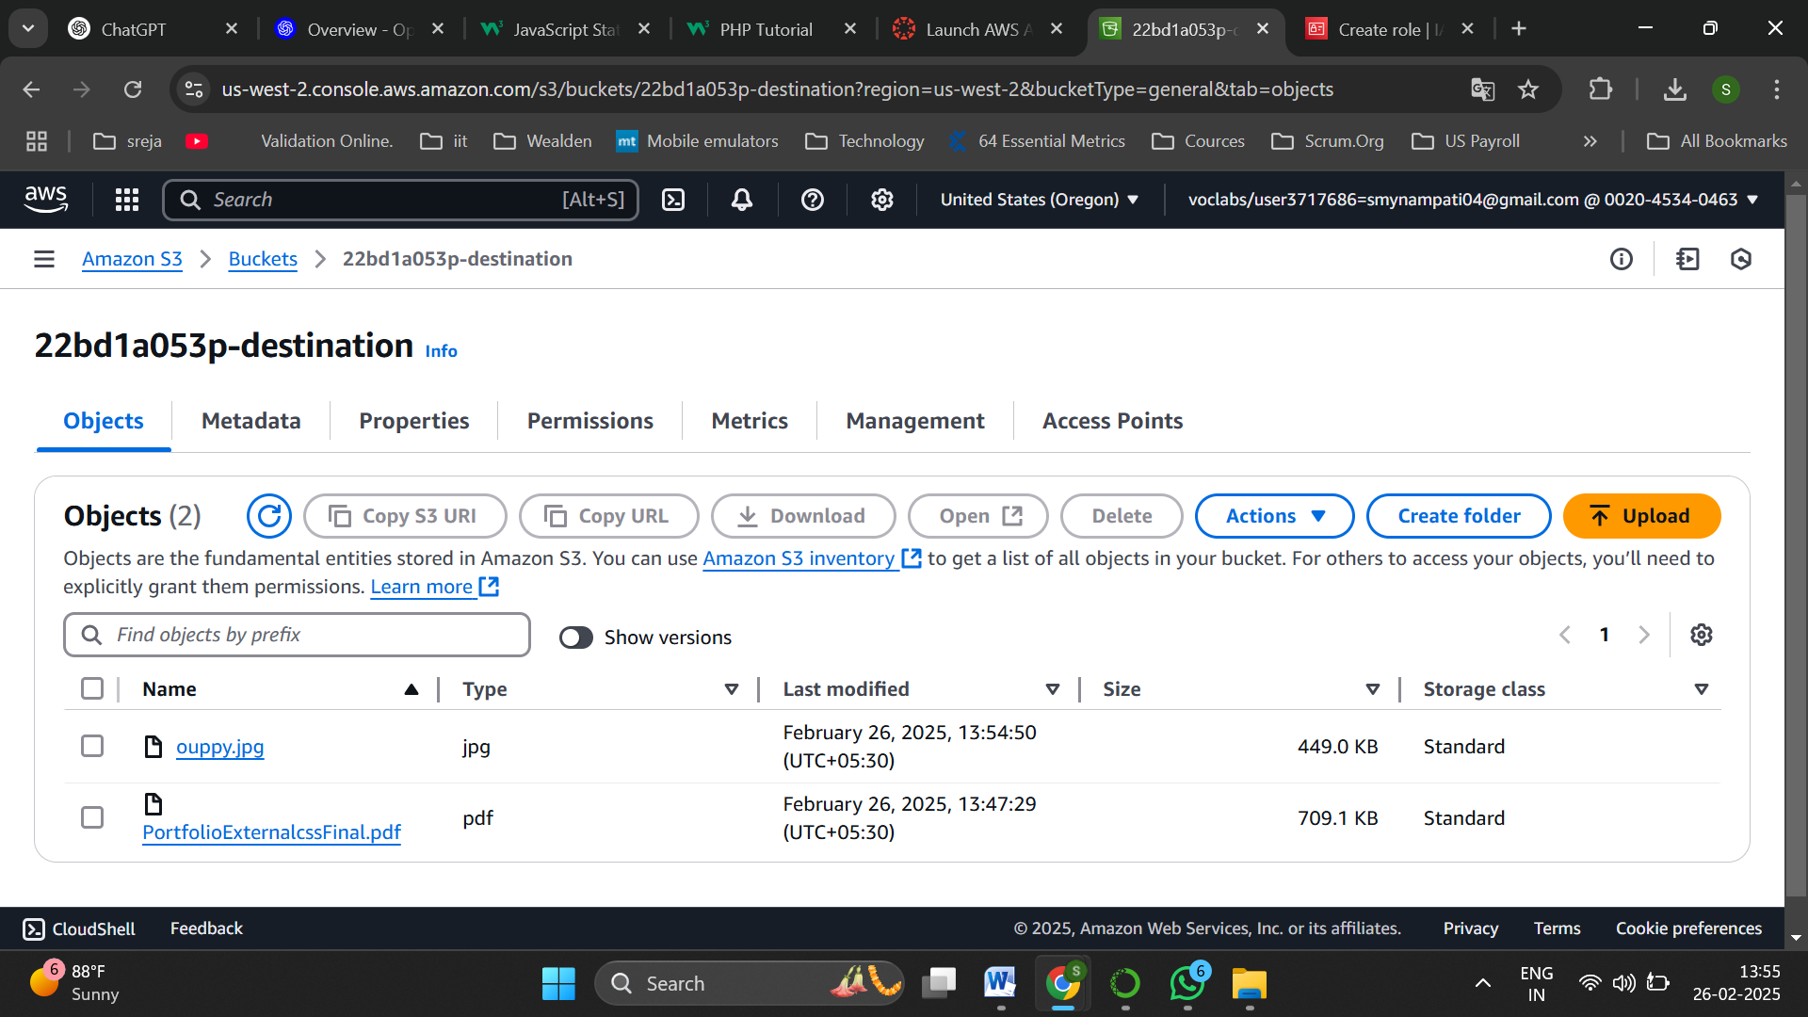

Successfully uploaded the object

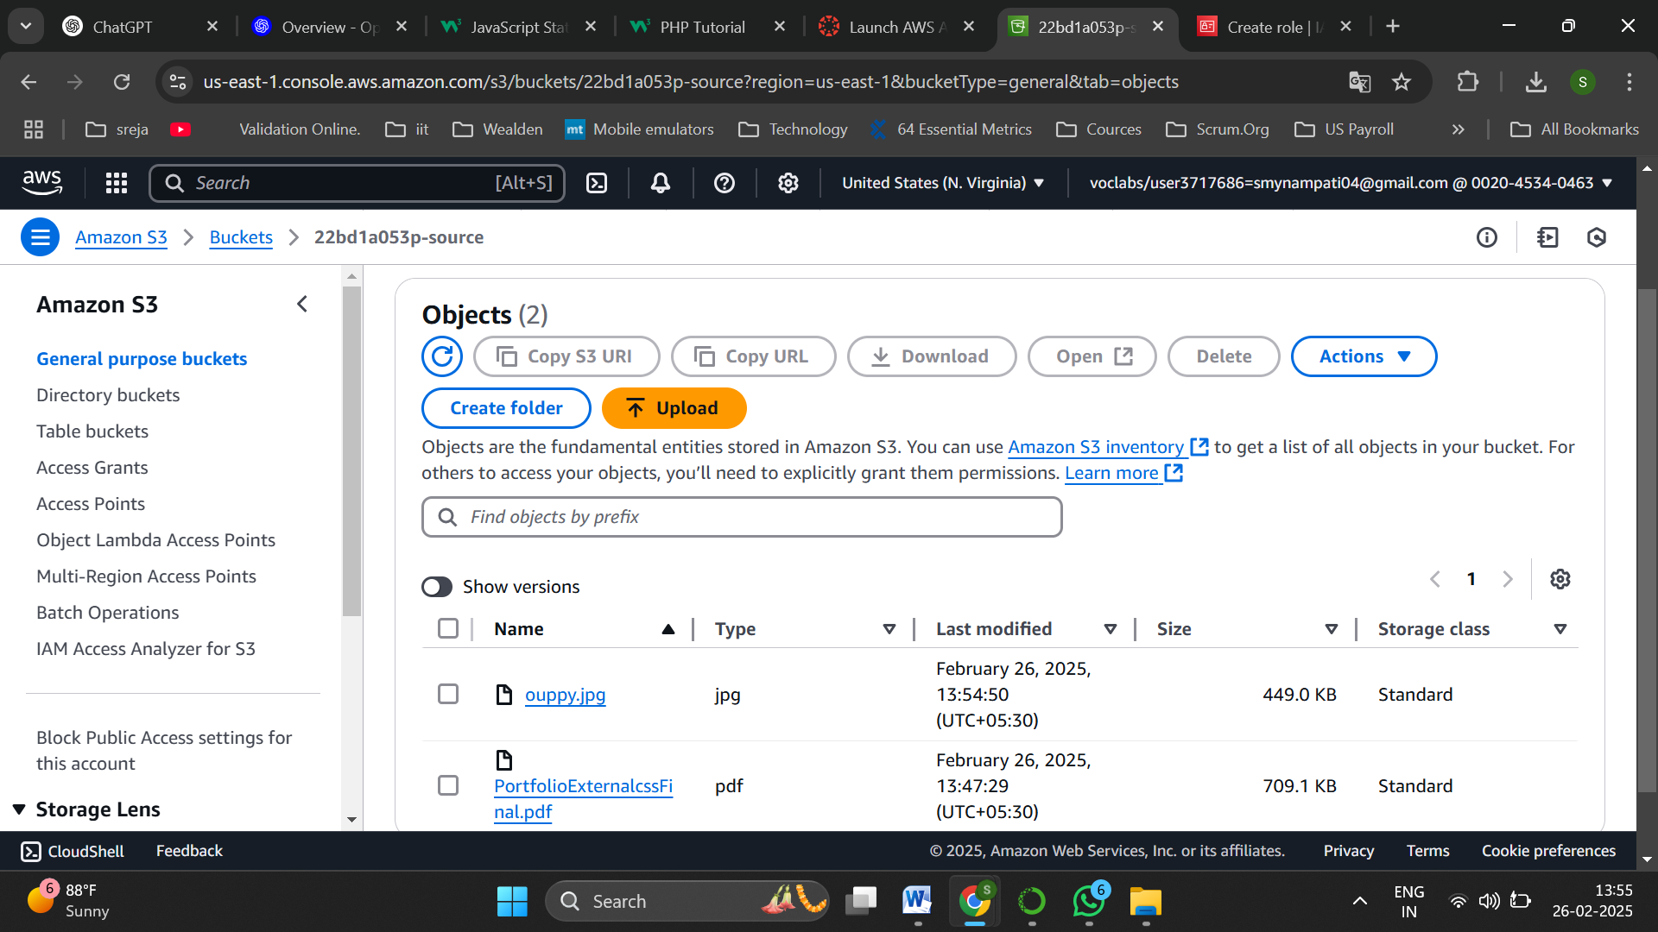

Now navigate to source bucket to see if the object is replicated and yes the object is replicate

Static Web Hosting:  
**Static Web Hosting** is a method of hosting websites that serve fixed content, such as HTML, CSS, JavaScript, and images, without server-side processing. AWS S3 provides a simple and scalable solution for static web hosting, allowing users to store website files in an S3 bucket and configure it for public access. Unlike dynamic web hosting, which relies on databases and server-side scripts, static hosting delivers pre-built content directly to users, ensuring faster load times, better security, and cost efficiency.

http://22bd1a053p-static-web-hosting.s3-website-us-east-1.amazonaws.com

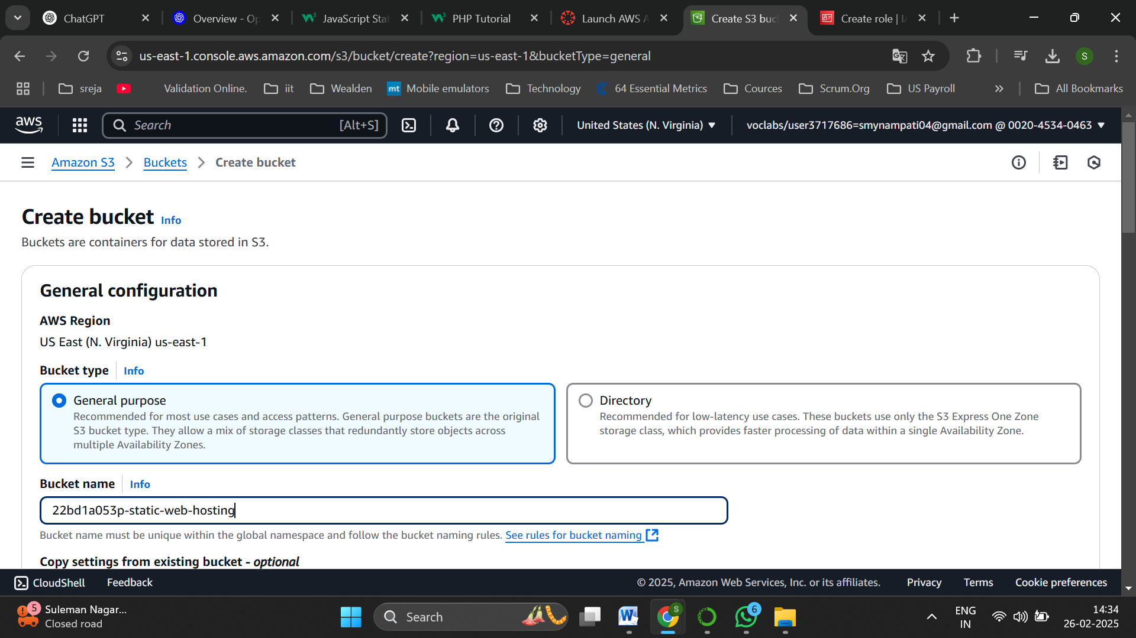

Create a bucket for static web hosting

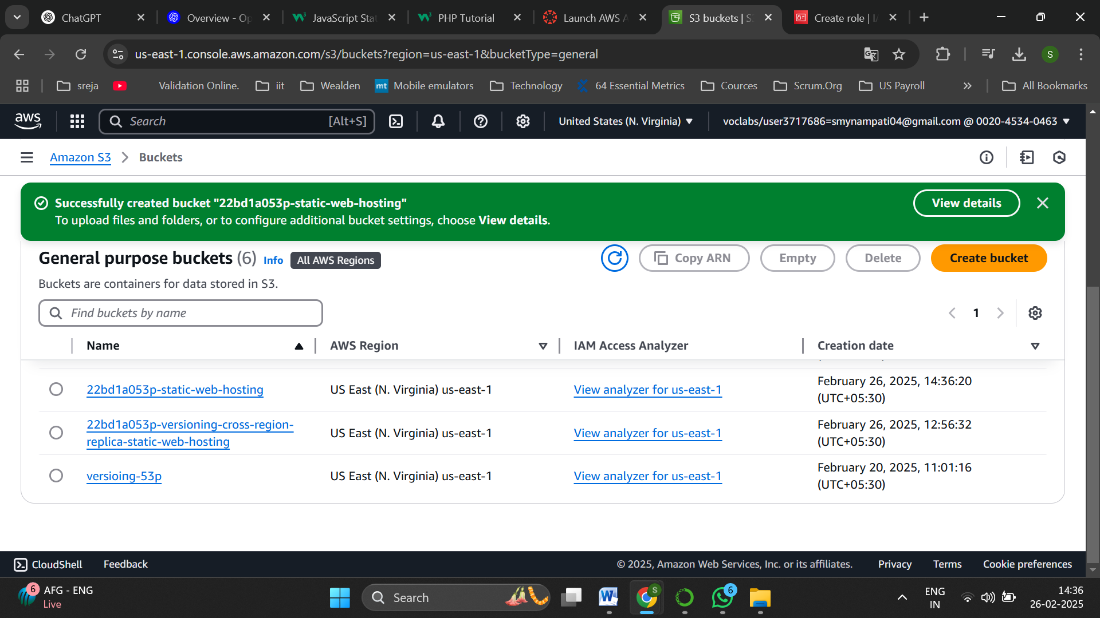

Bucket is created successfully

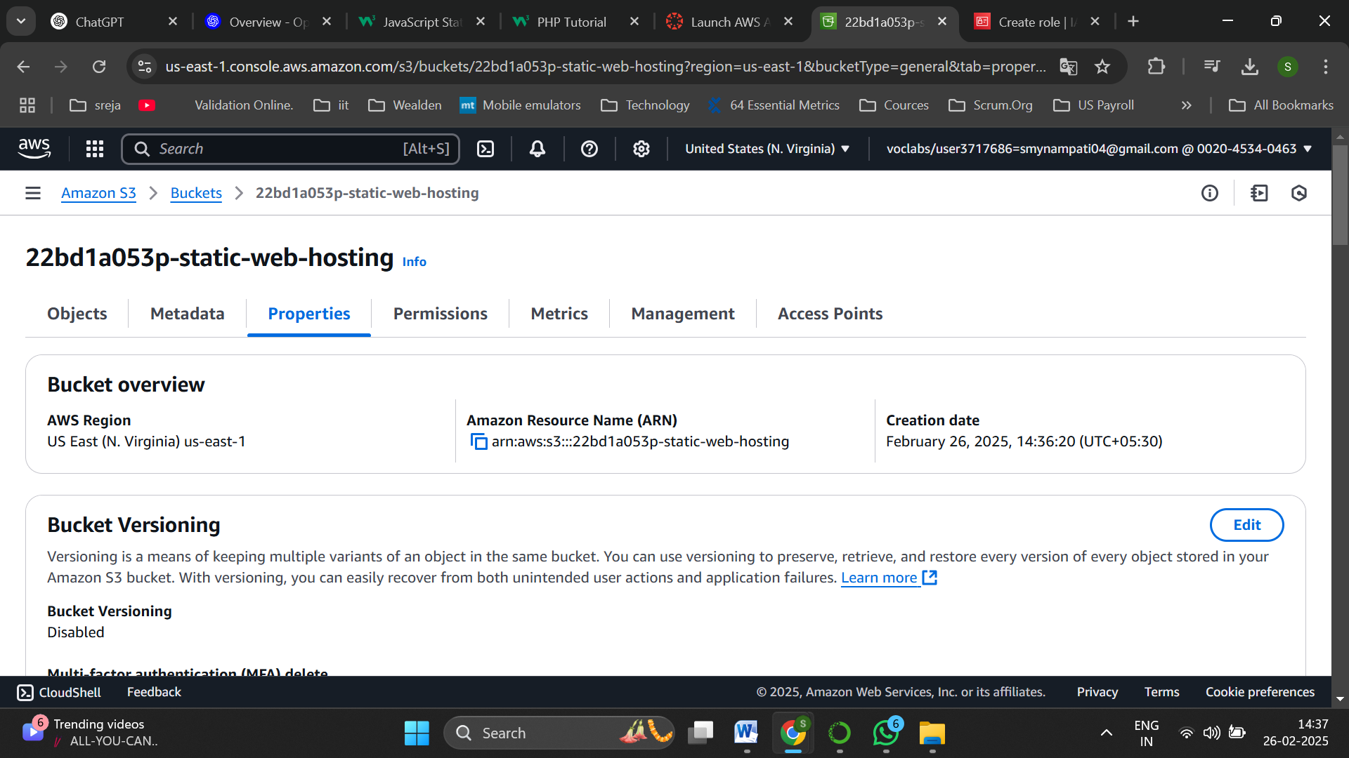

Navigate to the properties of created bucket

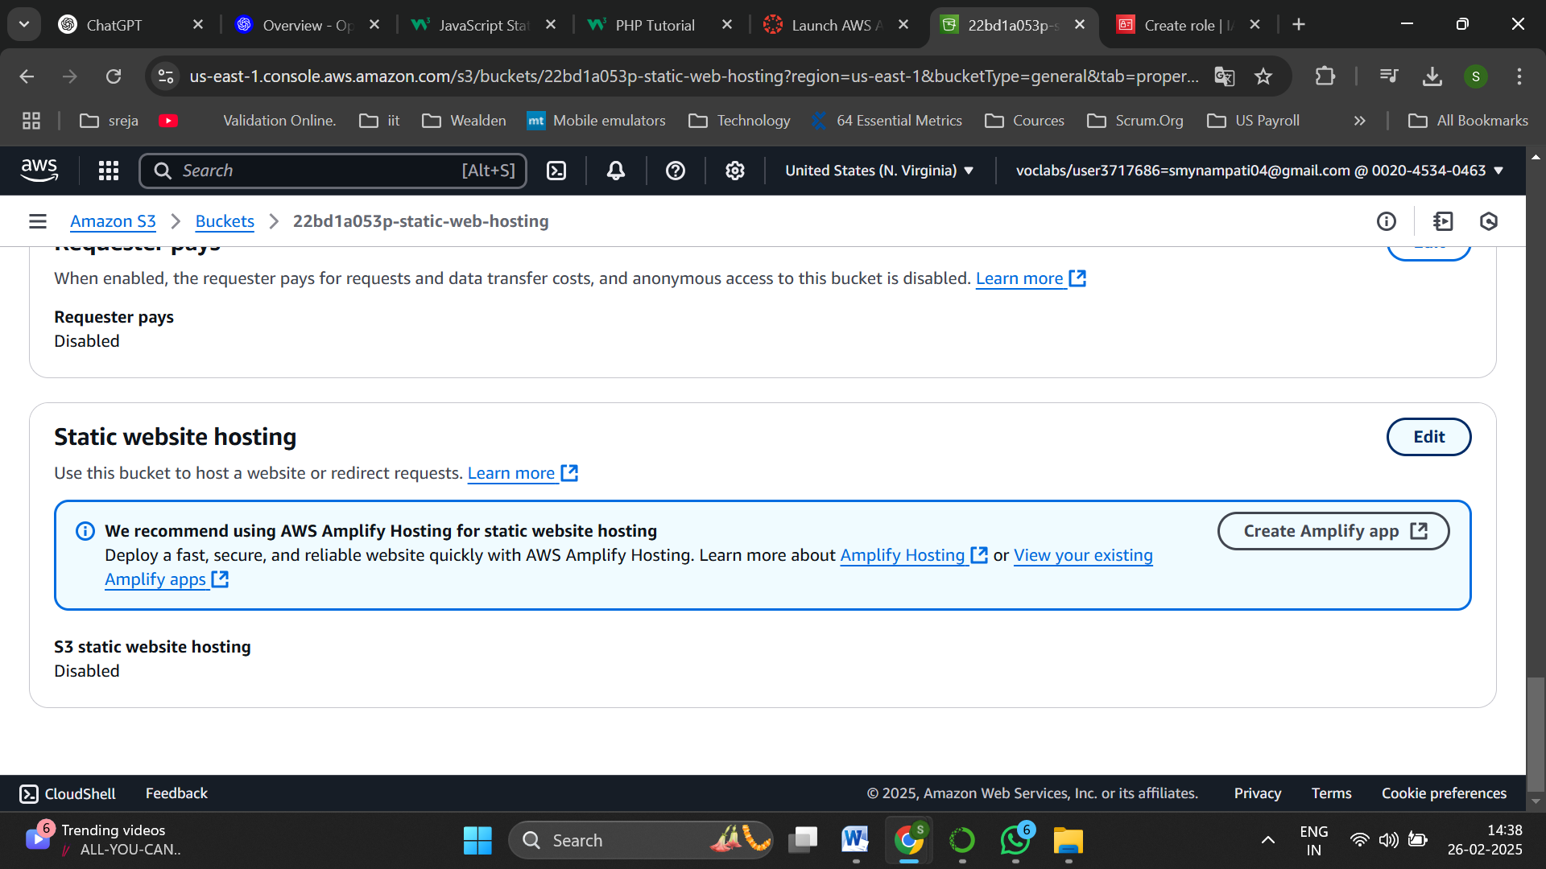

Scroll down to static web hosting and edit it

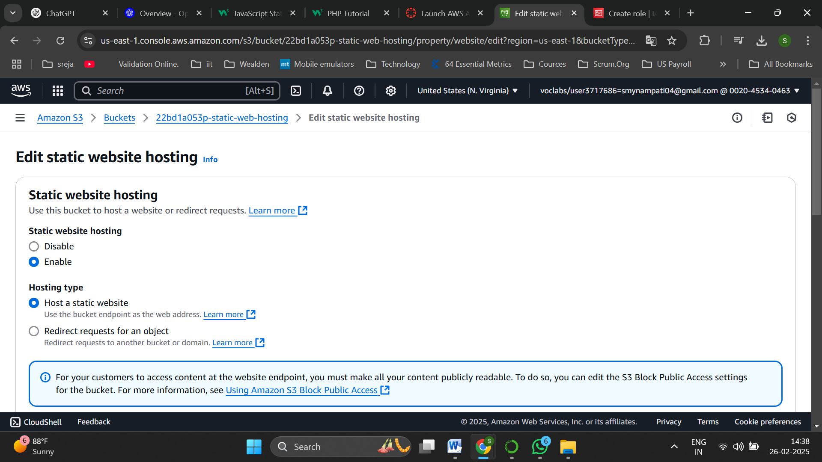

Enable static web hosting

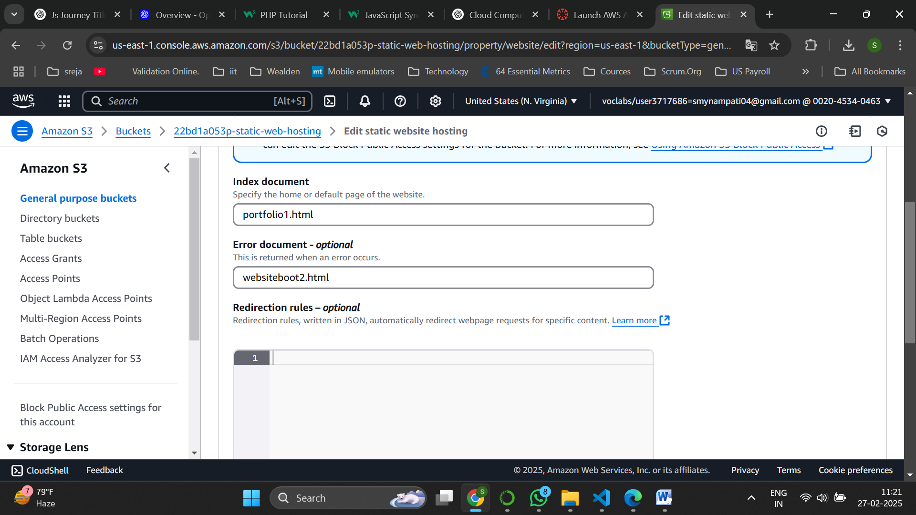

Set the above files as shown

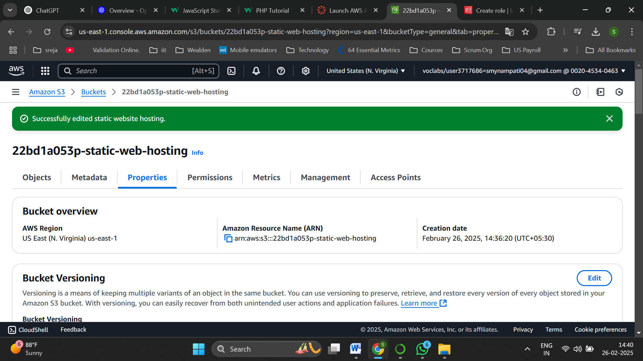

Edited successfully

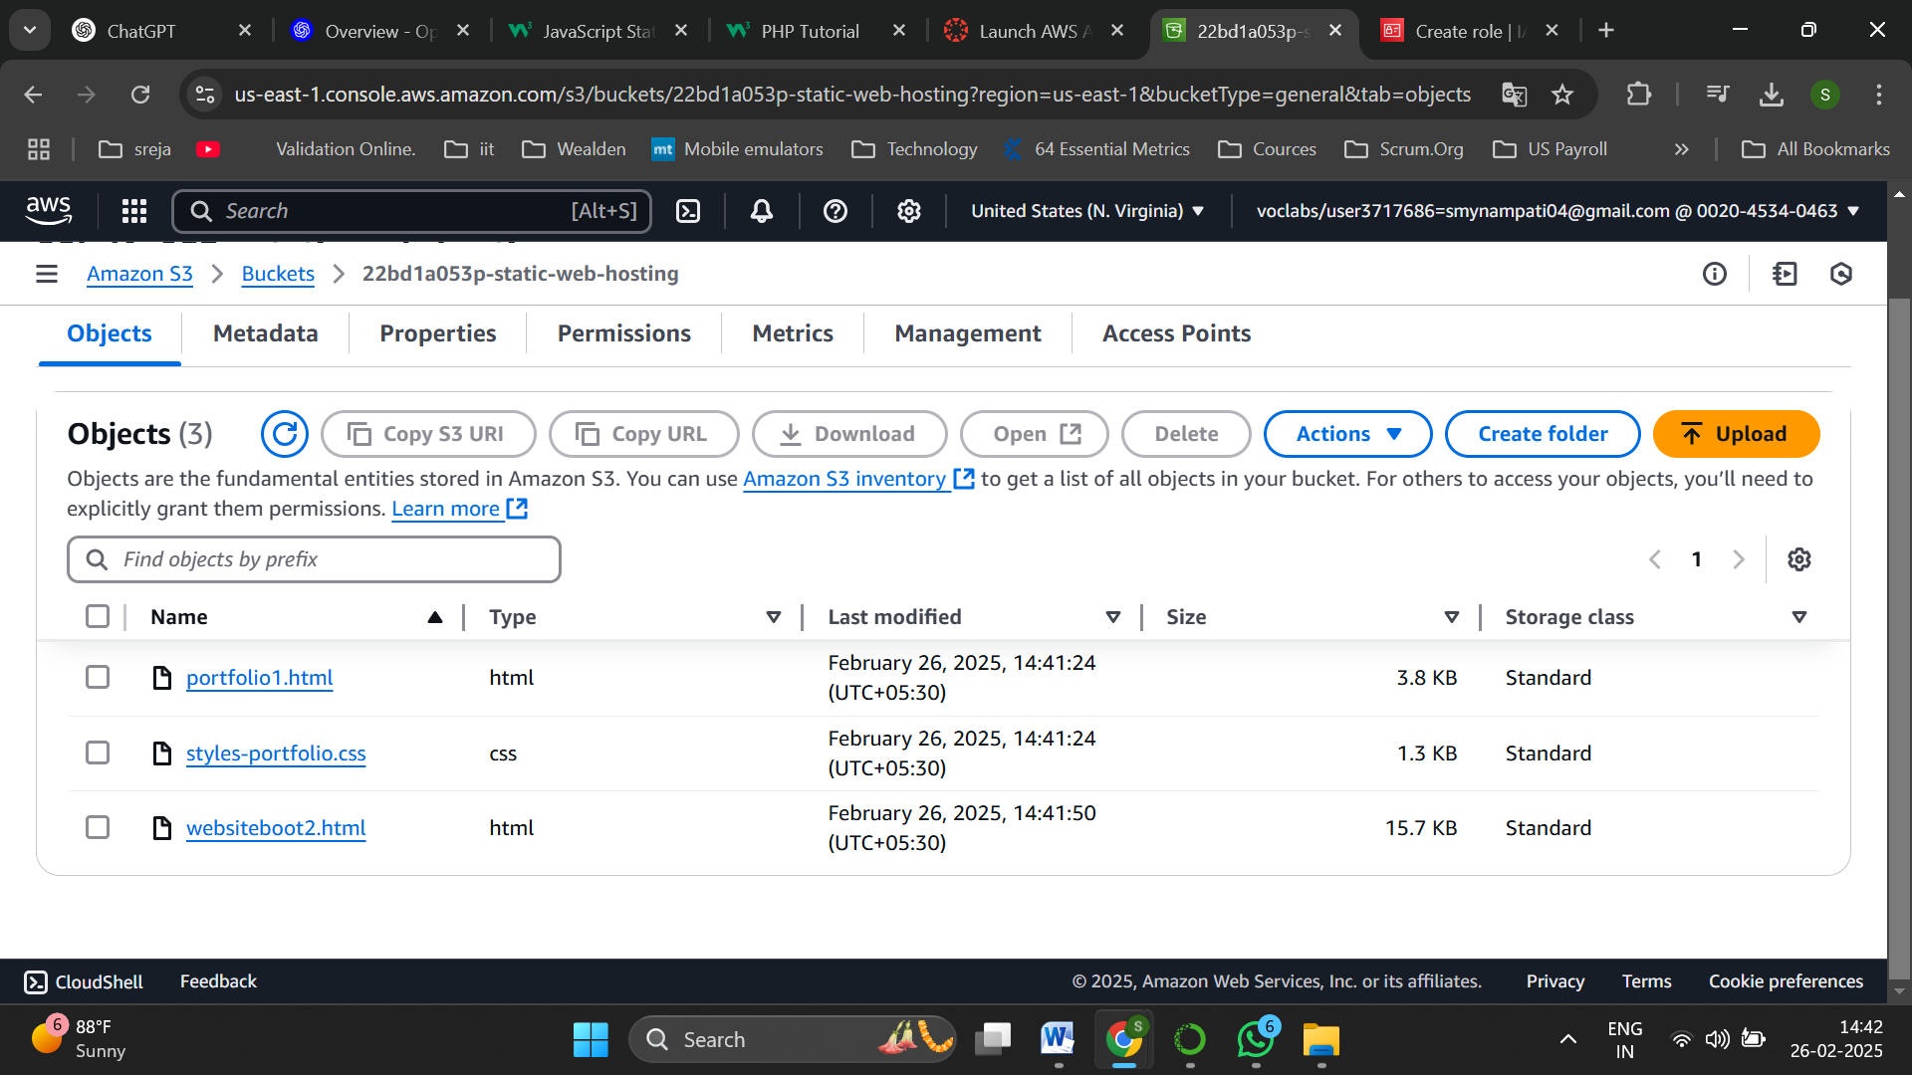

Now upload files to perform static web hosting

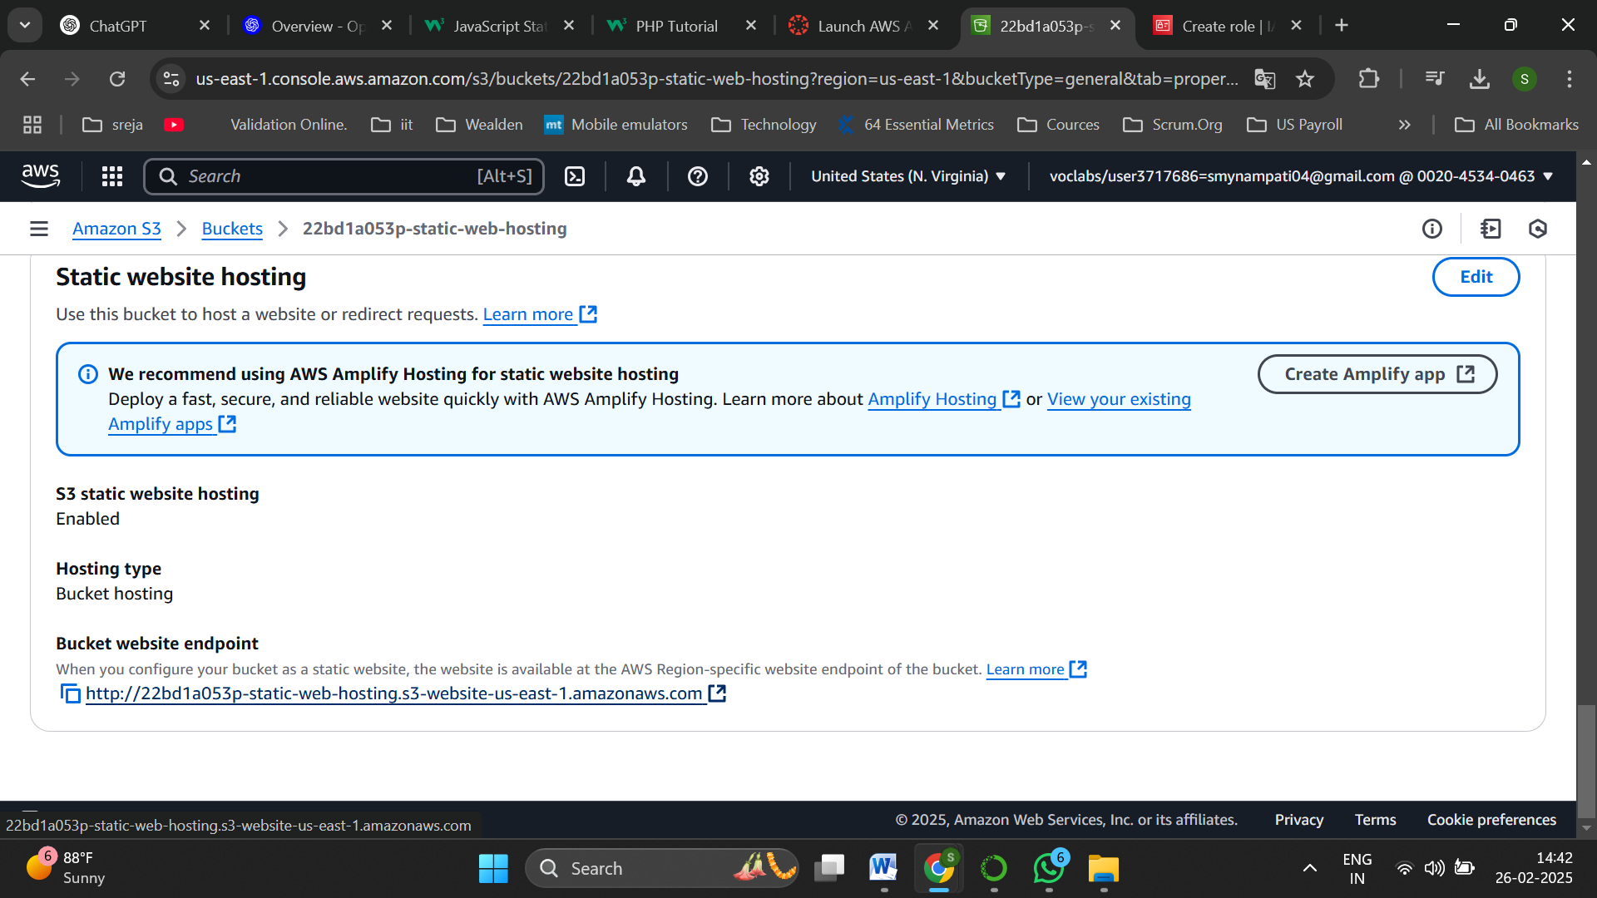

Click on the link and try to access via browser

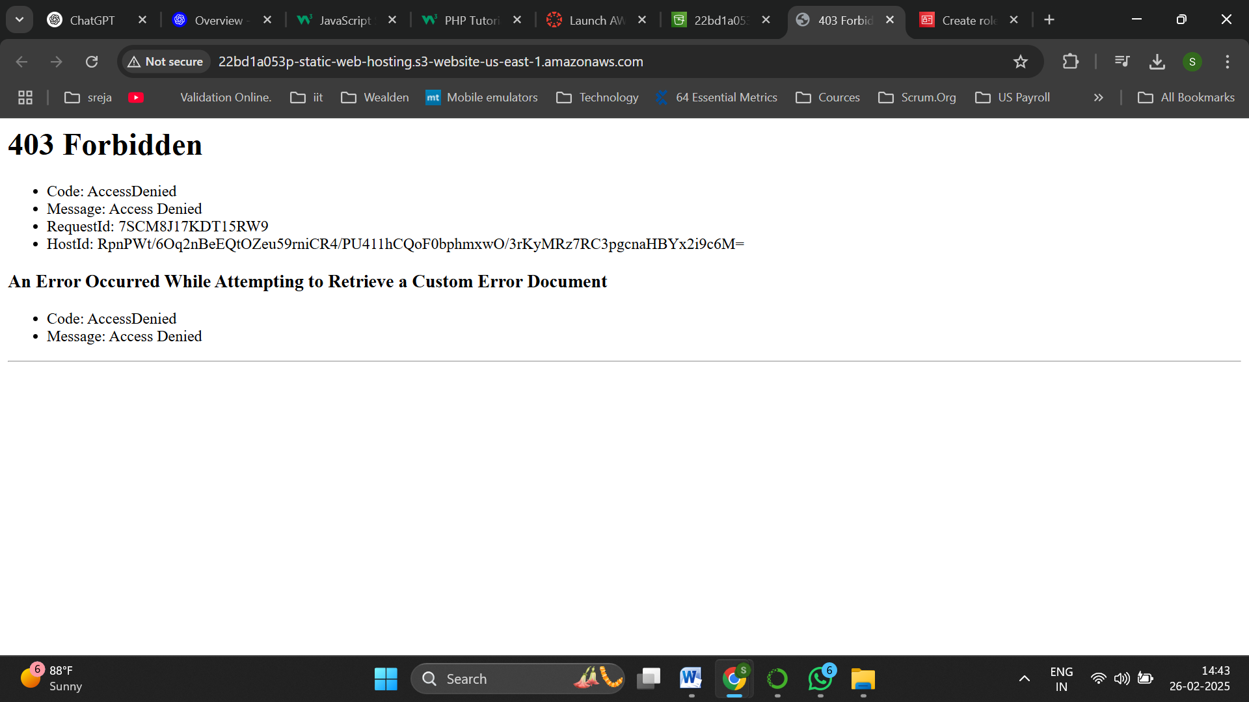

Error occured

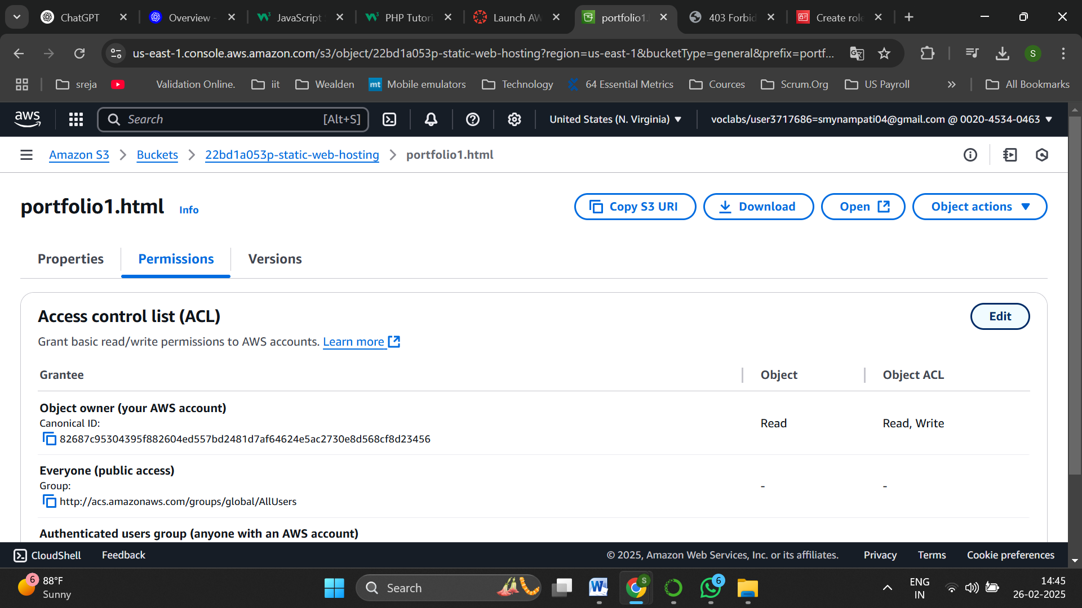

Navigate to permissions of the object to host and click edit

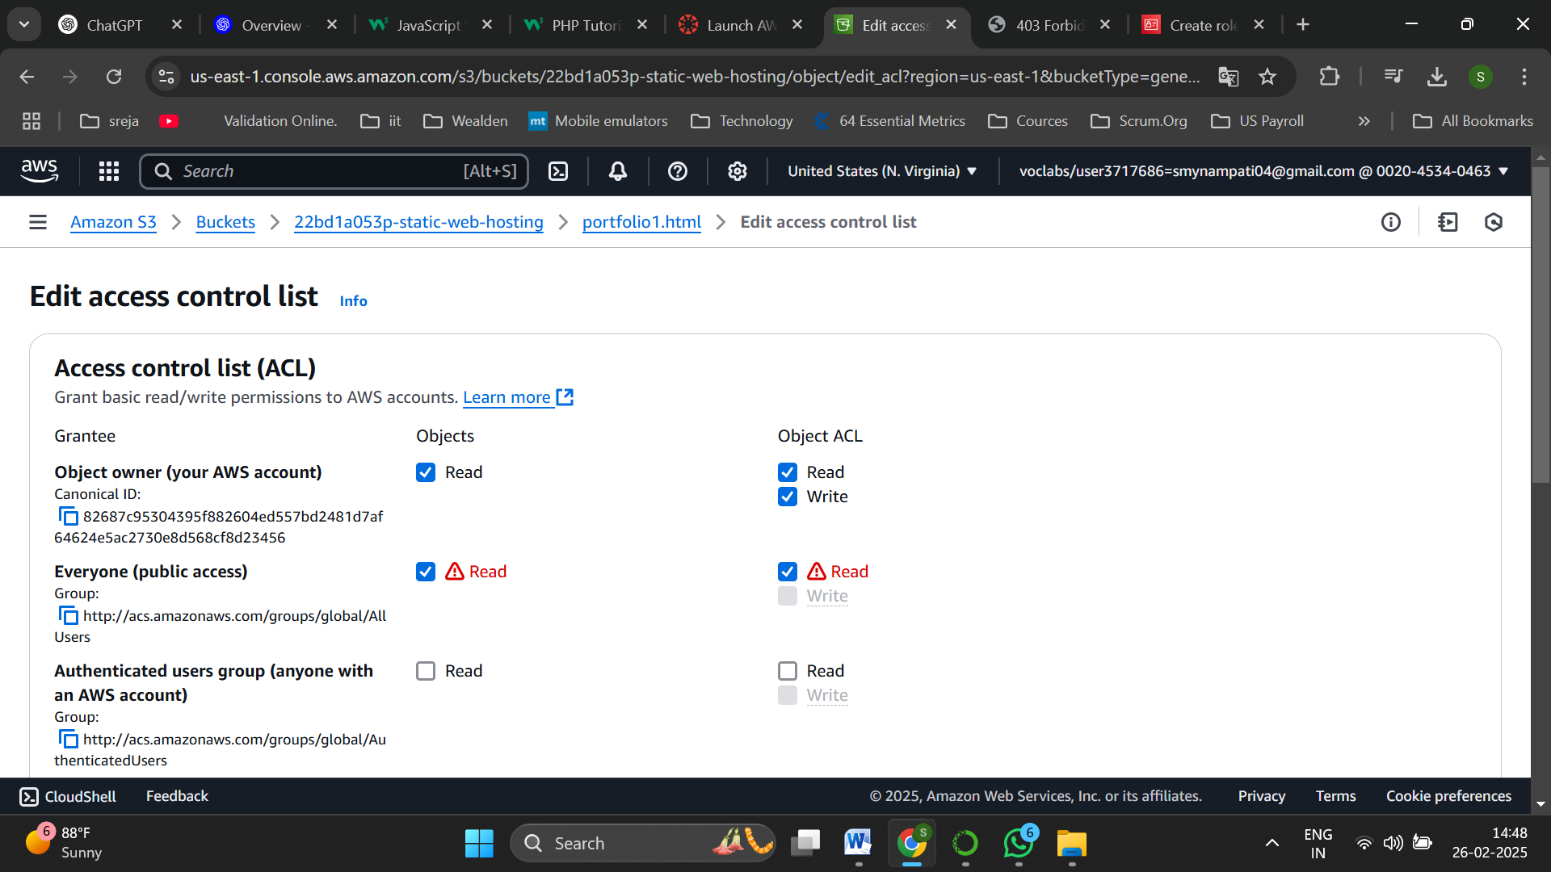

Enable public access

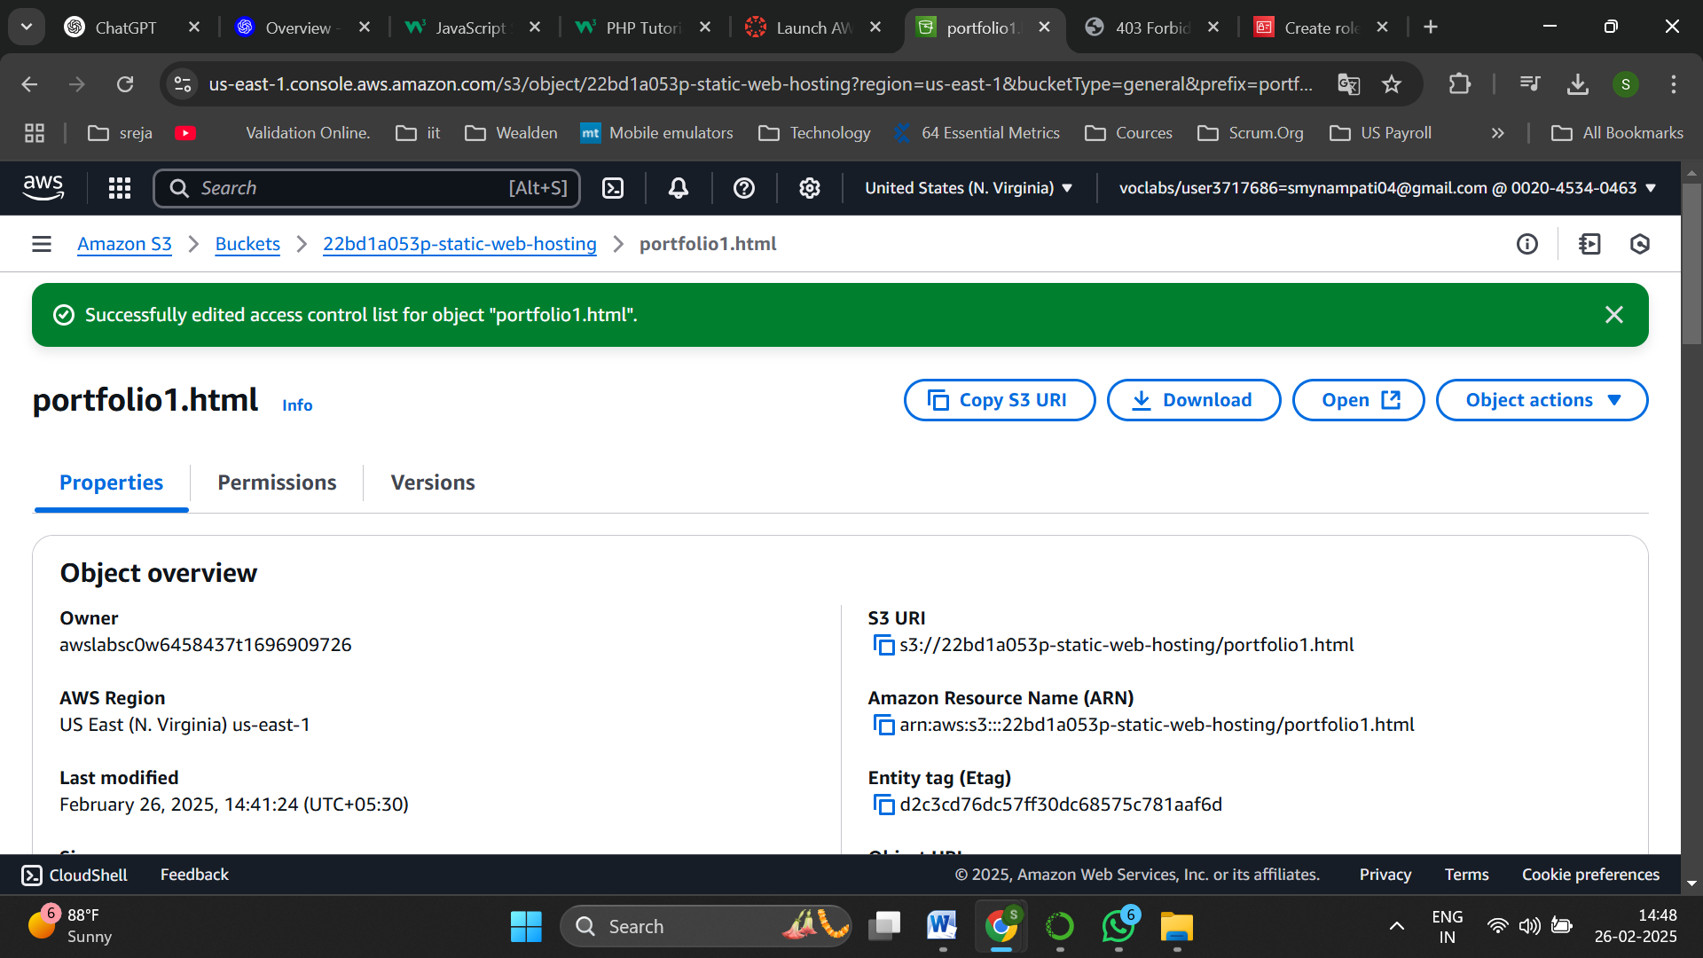

And save changes

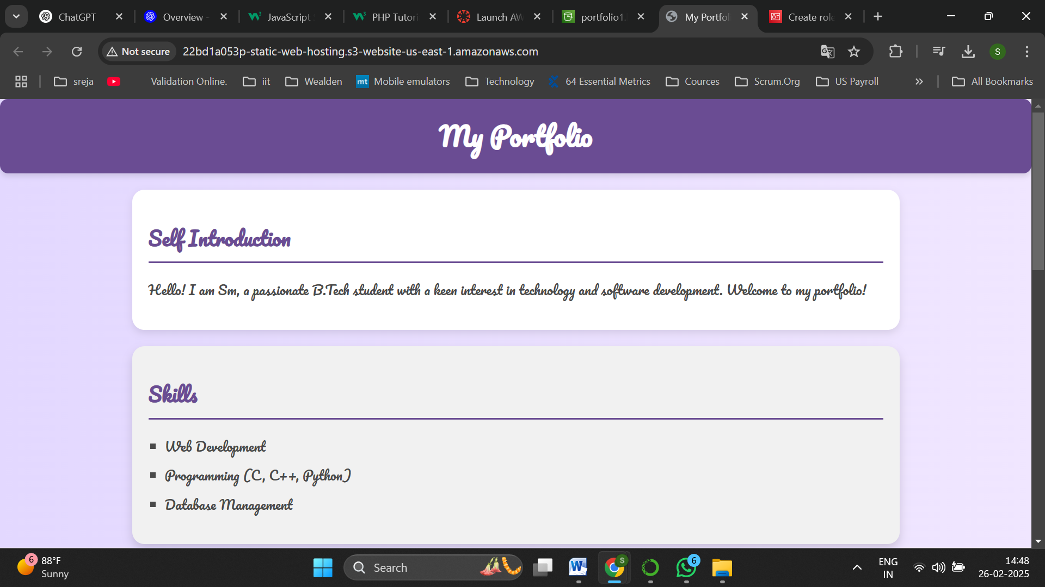

Now access via browser

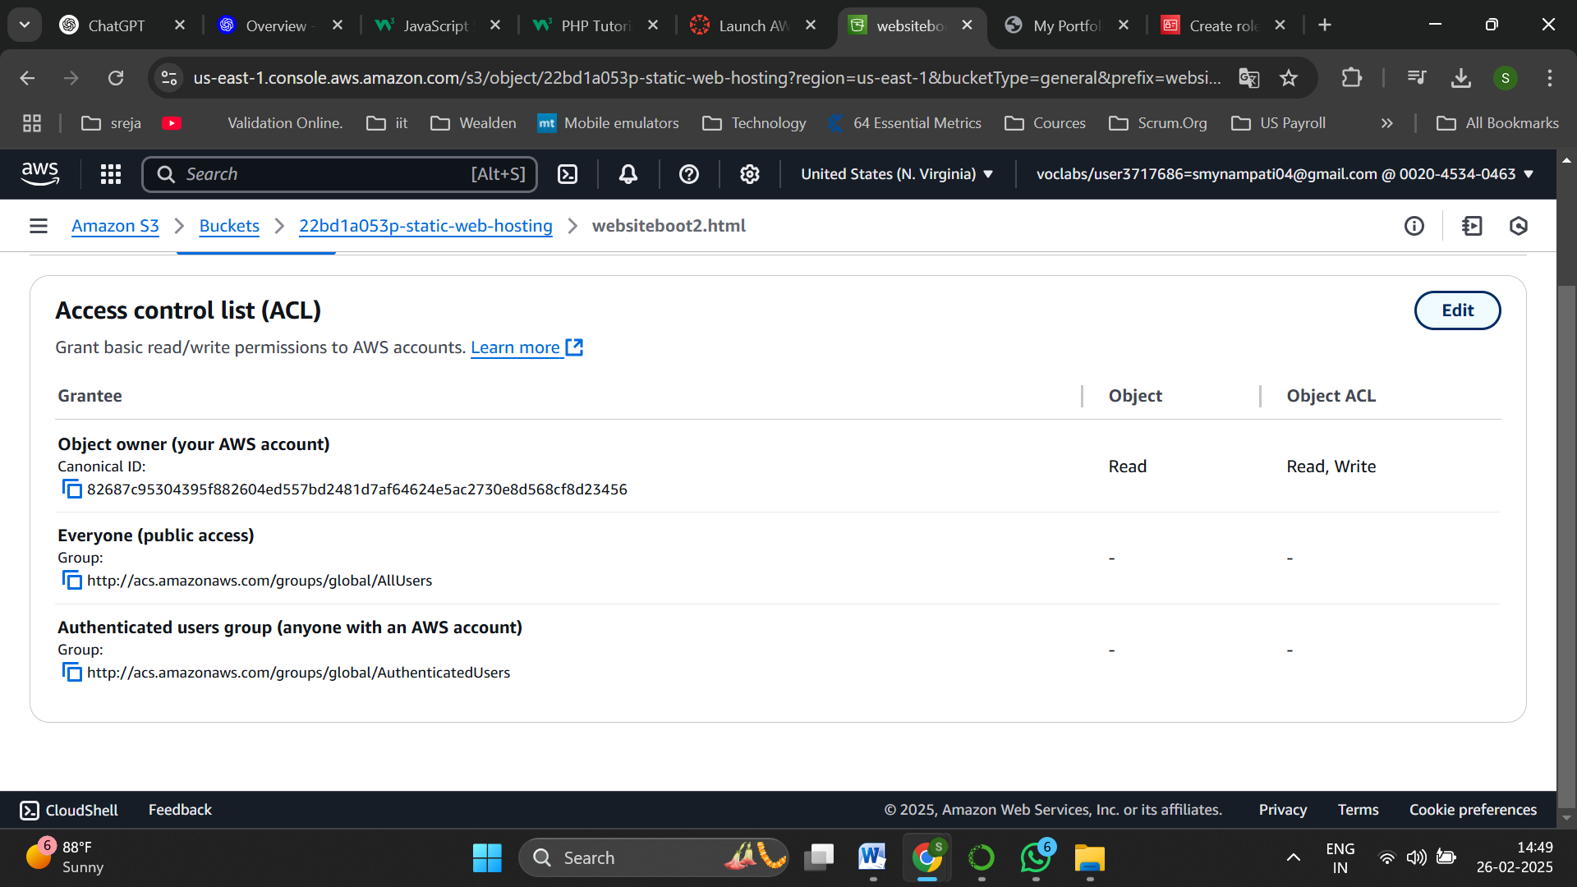

Do the same for the the error.html file

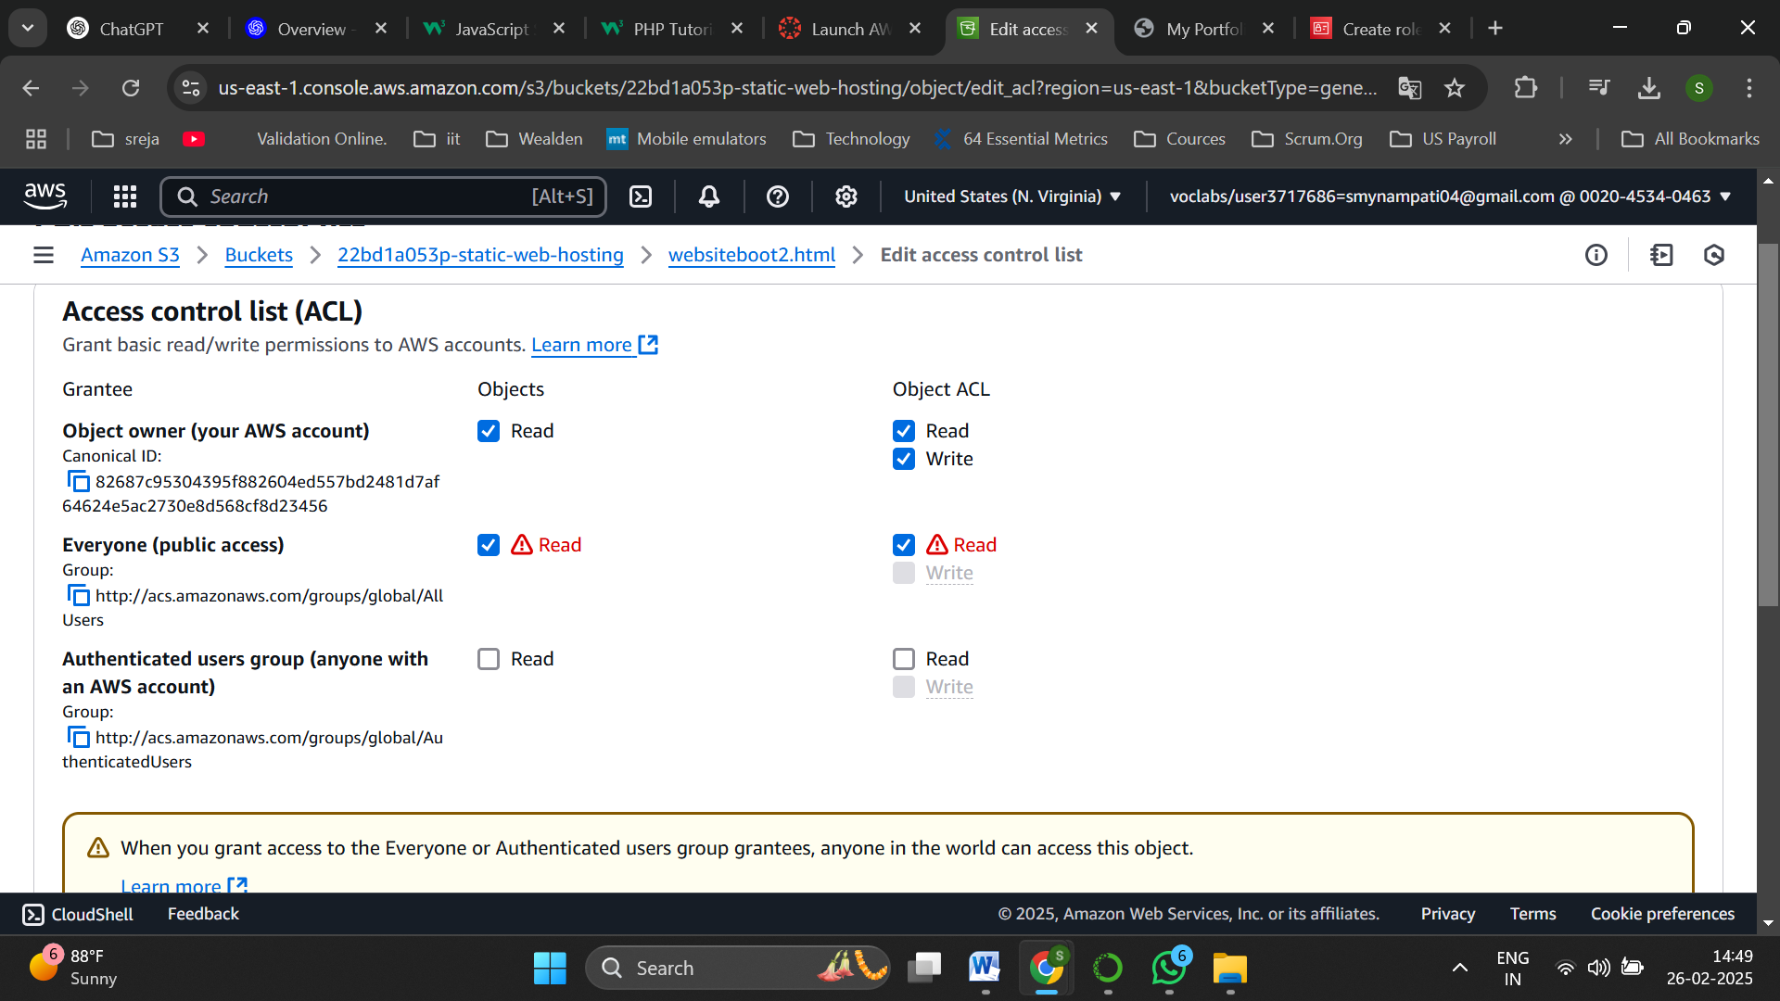

Enable public access

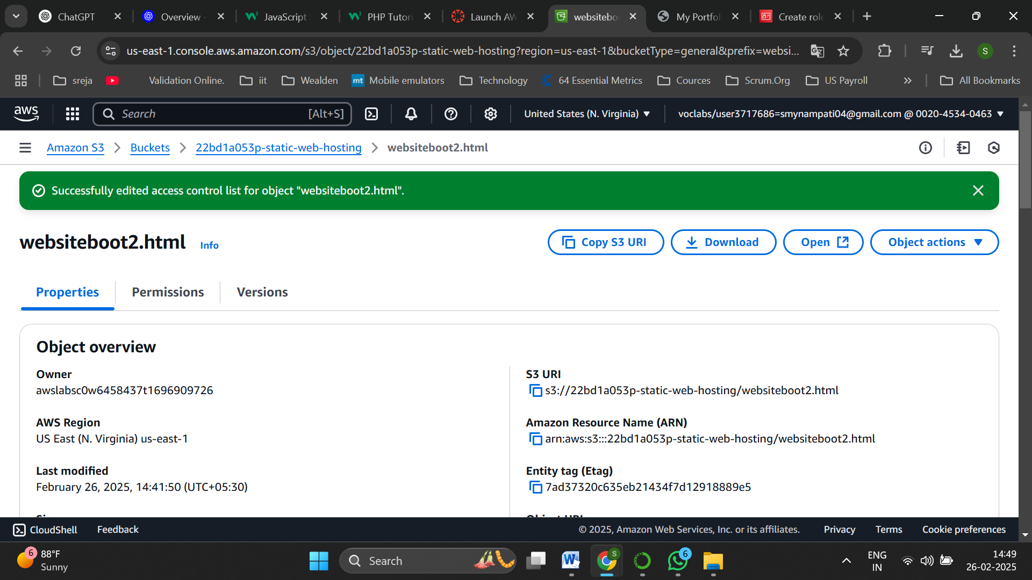

Successfully updated

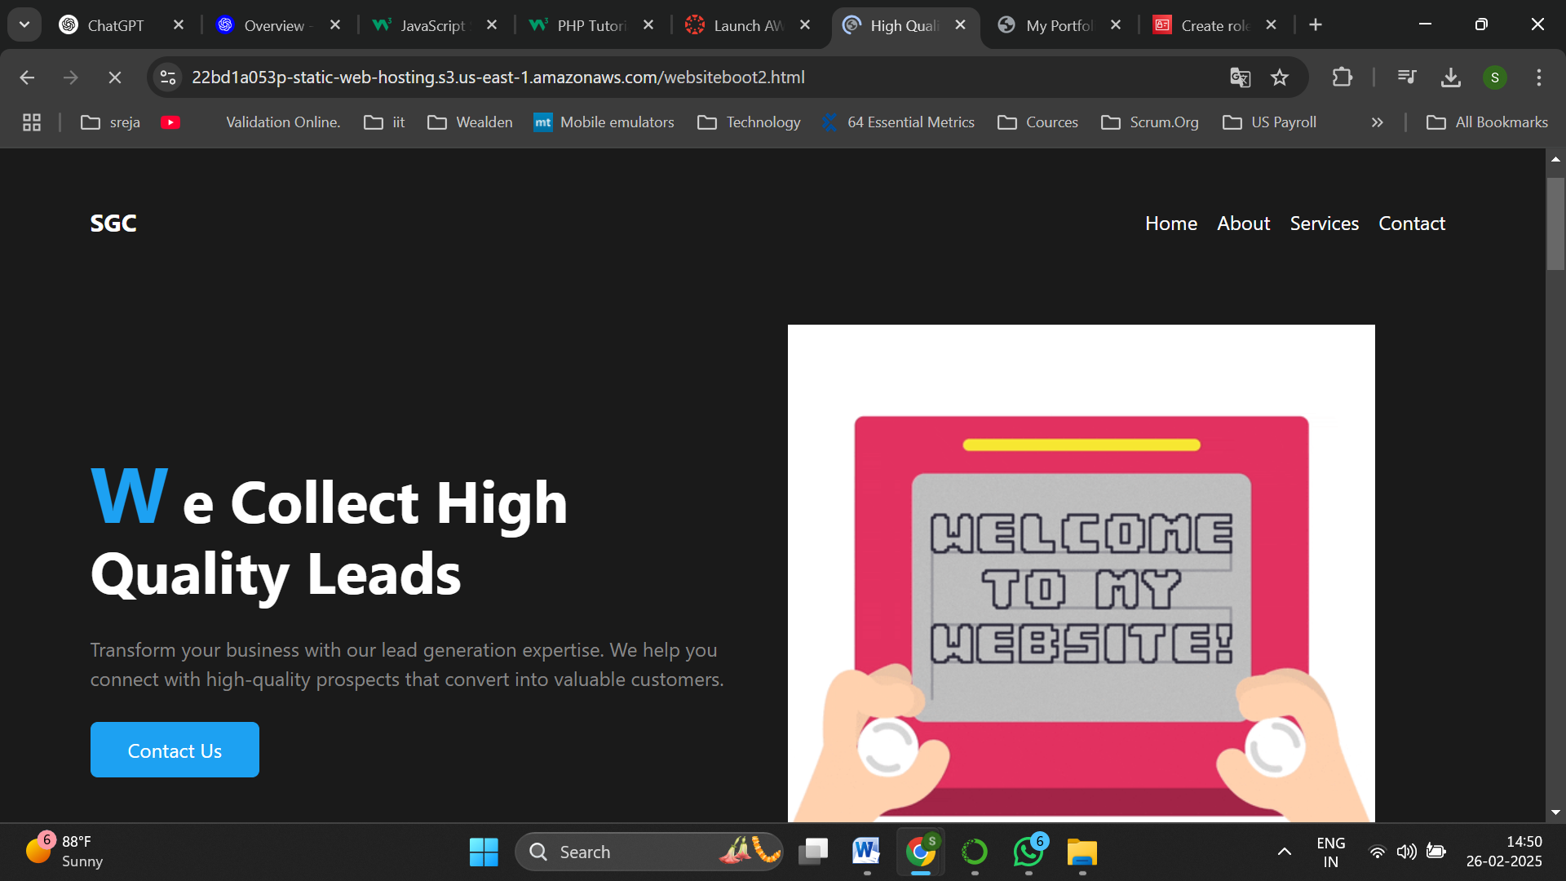

Static web hosting is performed